TIRELO BOSHA - FINAL CLOSE OUT REPORT

GRANT REFERENCE # - TB/CFP/2/2015/0369

Name of grant beneficiary | Centre for Public Service Innovation
Title of the action | Reduction and prevention of crime and theft of ICT equipment in schools
Location(s) of the action | 23 non fee paying school in Gauteng North
Name of the Partners to the Action/Project | Memeza Shout Crime Prevention NPO, Gauteng Department of Education, South African Police Services, Community Policing Forums
Budget | R1 419 850
Start date of the project | 5/9/2016
End date of the project | 28/2/2018

Report prepared by | Nsizwa Dlamini
Signature by project manager | 
Location | Centurion
Date report due | 28/2/2018
Date report sent

Report received by Tirelo Bosha PMU
Date and place of receipt
Signature

FINAL IMPLEMENTATION REPORT

1. Project summary
Overall objective | A communication and rapid response network is established in 23 No Fee Paying schools through the installation of the locally developed Police Sector Alarm, directly linked with SAPS sector vehicles/station, CPF and surrounding community
Specific Objectives | SPECIFIC OBJECTIVE 1: Government ICT infrastructure in schools is protected  SPECIFIC OBJECTIVE 2: SAPS and CPF frontline service delivery is improved  SPECIFIC OBJECTIVE 3: Job Creation  SPECIFIC OBJECTIVE 4: Knowledge Sharing
Expected Results | Result 1: Procurement / manufacturing of equipment  Result 2: alarms are distributed and installed  Result 3: Job creation  Result 4: Knowledge is shared  Result 5: Scaling Project
Main activities | 1. PHASE 1 - ACTIVITY  Preparation Activity 1- Kick off and Launch scheduled  Preparation Activity 2- Scope of Work to be completed  Preparation Activity 3- Report on Procurement of Alarms  Perpetration Activity 4- Report on awareness campaign strategy  Perpetration Activity 5- Report on resources employed for project  Preparation Activity 6- Report on Site visits to all 23 schools to establish implementation requirements.  PHASE 2 - ACTIVITY  Execution Activity 10- Report on training activities for installers and project staff  Execution Activity 11- Report on installations at 23 schools  Execution Activity12- Report on distribution of Personal Alarms  Execution Activity 13 - Report on SAPS, CPF and Community Knowledge Sharing Sessions  Execution Activity 14 - Report on Monitoring of impact  Execution Activity 15 -Replication report  Execution Activity 16 - Report on project close out

2. Assessment of implementation of project activities

2.1 Executive summary of all project actions – no more than 1 page
Please give a comprehensive overview of the project’s implementation for the reporting period
The scope of this project saw the implementation of 138 Police Sector Alarm systems in 23 allocated ICT schools. The Police Sector Alarms enabled the Reduction and Prevention of crime and theft of ICT equipment in schools through the Pro-activation of the South African Police Services (SAPS), Community Policing Forums (CPF) and mobilization of communities.
High-level activities of the project included:
Phase 1 included activities focused on Preparation for the project: Activity 1- Kick off and Launch scheduled, Activity 2- Scope of Work, Activity 3- Report on Procurement of Alarms, Activity 4- Report on awareness campaign strategy, Activity 5- Report on resources employed for project, Report on Site visits to all 23 schools to establish implementation requirements.
Phase 2 included activities around Execution for the project: Activity 10- Report on training activities for installers and project staff, Activity 11- Report on installations at 23 schools, Activity12- Report on distribution of Personal Alarms, Activity 13 - Report on SAPS, CPF and Community Knowledge Sharing Sessions
Phase 3 included reporting and monitoring of the impact of the project.
For the reporting period from January to March 2017, the main project activities were based planning, including procurement, training and installations. Activities during this phase of the project was delivered on time.
For the reporting period from April to June 2017, the main project activities were based on monitoring and knowledge sharing, with training activities continuing. Overall progress was on track, however there were delays in finalizing the strategy of awareness campaigns and distributing of Personal Alarms with Gauteng Department of Education, which was resolved in Q5 of the project. All installation were completed, apart from 2 schools that were under construction, which was also completed in Q5 of the project.
For the reporting period from July to September 2017, the main project activities were based on monitoring and knowledge sharing. The main focus during this time of the project was measuring of the SAPS response, which is summarized below. This quarter also included a project Site Visit by Tirelo Bosha and CPSI on the 6th of September 2017 to the Westbury Secondary School.
For the reporting period from Oct to Dec 2017, the main project activities were based on monitoring and knowledge sharing. During this time approval was received on the 12th of December 2017 for a Scope Change w.r.t the distribution of Personal Alarms and Awareness campaign, which was concluded by the Gauteng Department of Education during Q5.
The final period of the project from December 2017 to February 2018 consisted of monitoring of impact and SAPS response times, and Memeza and CPSI doing routine site visits to the schools to check technical workings of alarm systems and resolve any maintenance issues. This period also included the Tirelo Bosha site visits to 10 schools, with will follow by end of Feb 2018.
For all periods quarterly reports were supplied on time.

2.2 Activities and results – no more than 2 pages
Please list all activities of the contract implemented as per annexure I of the agreement/individual result framework.
- Activity 1: Kick off and Launch was successfully held with all stakeholders on the 17th of November 2016. Minutes and attendance register was supplied with Q1 Reporting. COMPLETED SUCCESFULLY

- Activity 2: Preparation Activity 2- Scope of Work to be completed- The Scope of Work/MOU was agreed and signed with CPSI early in 2017. COMPLETED SUCCESFULLY

- Activity 3: Preparation Activity 3- Report on Procurement of Alarms. All hardware was procured during Q1 of the project and proof of procurement supplied with Q1 reporting. COMPLETED SUCCESFULLY – EQUIPMENT PURCHASE REPORT SUPPLIED WITH QUATERLY REPORTS
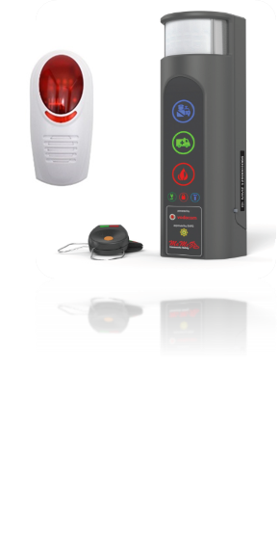
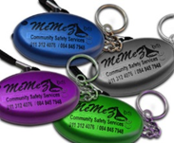
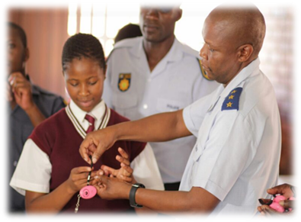

- Activity 4: Perpetration Activity 4- Report on awareness campaign strategy. There was a delay in the delivery of this activity due to the scope change requested by Department of Education to extend the reach of the distribution of Personal Alarms and the Awareness strategy. The Scope change for the awareness campaign and distribution of Personal Alarms were approved on the 12th of December 2017. COMPLETED SUCCESFULLY IN Q5
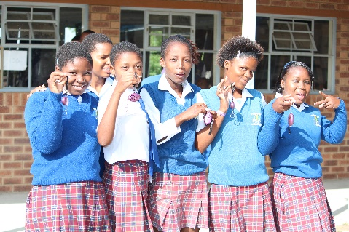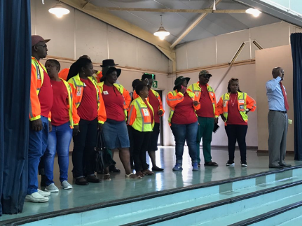
- Activity 5: Perpetration Activity 5- Report on resources employed for project. Through The project 10 direct jobs have been created, of which consists of Community Installers, Technical and Administrative staff. A further 11 indirect jobs were created during the period of the project. Reports have been supplied detailing salary payments and training provided to staff. COMPLETED SUCCESFULLY WITH PROOF OF SALARY PAYMENTS AND CONTRACTS SUPPLIED QUATERLY – JOB CREATION REPORT.
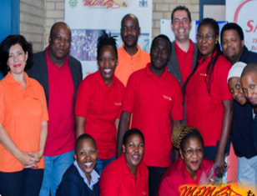
- Activity 6: Preparation Activity 6- Report on Site visits to all 23 schools to establish implementation requirements. Site visits have been completed successfully quarterly and reports on site visits have been supplied, with the final report on final site visit findings on maintenance challenges included further down in this report. COMPLETED SUCCESFULLY.

- Activity 10- Report on training activities for installers and project staff – Staff received in depth training on Memeza solutions and technical installations, and proof of training sessions were supplied to project team quarterly. COMPLETED SUCCESSFULLY.

- Activity 11- Report on installations at 23 schools - Installations to all schools were completed in time, except for 2 schools that were under construction. The final 2 schools were completed in Q5 of the project. COMPLETED SUCCESFULLY
- Activity12- Report on distribution of Personal Alarms – Although the procurement and branding of Personal Alarms were completed as per the project plan, there was a delay with the distribution of the Personal alarms and awareness campaign. Gauteng Department of Education requested a change of scope to allow them to reach a wider network of schools with the Distribution of Personal alarms, which was approved by Tirelo Bosha. The scope change resulted in the following deployment plan: Districts were called per region by the Gauteng Department of Education with each coordinator given to distribute to schools in their region (2 alarms per school). Coordinators conducted meetings with School Principals and community with the idea of mobilizing community members in support of the Patrollers in situations where personal alarms are activated. The process was concluded prior to December 2017 School holidays. COMPLETED SUCCESSFULLY

- Activity 13 - Report on SAPS, CPF and Community Knowledge Sharing Sessions - Technical training provided and proof submitted in Q1, Memeza back end management system training provided in Q1, Training material printed and provided - costing provided as proof, Training attendance registers supplied and overall Training and Knowledge Sharing Report provided in Q3 – COMPLETED SUCCESSFULLY
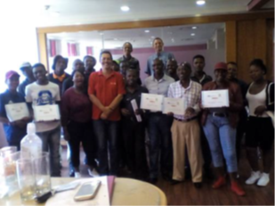
- Activity 14 - Report on Monitoring of impact – Due to Memeza being ahead of schedule with installations at the various schools, the monitoring element of the project impacted started much earlier than anticipated in January 2017, and therefore quarterly reports all included measurements of SAPS response times and impact. SAPS response times average between 7 to 10 minutes, COMPLETED SUCCESFULLY

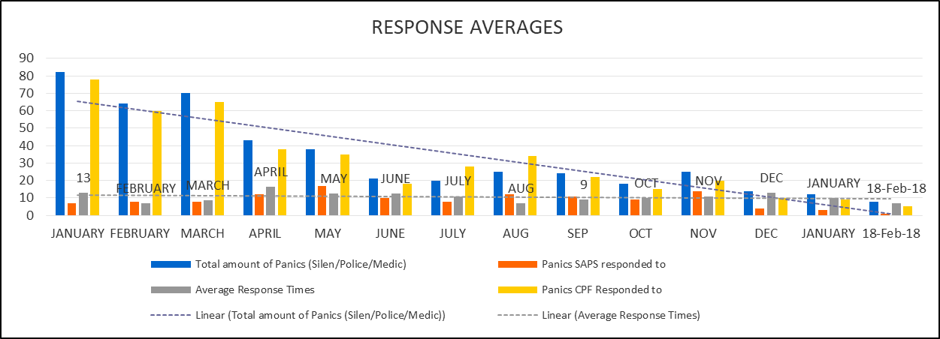
- Activity 15 -Replication report- The replication report attached hereto addresses a short summary of the learnings and elements to be taken into consideration when scaling the project. COMPLETES SUCCESFULLY

- Activity 16 - Report on project close out (THIS IS THE FINAL CLOSE OUT REPORT)

2.3 Activity action plans
<Please provide an overview of the original and actual activity action plan and indicate the reason/s for deviating from the original plan (if applicable).>
The original activity and action plans stayed in place and was delivered as per original planning. The only 2 elements that were delayed in delivery included:
- Personal Alarm distribution which was only concluded in Q5 due to a delay in strategy finalization from the Department of Education.
- Final 2 schools which were under construction and could only be implemented by Q5.
- Although delays were experienced with the above 2 deliverables, the overall project was still delivered in time.
Original plan as per Annexure I of the Agreement – 1st Action plan below and Final plan as per Annexure 1 of Agreement – 2nd Action plan below

3. Partners and cooperation

3.1 Partnerships
How do you assess the relationship between the formal partners of this Action (i.e. those partners who have signed a partnership statement)? Please provide specific information for each partner organization.
3.1.1.1. SAPS – Good, and through the project the relationship have improved. Currently we are working with SAPS on a National launch date for the project.
3.1.1.2. CPF – Excellent – The Gauteng Community Policing board have adopted the Memeza project as their own and support the deployment of further projects fully.
3.1.1.3. GED – Excellent – the CPSI through this project has become a valued partner to Gauteng Department of Education, with the CPSI and Memeza now being the first to call when help is required with safe guarding No Fee paying schools.

3.2 Tirelo Bosha PMU / DPSA
How would you assess the relationship between your organization and the Tirelo Bosha PMU/DPSA? How has this relationship affected the Action?
The CPSI’s relationship with Tirelo Bosha/DPSA is good, and the work we are doing through this project is improving the relationship increasingly. The assistance through the Tirelo Bosha programme have given the CPSI the footprint in schools required to make a difference and showcase the impact solution. The impact in reduction of crime in schools and improvement of Service Delivery by SAPS and CPF have been significant.

3.3 Other organizations
Where applicable, describe your relationship with any other organizations involved in implementing the Action:
• Sub-contractor(s) (if any)
  - MAMI Product Manufacturing - Excellent
  - JALIA System Maintenance – Excellent
  - Memeza Shout - Excellent
• Final Beneficiaries and Target groups
With implementation we are seeing the beneficiary list growing, now that we have confirmed numbers of learners and teachers in the schools impacted.
- Beneficiaries:
  - Gauteng Department of Education - reduction of theft of ICT equipment - Excellent
  - Department of Community Safety - better protection and safety of learners and schools - Excellent
  - The South African Police Services - quick response time - Good
- Initial Target Groups:
  - 3510 underprivileged GDE learners (JHB North township areas)
  - 23 No Fee Township Secondary Schools - Good
  - 10 Jobs created for local community members – Very Good
  - 115 Community Patrollers empowered – Very Good
  - Further target group reached with scope changed – 1500 No Fee paying schools and 3 000 Patrollers
• Other third parties involved (including other donors, other government agencies or local government units, NGOs, etc)
None

3.4 Links and synergies
Where applicable, outline any links and synergies you have developed with other actions.
- Department of Education is keen to expand the project to all No Fee paying schools in Gauteng, this is already visible through the change of scope requested for the Personal Alarm distribution.
- SAPS National, is keen to get further funding to ensure safety and service level improvement for all No Fee paying schools Nationally.

4. Results and impact assessment

4.1 Assessment of Specific Objectives
Please elaborate on the (non-) achievement of the Specific Objectives.
- To what extent have the objectives been achieved? What worked out as assumed? What did not and why? Use the indicators as guidance, if available.
- All objectives set out at the start of the project have been achieved in the following sense:
  - Overall Objective achievement: A communication and rapid response network was established in 23 No Fee Paying schools through the installation of the locally developed Police Sector Alarm, directly linked with SAPS sector vehicles/station, CPF and surrounding community, which after 18 months proved to reduce SAPS response times to between 7 and 10 minutes. It has also been found that there has been a 100% prevention rate of ICT theft since the installation of the Memeza Community Alarm systems. There was no theft of ICT equipment experienced after installation of alarms in the 23 schools.
  - It can therefore be confirmed that the specific objectives were achieved in the following manners:
    - SPECIFIC OBJECTIVE 1: Government ICT infrastructure in schools is protected – Result 100% prevention rate
    - SPECIFIC OBJECTIVE 2: SAPS and CPF frontline service delivery is improved – Result – 7 to 10 minute response time – improvement from over 30 min
    - SPECIFIC OBJECTIVE 3: Job Creation – Result – 10 Jobs created out of project, however even more jobs indirectly created as further partners came on board through internship programmes focused on supporting the schools project – total of 21 jobs created
    - SPECIFIC OBJECTIVE 4: Knowledge Sharing – Result - Through the project not only were youth trained as installers and administers of the project, all these individuals have now been provided permanent positions within the implementing agent, Memeza Shout. Knowledge sharing with SAPS and CPF have resulted in quicker response times and buy in to the project.
- Did the assumptions hold true?
  - Schools taking responsibility for reporting technical faults – One of the assumptions that did not hold true was to do with maintenance and schools taking responsibility for their sponsored alarm systems. With the site visits we found that about 60% of the schools were not reporting technical or maintenance issues timeously. To mitigate this challenge in future, Memeza provided additional training to School principals and staff on the importance of reporting technical faults to ensure their alarm systems work optimally.
  - Schools not taking responsibility for minor maintenance items such as replacing the remote-control batteries. Again it was found that about 60% of schools had to be educated again in their responsibility as a school to ensure that small items such as remote control batteries are replaced.
  - Vandalism by learners – It was found that 4% of the 138 Community Policing Alarms installed were vandalized by learners over the 12 month period, of which Memeza and CPSI addressed all vandalized alarms by end of Q5.
  - SAPS Response – Although where SAPS do respond the response times have decreased, there are still challenges with capacity to respond at times and some police stations being slow to adopt the programme. Here we will need the Minister for Public Service and Administration to speak to the Minister of Police to ensure that police stations are compelled to respond whenever alarms are activated.

- What is the potential long term effect/impact of the intervention at specific objective level?
  - The overall objective was to improve SAPS SLA’s and Reduce theft of ICT in No Fee paying schools – the objective was achieved successfully and therefore can be assumed that the potential long term effect will only be improvement of the current findings. The National launch plans currently in process will even more so enforce this statement. There will be a need for buy-in by Minister of Police at national level, because without commitment from the police, the project will not have long-term impact.
- Assess the most important influencing factors: what factors had a major influence on the intervention (positive or negative)?
  - The positive influence was definitely made through the communication channel created through the Memeza Community Alarm system linking SAPS, CPF and Communities with each other. The proof is in the improvement of response times and 100% prevention of theft.
  - The most negative influence of the project was the rise in costs of petrol to do regular site visits and maintenance work, which meant an overspent on this budget item in the project.
  - A negative influence to mention is also the adoption of the project by some police stations, which will be resolved through the National SAPS Launch.
- Did the intervention lead to any positive unexpected results? And/or did the intervention lead to any negative or perverse effects?
  - The intervention lead to a more positive results in the fact that SAPS response service levels are even better than initially expected.
  - The negative result of the project is the fact that we found the amount of alarms sponsored per school was not enough as there are many more ICT classrooms that require safety equipment, and this still leaves schools at risk.
- Did the intervention impact on third factors/parties?
  - The intervention lead to the creation of a very healthy partnership between Gauteng Department of Education, CPSI and SAPS, including CPF and Communities around the schools.

4.2 Assessment of Overall Objective
Please elaborate on the contribution of the project results and specific objectives towards the achievement of the overall objective. Indicate both the short and long term effect, if possible.
Overall, the project is a success due to the achievement of the overall objectives 1) Reducing response times and improving SAPS SLA’s and 2) Preventing theft of ICT in No Fee paying schools.
Project statistics show that SAPS response times improved to an estimated 30 min, to 7 to 10 minutes to respond, and over the 12 month period of the deployment of Memeza Community Alarms have shown a 100% theft prevention rate of theft of ICT in schools.
The project results have proven to be so positive that further Corporates such as HPE came onboard to assist with replicating the project on a smaller scale in Mooi Nooi, North West Province, where SAPS response times are now measured at an improved 7-12 minutes, compared to 25 to 30 minutes prior to the project, and again a 100% prevention rate was measured over the past 6 months. See HPE Schools project infographic below:
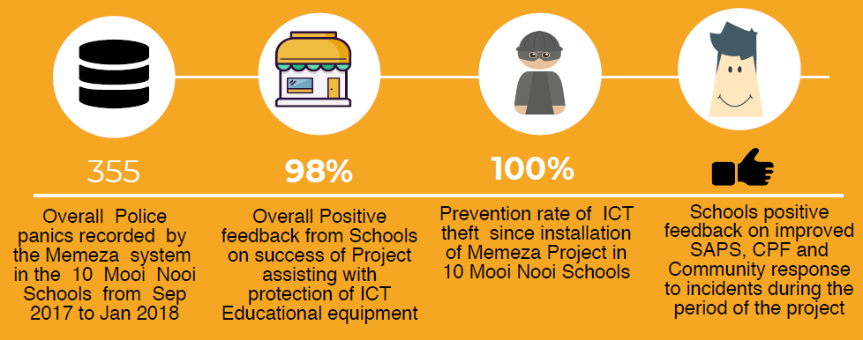
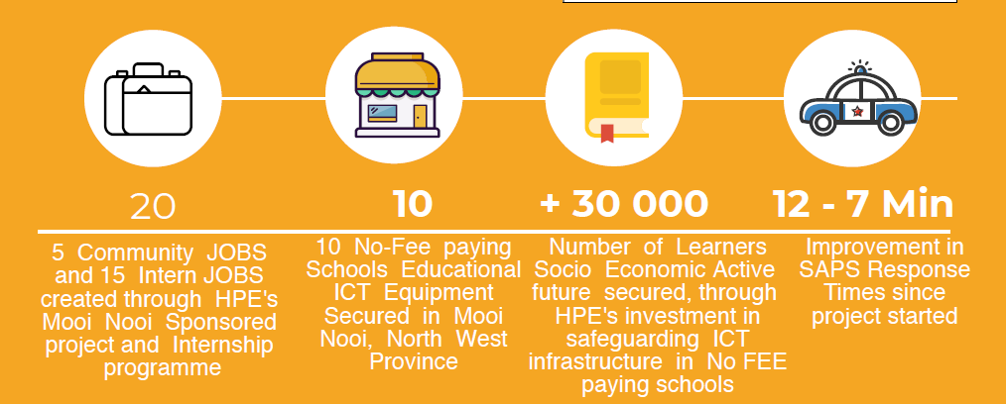

5. Challenges/successes and lessons learned
Lessons learned can be drawn from the intervention’s strategy, activities, outputs, objectives, contextual elements, risk management, project management, or any other aspect related to the project implementation.
Please provide an overview of the major challenges and their origins, the corrective actions chosen and the reasoning behind them, the impact on the project and the corresponding lessons learned.
Please provide an overview of foreseen and unforeseen successes, how they came about, what opportunities they instigated, the impact on the project and the corresponding lessons learned.
- Schools taking responsibility for reporting technical faults. With the site visits we found that about 60% of the schools were not reporting technical or maintenance issues timeously. To mitigate this challenge, Memeza provided additional training to School principals and staff on the importance of reporting technical faults.
- Schools not taking responsibility for minor maintenance items such as replacing the remote-control batteries. Again it was found that about 60% of schools had to be educated again in their responsibility as a school to ensure that small items such as remote control batteries are replaced. Although the project caters for a certain period of standard maintenance, sponsored schools needs to take responsibility for minor maintenance elements over the long run, to ensure sustainability. Over the past 3 months, this is the summary of maintenance issues that was fixed by Memeza:
- Vandalism by learners – It was found that 11% of the 138 Community Policing Alarms installed were vandalized by learners over the 12 month period. Lessons learnt here could be that Memeza alarms need to be installer higher up against the wall where learners cannot reach or access the technology.
- SAPS Response – Although where SAPS do respond the response times have improved, there are still challenges with capacity to respond at times and it was found that some police stations are more eager to participate than others. The National SAPS launch we believe will address this challenge and response SLA’s will then be enforced.
- Successes include:
  - Result 100% prevention rate
  - SAPS response time improved to between 7 to 10 minutes.
  - Viability of the project to create sustainable jobs have been proven.
  - Viability for the project to share knowledge, empower and build stronger response mechanisms have been proven.
  - The project’s ability to bring Private and Public Partnerships to the front are clear, with the success of the project bringing new corporate partners on board.

6. Recommendations
On the basis of the above analysis and lessons learned, kindly formulate a number of recommendations that could be relevant for the next phases of the Tirelo Bosha program (replication and or upscaling). Recommendations should be formulated as specific and clear as possible.
- Gauteng Department of Education to allocate annual budgets for upkeep and maintenance of Community Policing Alarm Systems in No Fee paying schools- assistance with long term maintenance and upkeep is required by the No Fee paying schools. It is still a concern that after the project ends, Schools will need to take responsibility for paying the small monthly subscription fees for data and sms usage, and ensuring they can pay for small maintenance elements. The ideal situation here would be for Department of Education provide a budget annually that will assist these No Fee paying schools with these minor costs.

- SAPS National Launch to be prioritized to ensure full buy in– It is suggested that the SAPS National launch be prioritized with Government so that the buy in of all SAPS at station level can be ensured.

- Community Policing Forums to be utilized more effectively in schools and to be provided with the tangible safety tools needed to be empowered to respond to crime pro-actively , as these are the feet on the ground with many resources that could assist with alleviating pressure from SAPS to respond. Currently with the additional scope of No Fee-paying schools, 2 patrollers per school received Personal Alarms. It would be beneficial if all patrollers in schools and surrounding communities to receive Personal Alarms or any tangible safety tool that can assist them to communicate with each other and SAPS in time of crisis.

7. Sustainability beyond the project
Please indicate how the government institution will ensure financial and operational sustainability of the achieved results beyond the project duration.
Option 1 – CPSI and Memeza is in discussions with Gauteng Department of Education and Department of Community Safety to provide annual budgets for the upkeep and maintenance of the Memeza Community Alarm systems in No Fee paying schools, however no definite way forward have been concluded and the assistance of DPSA to highlight the importance of this assistance would be appreciated.
Option 2 - Due to the Memeza solution designed to be very affordable, there is also an option for No Fee paying schools to pay a small monthly fee to cover their data/sms costs. The maintenance costs on the Community Alarm system is very low, with replacement of remote batteries over 3 to 6 months at a cost of no more than R50. It can therefore be said that it could be manageable for schools to pay their own subscription fee’s, if Government budgets are not made available early in this financial year.
Option 3 – Because of the positive impact the project has, Corporates such as Vodacom have come onboard to not only sponsor hardware, but also assist No Fee paying schools with a certain period of monthly subscription fees which will facilitate the costs of sms and data usage. This solution is currently in place for No Fee paying schools, while a longer term solution is established.
As a project team, we are confident that with the positive results yielded by the project, Gauteng Department of Education will in this financial year come onboard with a budget that will assist with the upkeep of alarm systems in No Fee paying schools, and that in some cases certain schools will be able to afford to pay their own monthly subscription fees and/or corporates such as Vodacom will continue to assist those schools that cannot afford to pay with sms/data costs of the alarms. It is however always key to ensure that further sponsorships through programmes such as Tirelo Bosha, and other Government programmes, including Corporate funding stay priority to ensure that all work together to broaden the footprint of schools that can receive Memeza Community Alarm systems.

8. Other
Please indicate any other relevant information that you assume relevant (e.g. impact studies, press releases, survey outcomes,…)
Herewith testimonials from other schools outside of the Gauteng province, also confirming the success of the project:

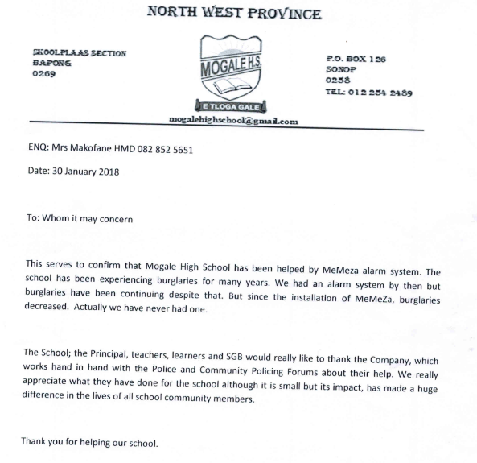
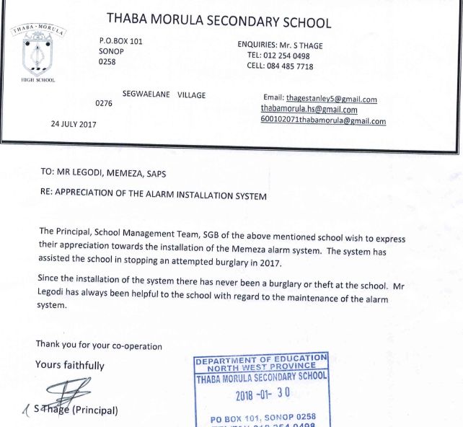
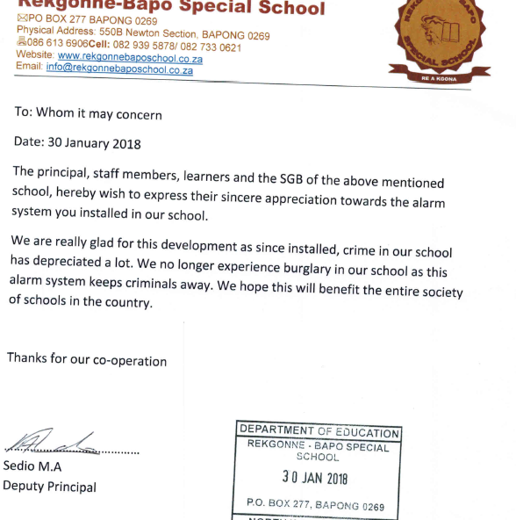

The information provided in the report must correspond to the description of action that appears in Annexure I of the Agreement, Description of Approved project and to the project-specific individual result framework.

