Department of Education believes twinning programme will transform education system
JOBURG – Gauteng Department of Education believes twinning of schools is a solution for insufficient infrastructure and resources and lack of social cohesion due to the low levels of integration and interaction between pupils at different schools.
May 29, 2015
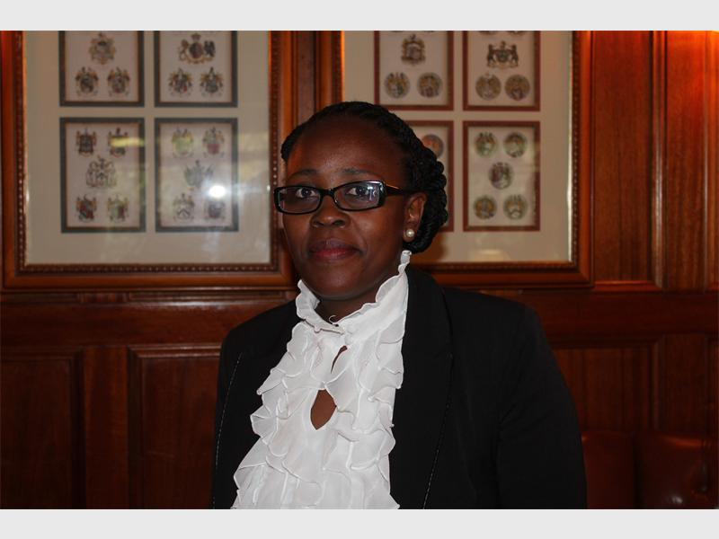
Gauteng Department of Education spokesperson Phumla Sekhonyane said the Department is determined to make school twinning programme a success.
While the Gauteng Province prides itself in having the highest pupil performance in the country, the Gauteng Department of Education is equally aware of the challenges faced by schools in the Province.
Spokesperson for the Department Phumla Sekhonyana said the Department recognises that the continuing disparities in accessing resources and quality education perpetuate socio-economic disadvantage, thereby reinforcing and entrenching historical inequality. “This is demonstrated by the unequal distribution of resources and quality education in township and former ‘model C’ schools. Therefore, the Twinning Programme has been developed in terms of the Department’s ‘Reorganisation of Schools Strategy,’ which is aimed at achieving an optimal level of performance in all of the schools in the Province,” explained Sekhonyane.
She said the Department has conducted extensive research which has revealed that the management and governance of a school, through its School Governing Body, largely determine the policies, values and other matters critical to the overall philosophy of the school, and it is through this structure that the objectives of twinning can be met.
Sekhonyane mentioned that the Department intends to achieve its objectives through a legal, structured, and methodical approach. “The ‘twinning’ will involve the creation of a single School Governing Body (SGB) to govern two schools – one, a township school, and the other a suburban school.
She highlighted that the programme has been carefully structured, with the best interests of the schools and its pupils in mind. “Research and consultations with all of the affected stakeholders have preceded the process, to ensure that the programme yields a favourable outcome for all of the schools involved,” said Sekhonyane. The recent SGB elections has impacted on the work of the team as the team is now required to begin new consultation processes with newly elected SGBs. The team has successfully consulted with the following schools and work is in progress to twin them:
- Bovet Primary School and Lyndhurst Primary School (Alexandra and Sandton) – soon to be gazetted.
- Cultura High School and Zithobeni Secondary School (East Rand) – notice of intention is soon to be published.
- Sandown High School and Alexander Secondary School (Sandton and Alexandra) – notice of intention is soon to be published.
According to Sekhonyane, the twinned schools will be provided with additional focus and support in respect of curriculum and assessment development; teacher provisioning and support; leadership and management; infrastructure development and maintenance; planning, finances and resourcing; information and communication technology (ICT) in education; social cohesion; school functionality, including community involvement, skills development and access to quality early childhood development.
She said the Department will provide the twinned schools with iPads and smart boards, and they will become completely digital. “The twinned schools will also be provided with a coach, which will ensure that it operates optimally and with a high level of skill and knowledge,” she added.
Sekhonyane said, “The pupils, teachers, and parents alike, will also be afforded an opportunity to interact and engage with people from different backgrounds, which is essential to the broader integration of South African society.”
Author: Belinda Pheto
Source: https://northcliffmelvilletimes.co.za/199504/department-of-education-believes-twinning-programme-will-transform-education-system-2/

