Pratichi Institute Commissioned by the Department of Backward Classes Welfare, Government of West Bengal

September, 2017
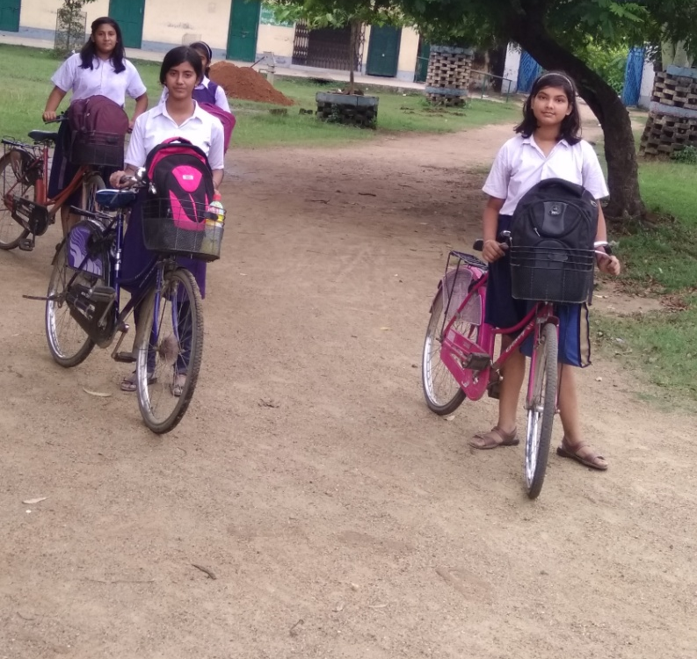
Wheeling Education: An assessment of the Sabooj Sathi (Bi-cycle Distribution) Scheme for School Students of West Bengal

Foreword

Free distribution of bicycles to sections of high school students has been one of the most popular inclusions in public actions in several of the Indian states. The Government of West Bengal in 2015, nevertheless, joined the bicycle distribution club in a radical way : instead of providing bicycles to certain groups of students selected on the basis of gender, caste, or economic condition, it took a wide inclusive path and launched a programme, called SaboojSathi, literally meaning the green companion, that aimed to distribute bicycles among all students of standard 9 through 12 studying at the government or government aided secondary and higher secondary school. The nodal agency of the scheme, the Department of Backward Classes Welfare, entrusted Pratichi Institute of the Pratichi Trust (India) to carry out an assessment of the scheme. In line with the mutually decided methodology of carrying out the exercise in two phases, the research team of Pratichi Institute has prepared the present report based on its first phase of work. The report presents many interesting findings, among which the most important are perhaps the connection of the scheme’s drawing high appreciation from students, parents, and teachers with that of its design, namely universal coverage. In addition to helping in students’ increased access to high school education the scheme, as underscored in the report, offers important lessons for policy makers, implementers, and commentators. Successful as it is, the implementation of the scheme also raises some important concerns on the overall delivery of education, informed by which the government can helpfully take up further reforms to make educational delivery equitable with ensured quality.
Kumar Rana, Sabir Ahmed, ManabeshSarkar, Sangram Mukherjee, Subhra Das, Susmita Banerjee, and AbdurRafique carried out the exercise. Saumik Mukherjee provided excellent logistical support. Officials of the Department of Backward Classes Welfare, Government of Wes Bengal, district and block level officials involved with the implementation, and the teachers, non-teaching staff of the selected schools extended cooperation in a big way. Last but not the least, students and parents cooperated with the study team wholeheartedly. On behalf of the Institute I take this opportunity to thank them all.
ManabiMajumdar
Honorary Director
Pratichi Institute
Contents
Executive Summary | 1
- The Context | 3
- Objectives and Methods | 10
- Mechanism of Implementation | 12
- Progress in Implementation | 14
- Reflection from the field | 18
- Challenges to address | 23
- Conclusion | 27
Appendices
Appendix1. TableA1: Share of SC, ST, and Muslims to total population and proportion of the students from the respective groups received bicycle under SaboojSathi (First and Second Phase) | 30
Appendix 2: Standard Operative Procedure of SaboojSathi | 31
List of Tables, Figures, and Pictures
Table-1. Percentage distribution of villages by their distance from secondary and higher secondary schools in rural areas of West Bengal (in percent)
Table 2. Bicycle distribution program among school children in India
Table 3: Percentage of girls and boys who have received bicycles under SaboojSathi (First and second phase)
Table 4. Gender and standard wise distribution of recipients of bicycle (in phase 1 and 2)
Figure 1: Percentage of girls and boy recipients in standard 9 through 12.
Figure 2: Share of SCs, STs and Muslims to total population and share of student recipients of bicycles from the respective groups.
Picture 1. Bicycles for Distribution Bicycles ready for Distribution
Picture 2 Students' imagination of SaboojSathi
Picture 3 Student recipients carrying their bicycles on a motorised van to the local mechanics shop to get them ready to use

Executive Summary
A perfect union of policy, based on ideological commitment, and a sound implementation mechanism makes the program unique. The policy of bringing all high school-going students into the fold of the programme, SaboojSathi found its root in the principles of equity – creating equal opportunities for all students irrespective of their class, caste, gender, linguistic, or other backgrounds.
Owing to the difficulty in accessing the schools many of the students, particularly from poor and disadvantaged background, who form the majority of the students attending public run schools, had to drop out at the threshold of high school education. The problem had particular bearing on the girls, the set of traditionally discriminated against population. The government’s decision to provide each of the high school students with a bicycle was a result of clear headed thinking on the issue of meeting the challenge of inaccessibility.
The policy of bringing all high school-going students into the fold of the programme, SaboojSathi found its root in the principles of equity – creating equal opportunities for all students irrespective of their class, caste, gender, linguistic, or other backgrounds. Universalization of the scheme, as the study findings suggest, has had its positive influences on the implementation of the scheme. The relatively much higher success of the scheme than what is generally seen in cases of other public programmes aiming to support selected rather than the entire population seems to have drawn from the policy of universalization, which expanded the scope social watchdogging by creating scope for using the voices of the powerful minority of the society, who are not-so-needy but can influence public programmes and social dynamics.
The delivery was made further robust by invoking a technologically forward-looking mechanism. The whole process of identification of suppliers to the delivery of bicycles to the students has been made on line, which added a lot of value in terms of transparency to the scheme.
Apart from its immediate goal of ensuring accessibility to high schools the scheme has had a huge societal impact by enhancing the general mobility of the population and of the girls in particular. The bicycles distributed among the students are not only used for schooling but also for several other purposes, such as going to the market, health centres, cinema or local fairs, and so on. The bicycle, literally, is breaking many boundaries.
Nevertheless, the scheme needs to be freed from certain problems. Firstly, it has to be ensured that no student should be required of paying any additional charges for fitting, or any other purposes. Secondly, the differences between records of students and actual number of bicycles distributed have to be addressed. Thirdly, provisions must be made for differently able students (children with special needs), who cannot use the standard bicycle. Fourthly, the ‘grievance’ tab on the website must be fully activated so as to enable the students to register their complaints and put their suggestions on record. Fifthly, and perhaps most importantly, in order to maintain the pace of success of the scheme the government has to make special arrangement of human resources for the implementation of the scheme; the modalities of getting the works done by borrowing people from other departments and institutions can have serious implication on the delivery of the respective departments’ and institutions’ designated works.
The problems related with the implementation may not very serious in nature can be fixed by making some policy reforms. However, as our analysis shows, the implementation of SaboojSathi, while effective in eradicating certain difficulties of students’ acquiring education, points out towards serious need for urgent policy reforms in the education sector. As the SaboojSathi implementation data points out, participation of girls at higher secondary level declines substantially; in certain districts girls’ participation in high schools is worryingly low; and participation of students from disadvantaged sections, especially the Adivasis and the Muslims, at high school level is lower than that of the other social groups. SaboojSathi’s immensely supportive role, and the lessons offered by its very effective implementation, must be utilised completely by taking note of the core problems involved in the delivery of education as a whole.

1 The Context

Two articles, among several others, preserved for public viewing at the Nobel Museum at Stockholm invariably catch the attention of viewers. The first is a slate; and the second, a bicycle. Both were donated by two Indian Nobel laureates from the same place – Santiniketan, West Bengal. However, the connection between the two articles goes much beyond the geographical affinity of the donors, both of whom dedicated their lives to the cause of human emancipation. In isolation the two articles may signify two different insistences: the slate, donated by the poet-philosopher Rabindranath Tagore, on which the child begins to learn writing letters, and the bicycle given by the economist-philosopher Amartya Sen, denoting the inescapable importance of looking forward. Yet, in the final count the slate and the bicycle cannot but be seen together, for they form an inseparable bond between education and forward look leading to the ultimate state of human emancipation where ‘the mind is without fear and the head is held high/where knowledge is free…’.
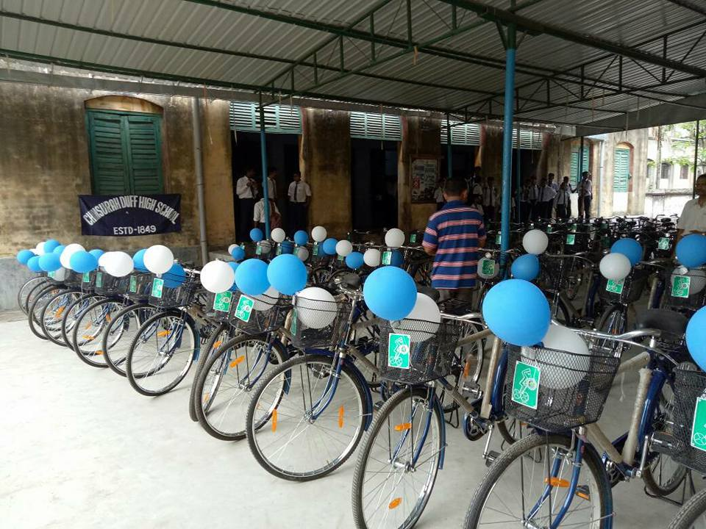
This point finds beautiful articulation in Peter Golkin’s words: ‘My two favourite things in life are libraries and bicycles. They both move people forward without wasting anything. The perfect day: riding a bike to the library.’ The discovery of letters gave the world a new and different shape, and the radically changed pursuit of knowledge resulted in making educational opportunities one of the most important factors of gaining and sustaining freedom. Since the first verifiable claim for a practically used bicycle by Baron Karl von Drais in Germany in 1817, the bicycle has changed the scope and pattern of transportation in the world. With over one billion bikes in use in the world today, every one in every 7.5 persons has a bicycle. In the last fifty years the production of bicycles has doubled –from 11m in 1950 to 104m in 2002. Historically, ‘[i]ndustrial countries have a surprising number of bicycles per person’.Most of the countries which have achieved higher degrees of human development tend to be the leaders in bicycle use. The top ten bicycle using countries in the world include China, Belgium, Switzerland,Japan, Finland, Norway,Sweden, and Germany. Many countries have taken special bicycle promotion programmes.China has been a bicycle stronghold, but of late, a section of the nouveau riche has developed an inclination towards cars.Yet, it leads the world in terms of bicycle use, and also in production and controlling the world bicycle market: China supplies 67 percent of the global demand of bicycle (a large share being consumed by the economically advanced Europe and America), while India’s share is only 10 percent (cateringmainlyto the financially underprivileged African countries).
Picture 1. Bicycles for Distribution Bicycles ready for Distribution

While bicycle use in the West and other developed countries is more on city roads, the simple two-wheeler has tremendous potential and use in the rural areas, where, ‘bicycling may be the quickest and most affordable way to travel. Giving bikes to rural health care workers helps them visit patients who do not have access to cars or are too sick to travel. Health care providers in Uganda, for instance, have done this to administer testing, counseling, and ongoing anti-retroviral treatments to HIV/AIDS patients. Immunisation initiatives and family planning services have also benefited from bicycles.’ And, in a country like India, the bicycle can potentially change the quality of lives of the people, particularly women, in a radical way. For example, headloading (of fuel, harvest and other goods) by women, estimated to be 11.8 millions, is a phenomenon across the country. Studies show how terribly headloading affectswomen’s and children’s health. A bicycle can reduce not just time but also the severity of threats to women’s health. And, perhaps the most important possibility that the bicycle offers is to enhance educational opportunities of students attending high schools or failing to attend them owing to the problem of accessibility. The bicycle, precisely,
Enhance[s] the socioeconomic growth opportunities of low- income households in the country by enabling them to access jobs, markets, schools, and medical facilities in a fast and affordable manner. From the perspective of attainment of the Millennium Development Goals, use of cycles by our low income population can have a significant role in poverty alleviation, enhancing school enrolment, gender empowerment, and enabling faster access to health facilities.
Despite the tremendous importance and desirability of bicycle use for promoting inclusive development and sustainable mobility,
India is witnessing a very slow growth in cycle ownership and a decline in the use of cycles as a mode of transport…Growth in cycle ownership in India over the last one decade has been very slow. Household cycle ownership increased at a rate of about 3% per annum between 2001 and 2011. Nearly 45% households, i.e., about 111 million households in India owned bicycles in 2011. This was just marginally high as compared to 2001; 44% households (84 million households) owned cycles in 2001. A comparison with China indicates that almost every household in rural China owns a cycle, as compared to less than 50% households in rural India. China’s urban cycle ownership level is also higher as compared to India.
Of the several factors behind the comparatively lower level of bicycle use in the country, the most important seems to be the problem of affordability: prices of bicycles are much above the financial capability of a large number of households, and there is a lack of availability of financial assistance – aid or loan. Poor affordability has a direct bearing on school education. Studies attribute the distance of schools from students’ habitations as one of the most significant impediments that restrict enrolment and attendance rates at high school level. For example, the NSSO reports that access to secondary schools for 34 percent of the surveyed households is two kilometers or more. Given the very high degree of private tuition, an exponentiallygrowingnecessity, for almost all the students, makes the travelled distance longer.Private tuition is an artificially created necessity, pointing out to public failure of addressing the notional and practical gaps in education. Regrettable as it is, one cannot ignore the existence of private tuition, which inter alia other negative impacts increases the cost of schooling. According to the NSSO for the high school children the expenditure on transportation to school (and private tuition) forms a substantial proportion of the total expenditure on education. Since the figures reported pertain only to the currently attending high school students it can be assumed that section of students unable to bear the cost are deprived of the opportunities of high school education. Field level studies support the assumption.
That accessibility to high school education, across the country, is a real problem is also found from Census data. For example, of 40218 villages in West Bengal, availabilities of secondary and higher secondary school facility within villages are 23 percent and 16 percent respectively; on the other hand, students from 15 and 29 percent villages have to travel five kilometers or more to attend secondary and higher secondary schools respectively (see table 1).

Table-1.Percentage distribution of villages by their distance from secondary and higher secondary schools in rural areas of West Bengal (in percent)
 | Within village | Below 5 km | 5 km or more | Not available | Total Villages
Secondary | 23.0 (9242) | 54.1 (21773) | 14.9 (6004) | 8.0 (3199) | 40218
Higher Secondary | 16.02 (6500) | 45.6 (18324) | 28.8 (11570) | 9.5 (3824) | 40218
Source: Census of India 2011
The realisation of difficulty in accessing high school facilities, especially for students with disadvantages owing to gender and caste, has found an interventional reflection in public policies in the form of providing bicycle mainly to high school girls (see Table 2).
Table 2. Bicycle distribution program among school children in India
State | Scheme | Coverage
West Bengal | SaboojSathi, 2015 | All students of standard 9-12 (irrespective of caste, religious affiliation, gender)
Karnataka | Free Bicycle distribution scheme 2006 -2007 | Rural and hilly region students.  Students enrolled to class 8th in Gov. and Gov. aided Schools of BPL family.  http://www.schooleducation.kar.nic.in/pryedn/bicycles.html
Odisha | Free Bicycles to Students of Standard 10, 2016 | Students residing in hilly and inaccessible areas of the state.  All girls, Scheduled Tribe (ST) and Scheduled Caste (SC) boys and boys belonging to BPL category and studying in Class X in government and government aided high schools, Madrassas and Sanskrit tolls.  Government provides Rs 2,600 for each identified beneficiary to purchase bicycles.  http://govinfo.me/distribution-free-bicycles-students-class-x/
Madhya Pradesh | Free Bicycle Scheme, 2995-06 | Girls and boys studying in standard 9th belonging to the rural sector who belong to villages where government high school has not been set up and they have to travel from one village to the other/ town/city to receive education are eligible.  Boys and girls studying in standard 9th, belonging to all categories will benefit under this scheme.  The female and the male students are provided bicycles of their choice and their Guardian is given a crossed cheque of Rs 2,400/-  http://govinfo.me/free-bicycle-scheme-madhya-pradesh/
Punjab | Mai BhagoVidya Scheme , 2011-12 | Girls should be studying in standards 9th, 10th, 11th and 12th in government school.  Girl student should belong to below poverty line (BPL).  http://govinfo.me/mai-bhago-vidya-scheme-punjab/
Andhra Pradesh | Badikostha Bicycle Scheme, 2017 | Every girl child studying in class 9th in government schools.  http://govinfo.me/free-bicycle-scheme-girl-students-andhra-pradesh/  https://www.sarkariyojna.co.in/badikostha-bicycle-scheme-girl-students-andhra-pradesh/
Assam | Free Bicycle Distribution  Under C.M.'s special schemes, 2010-11 | The scheme is especially introduced for girl students (Class – VIII & IX) who are form BPL (Below Poverty Line) families and are not able to pursue education due to long distance school or any other reason.  http://govinfo.me/wp-content/uploads/2016/08/Development-schemes-under-State-Government-Schemes.pdf
Rajasthan | 2012-13 | Girl students who live within the 5-km radius of the school.  http://www.hindustantimes.com/india-news/in-orange-cycles-for-rajasthan-school-girls-congress-sees-saffronisation-bid/story-a4syHvtCJF1zZvmeFrUD6J.html
Tamil Nadu | Free by cycle, scheme Tamil Nadu for SC/ST students, 2011-02 | Free bicycle scheme for students of class XI.  http://www.freeonlineindia.in/free-bicycle-scheme-tamil-nadu-sc-st-students/  http://www.ndtv.com/tamil-nadu-news/tamil-nadu-government-announces-free-bicycle-saree-and-dhoti-schemes-1644994
Bihar | Bicycle Yojana, 2006 | Bicycle scheme for everyone, beyond category/caste/class/religion.  https://www.mygovernmentschemes.com/bihar-bicycle-yojana-gives-wings-to-girls/#more-1618

The initiatives across states have been received well. Even in a state like Bihar, where delivery of public programmes in general suffers from severe inefficiency and other hurdles, the programme has been found to be effective in increasing girls’ enrolment, and, may have generated externalities beyond the cash value of the program, including improved safety from girls cycling to school in groups, and changes in patriarchal social norms that proscribed female mobility outside the village, which inhibited female secondary school participation.
Nevertheless, despite recognising the special underprivileged status of the girls the West Bengal Government identified the issue of access to schools as a general problem affecting students across communities and gender and introduced in 2015 a scheme called SaboojSathi to provide bicycles to all students enrolled in government or government aided schools. The goal of the scheme is ‘to enhance access to education, increase retention, encourage smooth passage to higher education and empowering the students to realise their aspirations.’ The success of public programmes, however well intended, are contingent on their strategic processes of implementation, which, in turn requires periodic scrutiny and assessment. From this point of view, the Department of Backward Classes Welfare, the implementing agency of the highly ambitious and apparently successful scheme, found it important to get an assessment of the said scheme done by an independent agency and invited the Pratichi Institute to carry out an assessment of the scheme.
- Objectives and methods
With the objectives of assessing:
- the efficacy of the program in meeting the declared goals; and
- problems, if any, related with (a) the implementation of the scheme and (b) the overall achievement of the scheme, the proposed study followed the mixed method research techniques and proposed to be carried out in two phases.
Phase I, based on the findings of which the present report is, incorporates:
(i) a rigorous exercise of the available secondary data, which will give an overview of the extent and pattern of implementation; and
(ii) a quick pilot study in one secondary and two higher secondary schools, in order to develop some understandings on the ground level processes of implementation, as well as perceptions of the students, teachers, and parents about the scheme.
Three districts, namely, Birbhum, Hugli, and Malda were selected for the exercise. Since the time in hand was very limited (30 days), the number of schools to visit was kept restricted to three – one in each district – and were chosen purposively – keeping in mind the urgency of completing the work within the stipulated time (in Hugli we had the opportunity of visiting six schools additionally). The selected schools were:
- LabpurSatyanarayanSikshaNiketan, Labpur, Birbhum;
- Haral United Madrasha, Pandua, Hugli; and ,
- ManikchakShikshaNiketan, Manikchak, Malda.
During our visits to the districts, blocks and schools, the research team members interacted with:
- the district and block officials (District Magistrate/ Nodal Officers of SaboojSathi/ Block Development Officer);
- head teachers and assistant teachers of schools;
- students of standard 9-12 (50 in each school);
- villagers of the catchment area of the respective schools.
The presented report has two purposes: (i) immediate – to have a glimpse of the impacts of the scheme, and apparent gaps in the implementation; and (ii) to gather suggestions and comments to modify the expanded and in-depth study to follow in the second phase.

- Mechanism of implementation

As mentioned above, the declared goal of the scheme, SaboojSathi, was to enhance access to education, increase retention and ensure transition to secondary and higher secondary level, and eventually clear the road for higher education by reducing the cost of schooling. It attached special importance to address the issue of drop out at secondary and higher secondary levels. Following the announcement of the scheme in the budget speech 2015-16 of the Finance Minister, Government of West Bengal, to distribute 40,00,000 bicycles to all students of standard 9 to 12 in all districts except Kolkata and Darjeeling, a task force was formed to develop the framework of the scheme and oversee its implementation. The Backward Classes Welfare Department (BCWD), Government of West Bengal was entrusted to implement the scheme.The task force, consisting of officials of various departments including the nodal agency, BCWD, charted out a draft road map. The Chief Minister of West Bengal inaugurated the scheme in September 2015. Although the scheme was to cover all students of standard 9-12, to begin with it was decided to distribute the cycles first among the outgoing students, namely, of standard 10 and 12. However, in October, 2015, it was decided to cover standard 11 students as well under the scheme.

The implementation of the scheme is broadly divided into two parts: a) procurement of the cycles from manufacturers through tender, and b) distribution of the cycle among the students. The specification of the cycle was finalised in consultation with the “Research and Development Centre for Bicycle and Swing machines” to ensure the quality and standard product, ensured transparency through e-tender and vendors were selected by a steering committee headed by a senior level official of the State. The nodal department held a round of discussions with the suppliers, discussed the quality aspect and modalities of delivery. To roll out of the distribution of cycle among the students, the following steps were followed:
- Formation of district cell, designating nodal officers at district and block level, association of DI, ADI, SIs and DIOs of NIC with the scheme;
- Identification of space for delivery and assembling work, point wise exact number of bicycles (for both boy and girl students) to be delivered at Block/ Municipality level;
- Providing the schedule of delivery to the respective suppliers as per the report received from the districts;
- Circulation of registration data of students (as available from the West Bengal Board of Secondary Education/ West Bengal Council of Higher Secondary Education/ West Bengal Board of Madrasa Education) in a specific format in MS-Excel sheet, and getting the students’ particulars in the Excel sheet finalised by the respective Schools;
- Completion of school mapping and data import through www.wbscstcorp.gov.in/ wbSaboojSathi
- Opening of school log-in for on-line updating of students’ profile by the Schools;
- gathering details from the Suppliers of their district level managers/ coordinators and consignment schedule(see Appendix 2 for details).

The district nodal officers work in coordination with the education department, responsible for assessing gender wise exact requirement of the bicycle, designing the distribution plan and supervision of the distribution plan. Schools also prepare the details of students eligible for the scheme with some specific information (name of the guardian, caste, etc). With the school level identity (ID) for uploading the information school authorities upload the student’s details directly, and through this a school wise list has been generated. The list generated by the school needs validation from the education officers at District level. The school also provides the details of actual distribution directly onto the MIS integrated into the website. The block office coordinates the school for distribution dates and other modalities.
The Standard Operating Procedure (SOP) insisted that “Distribution should take place generally at school level/ centrally as may be felt convenient by respective Districts. However, distribution at school level is recommended since a separate record showing distribution is to be created and maintained”. After the validation of the list by the education officers, the school prepares an exact requirement list with the following details: (1) Name of student (2) Father/ Mother/ Guardian’s Name (3) Registration No. (if available) (4) Class (5) Section (6) Roll No. (7) Gender. The following information needs to be filled in after the distribution of the cycle: “DATE OF DISTRIBUTION”, “BI-CYCLE-BRAND”, “FRAME NO.” School wise distribution details are uploaded into the website for transparency and public scrutiny of the list. Indeed, one of the most important features of the scheme is the nodal agency’s regular maintaining of the website. The site, unlike what is found with several other departments or programmes, is very user-friendly and provides real time data on the distribution of bicycles. Any person can check and verify for herself about any particular school’s or student’s record on the website. Aside from distribution records the website contains detailed information about the scheme, e-tender and other circulars and communications. On our days of access between 1 and on 16 September 2017 we found all the tabs on the home page of the site working well; the only exception was the grievance section. That it is one of the most visited sites is demonstrated by its huge number of viewership. At 1 PM on 16 September we found 212,007, 943 number of visits to the website.
- Progress in implementation
The government’s incredible commitment toward the scheme led it to take up the implementation through “mission mode”, and mobilise different departmental resources to ensure smooth distribution of bicycles to all eligible students. Preparation for the implementation was done within a very short time – about six months. It involved series of meetings with different departments, district level officials, suppliers, e-tendering, financial arrangements, gathering records of students to determine the actual requirements of bicycles, and the delivery mechanism at the grass root level. The first phase of the implementation involved distribution of bicycles to students of standard 10-12 (though initially it was decided to bring in the first phase only students of standard 10 and 12, students of standard 11 were also brought into the fold in the first phase itself). In the second phase distribution of bicycles was extended to include the standard 9 students. In the first and second phase of the implementation 3,423,004 students had received bicycles. The third phase of implementation is going on, and therefore, is excluded from the purview of the present report.
The general trend of girls’ outnumbering boys at high school level is very much reflected in the gender wise disaggregated number of the recipients of bicycle. Of the total 3,423,004 number of recipients in the first two phases the ratio of girls and boys stands at 51and 49. While among the total recipients girls outnumber boys (51 girls to 49 boys), and indicate towards higher girls’ participation at high school level, disaggregation of district wise, standard wise and social identity wise data underscore certain important problems.
Let us look at the district wise data. It is certainly encouraging to note that in most of the districts girl recipients either outnumber or equal the number of boy recipients, in four districts shares of girl recipients to total recipients are below 50 percent (see Table 3). They are Puruliya (42 percent), Bankura (44 percent), PaschimMedinipur (45 percent), and PurbaMedinipur (49 percent). Corresponditang figures in Murshidabad and Nadia are 50 percent in each. Fewer number of girl recipients than their boy counterparts in the districts mentioned above indicate the existence of certain conditions in the districts that restrict girls’ participation at high school level. PurbaMedinipur, which has achieved highest literacy rate in the state the symptom of thinner girls’ participation at high school level demands urgent policy attention. Also, why girls in particular districts (all in Paschimanchal) lag behind in pursuing high school education needs to be investigated to address the problem with added priority.
Table 3: Percentage of girls and boys who have received bicycles under SaboojSathi (First and second phase)
Dist | Total | Female | Male
Alipurduar | 73,144 | 51.5 | 48.5
Bankura | 162,129 | 44.4 | 55.6
Birbhum | 146479 | 51.5 | 48.5
Bardhaman | 299373 | 52.8 | 47.2
Coochbehar | 154470 | 53.5 | 46.5
DakshinDinajpur | 79061 | 52.2 | 47.8
Haora | 183989 | 55.6 | 44.4
Hugli | 217890 | 54.4 | 45.6
Jalpaiguri | 115526 | 54.1 | 45.9
Maldah | 158864 | 53.2 | 46.8
Murshidabad | 165436 | 50.1 | 49.9
Nadia | 254501 | 49.8 | 50.2
North 24 Pargans | 377327 | 51.6 | 48.4
PaschimMedinipur | 232132 | 44.5 | 55.5
PurbaMedinipur | 191808 | 49.3 | 50.7
Puruliya | 121522 | 41.6 | 58.4
South 24 Pargans | 310345 | 51.9 | 48.1
Siliguri | 50970 | 53.5 | 46.5
Uttar Dinajpur | 128038 | 56.4 | 43.6
West Bengal | 3,423,004 | 51.1 | 48.9
Source: Department of Backward Classes Welfare Department, Government of West Bengal
The second problem that the distribution of bicycle data highlights is that while girls outnumber boys at the secondary level the trend takes a reverse turn at higher secondary level. In other words, girls fail to maintain the pace they gather at the secondary level. There has been a steep fall in the proportion of girls in the transition from secondary to higher secondary level (from 55 percent at standard 9 to 48 percent at standard 12). In contrast, boys’ participation grows up from 45 percent at standard 9 to 52 percent at standard 12 (see Figure 1)
Figure 1: Percentage of girls and boy recipients in standard 9 through 12.

Source: Department of Backward Classes Welfare, Government of West Bengal
Girls who tend to slip off the track of higher studies belong to particular social group – the Adivasis. As the disaggregated data on distribution of bicycle on the line of social identity shows, the proportion of Adivasigirl recipients of bicycles falls steeply from 52 percent at standard 9 to 36 percent at standard 12 (see Table 4)
Table4. Gender and standard wise distribution of recipenets of bicycle (in phase 1 and 2)
Category | All |  | OBC |  | GEN |  | ST |  | SC |  | Muslims
Standard | Girls | Boys | Girls | Boys | Girls | Boys | Girls | Boys | Girls | Boys | Girls | Boys
9 | 55 | 45 | 56.2 | 43.8 | 56.0 | 44.0 | 51.7 | 48.3 | 53.1 | 46.9 | 62.1 | 37.9
10 | 50.1 | 49.9 | 50.2 | 49.8 | 51.4 | 48.6 | 38.4 | 61.6 | 50.6 | 49.4 | 55.4 | 44.6
11 | 47.9 | 52.1 | 47.9 | 52.2 | 50.3 | 49.7 | 37.8 | 62.2 | 46.8 | 53.2 | 53.4 | 46.6
12 | 47.9 | 52.1 | 47.6 | 52.4 | 49.9 | 50.1 | 35.5 | 64.5 | 47.4 | 52.6 | 51.6 | 48.4

Aside from the above problem there seems to exist another problem of general exclusion of certain social categories form higher level of schooling. For example, a scrutiny of the recipients’ data in line of social identity (SC, ST, and Muslims) with that of the data on the groups’ share to total population shows that while the proportion of SC students (30 percent) is higher than that of SCs’ share to total population (25 percent), data on ST and Muslims gives a reverse picture (see Figure 2). The proportions of ST students’ received bicycle (5%) is smaller than the STs’ share to total population (6 percent); in case of Muslims the corresponding figures are 22 percent (recipients), and 28 percent (share to total population). It is indicative enough that the Adivasis and Muslims in the state face some particular disadvantages that restrict their participation at higher level of schooling. The imbalances in the representation of students from certain social groups at high school level needs to be seen through the lens of overall educational delivery, which may require larger systemic reforms following a re-examination of the issue in amalgamation with the social, economic and political contexts.

Figure 2: Share of SCs, STs and Muslims to total population and share of student recipients of bicycles from the respective groups.

Source: Share of student recipients of bicycle: Department of Backward Classes Welfare, Government of West Bengal; . Share of SC, ST, and Muslims to total population: Census of India 2011

- Reflection from the field
The nineteenth century women’s rights activist Susan B. Anthony th ought that the bicycle, ‘has done more to emancipate women than anything else in the world. It gives women a feeling of freedom and self reliance.’ She stood and rejoiced every time she saw ‘a woman ride by on a wheel…the picture of free, untrammeled womanhood’. Two centuries have passed since the pedaled vehicle attracted Suasn Anthony’s amazement. And yet, the bicycle is still a symbol of freedom for a large part of humanity, standing at the receiving end of discrimination owing to their gender identity. Let us take the case of SumiSutradhar, a student of standard 10 studying atLabpurSatyanarayanSikshaNiketan, Birbhum. Her father is a carpenter; her mother works seasonally as an agricultural labourer. Sumi is the youngest of the three siblings – two sisters and one brother. Her elder sister was forced to discontinue her studies while she was in standard 8 as her parents married her off.
She also wanted to study, but the high school was five kilometers away and it was difficult for her to commute to school every day. She asked my father to buy her a bicycle. But my father is a very poor man, and he could manage to procure loan from relatives and employers to buy only one bicycle for my brother…when there is only one bicycle it naturally goes to the son…I would also have to discontinue studies. But thanks to SaboojSathi, I have got a bicycle…You know what happened after I have got the bicycle? [laugh]…My brother did not allow me to touch his cycle: ‘tu chelate parbina, kharapkaringdibi – you cannot ride the bike, you will break it’, he would say. Now, when I got the bike, he wanted to have a test ride of the new bike. But I paid him back in his own coin. [laugh]. Now it’s my bike, and as though it has become part of me. Aside from coming to school, I go to the market, to the fair, to hospital, and sometime when there is no much work I just go out for biking on the road.
That the bicycle has a different meaning for the girls was reiterated by several others. For example, HasinaKhatun, a student of standard 11 of Haral United Madrasah, Hugli, has received a bicycle under the scheme. In her admiration,
Without the bicycle [received under the scheme] I could not at all come to school. My father is a street vendor, and earns not more than a hundred rupees a day. Sometime we go to bed empty stomach, how can he buy a bicycle for me? But, I want to study. And my parents are also eager to see me continue my education. The school is six kilometers away, and aside from distance, I also had to face other challenges, namely eve teasing. Now we come in a group, with relatively freer mind.
The scheme seems to have received high appreciation not only by the students but also by their parents, especially mother. In a group meeting at Mastul village, some four kilometer away from Sumi’s school, women were unequivocally elated about the SaboojSathi scheme. As LataBauri lamented,
Had there been any such supportive scheme I would also have attended the high school. I had to stop going to school since it was at some distance away. My father was a poor agricultural labourer, and could afford neither a cycle nor the transportation cost [of motorised three wheelers] to attend the school.
While cursing her fate, she was all too happy to see the present generation of girls cycle to schools: ‘it is a feast for the eyes to see them going to school in groups – katosundar je lage’.
That the bicycle has a different – in some cases life changing – meaning for the girls was echoed by girls and their parents across the selected districts. Nevertheless, this special importance does not in anyway outweigh the importance of boys’ receiving the bicycles under the scheme. Large numbers of boys attending public schools belong to poor economic strata, and often suffer from lack of affordability. As Rahim Seikh of Nanoor, Birbhum, described,
I am a daily wage earner. Now the daily wage for a field labourer is Rs 160 per day. But availability of work is limited, and one gets it during sowing and harvesting seasons. Rest of the months I try to find employment in the market or elsewhere. How can I buy a cycle for my son? He had been fretting for a bicycle so that he could attend his classes regularly. He was often scolded by his teachers for being late or being absent. It was hard for him to walk down to school two hours a day. I tried to arrange some loan, but who would lend money to a pauper? The bicycle he has received from school [under the scheme] is a real gift. It is primarily being used by him to go to school, but it has also made our life much easier in other ways: going to market to buy things, taking patients to health centres or doctors, and so on.
Given that 34 percent of the rural population in West Bengal still depends on agricultural labour hiring for livelihood, Rahim Sheikh’s helplessness cannot be seen as an isolated case. Agricultural labourers, with no other resources than their person, are the most vulnerable section in the society, and the issue of affordability of schooling their daughters and sons alike. In addition to the agricultural labourers, we have 17 percent of the rural main workers who are dependent upon cultivation for their survival. In the particular setting of West Bengal, where land reforms have reduced the size of land holding substantially, many of the sharecroppers are recorded in Census enumeration as cultivators. This has its bearing on the nature and economic meaning of the criterion ‘cultivator’: many of the households recorded in Census enumeration as cultivators actually depend upon cultivation only partially. As BirenMondal of Hugli told us,
I have only two bighas (0.66 acres of land inherited from my father. In addition to this I cultivate another two bighas on share cropping basis. But the harvest I get from the four bighas can hardly sustain the family. So, I try to find other means of income, namely wage work and petty trading. And, yet I frequently run into pay day loans…You know, unless you have large chunk of land you cannot sustain on cultivation alone. The funny thing is that we are called chasi, cultivators, but chas, cultivation, is a thing of the past. No one can depend exclusively upon farming. The large landholders are also not real chasi, since they have other, lucrative, means of livelihood, such as service, trading, etc.
In other words, given the vulnerability of the majority of the rural population, the decision of universal distribution of bicycle has seemingly been proved to be a real help for the helpless. Of course, there are students among the recipients – both boys and girls – who could afford buying a bicycle for their wards. But, firstly, the number of such affluent parents is few. And, secondly, and perhaps most importantly, inclusion of this section into the fold of the scheme has made the balance tilt towards benefits over the cost. From a head teacher’s account we find two distinct but interconnected values of universalisation of the SaboojSathi scheme: first, its intrinsic value, and second, its instrumental effectiveness. In her words:
Universalisation has many benefits. First of all, it gives a sense of equality among the students. Of course they come from different socio-economic background. But, school is the place which is meant for abolishing the subjective differences – education is intrinsically involved with the goal of equality. So, a public programme inside the school campus should not make any discrimination – be it caste or gender or economic criteria. Secondly, any programme aimed to serve select population is bound to carry within a congenital danger of failure – partial or even total. Such selections for providing assistance are generally made on the basis of certain capability deficiency – being poor, or women, or low caste. Now, the select groups, owing to informational lacking and fragility of voice, cannot make much difference to the actual delivery of the programme. They generally cannot make any noise or register protest. And, the section that can do something effective keeps itself indifferent, since the programme does not serve their interest. What I am seeing in executing the bicycle scheme is amazing: even a small problem in the distribution does not go unnoticed. Immediately some or other parents would come and argue. What I meant to say is that universalisation of public programme creates an automatic mechanism of community audit. The 10 rupees you spend extra, to make the scheme universal, saves your 15 rupees on account of monitoring. Most importantly, it ensures the delivery.
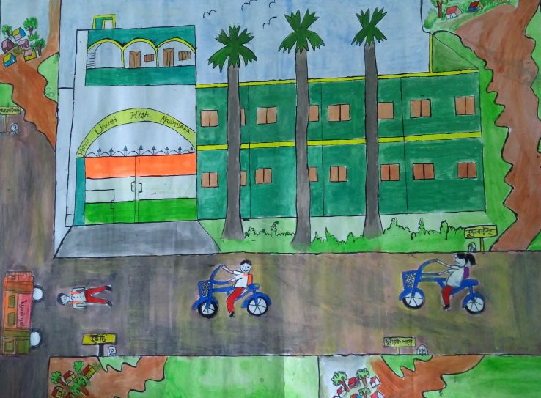
Picture 2 Students' imagination of SaboojSathi
In addition to facilitate the students accessing the schools, the bicycle is being used for various other purposes by the recipients as well as other members of their families – going to the market, transporting things, fetching water, attending ceremonies, going to cinema or local cultural functions, seeing a doctor, especially in emergency, and so on. But, one of the most important uses of the bicycle was found to be its serving the purpose of availing private tuition. It is a widely known fact that private tuition has become a part and parcel of the education system in the state (it takes a different form in other states – students’ resorting to coaching centres). Regrettable as it is, it has become a reality. Since many of the areas do not have a private tutor in the vicinity, students have to access supplementary teaching at places away from their home. Absence of a vehicle of their own, and/or, the lack of financial ability to meet the transportation cost to reach the private tutors, as reported by many parents and students, used to have a ‘depriving’ effect on the students. In addition, many of the students visiting private tutors had often had either to skip their morning meals or manage with some snacks as they did not have time to walk back home for meals. The bicycle has not only expanded the scope of availing private tuition but has also allowed the students to find some breathing time to have a proper meal. Certainly, one cannot justify the unavoidability of private tuition, but the fact is that it has become so, and for many students the bicycle has appeared as an enabler. Nevertheless, the facilitating role of the bicycle for private tuition should be given a different form by initiating larger policy reforms to make private tuition redundant. Of course, the issue has to be dealt with by the education department in particular and the entire state government in general. The implementation agency of SaboojSathi does not perhaps have much scope to contribute to that sort of reform, but certainly the experiences of the implementation which are suggestive of larger reform can be shared with the respective line departments dealing with the delivery of education.
In brief, conceptualisation of the scheme, designing of the implementational framework and the actual delivery have so far taken an aligned route. Nevertheless, the study team observed certain problems which need corrective attention.
- Challenges to address
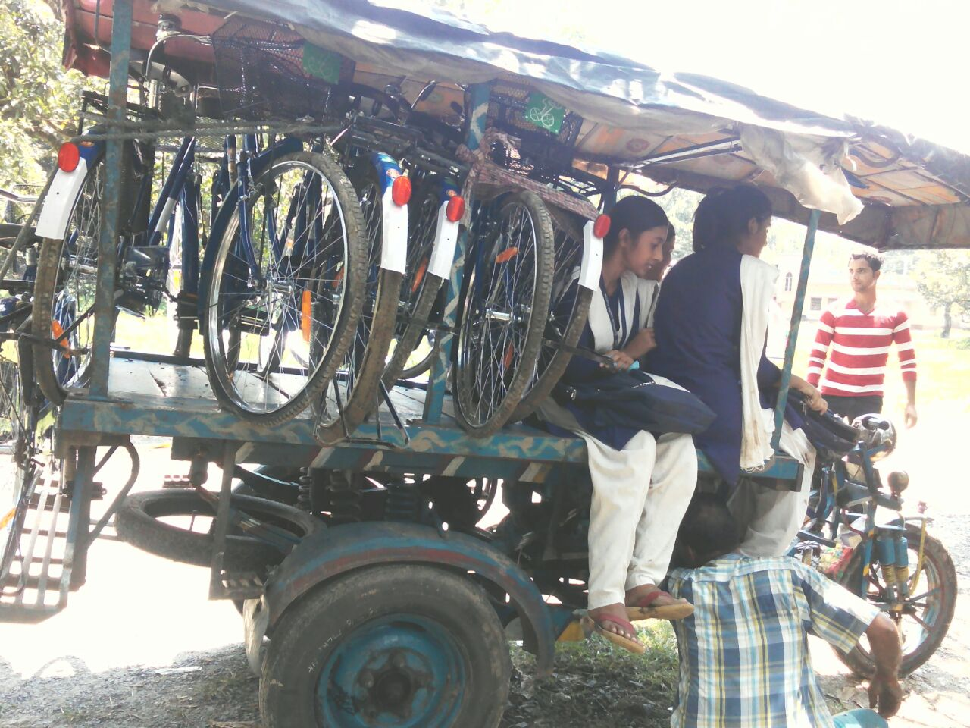
The most important problem raised by all the recipients was the requirement of some additional fitting for the delivered cycles. Although it was made mandatory for the suppliers that the cycles would be delivered to the students in running condition, each of the 150 odd students and different groups of parents we have spoken to complained that they had to spend between Rs 100-400 to make the cycles fit for riding. Local bicycle mechanics and school and block level personnel involved with the implementation also confirmed this. The problem of fitting reportedly arose from the arrangement of fitting.
According to the modalities the suppliers are to transport the bicycles to the point of delivery in knocked down condition and make the fitting over there. Now, the fitters, hired by the suppliers, get their wage on per piece basis. According to a local mechanic, ‘an expert fitter can fit at best 3 bicycles a day, but the fitters hired by the supplier fit 6-7 cycles a day. How is it possible? Moreover, sometime they replace the original wires and tears with some cheaper versions. Obviously there will be problems’. A clerk of a high school told us, ‘I have seen for myself how the fitters work. They don’t fit the rim-tape, an essential requirement to guard the tube. They don’t take care of fitting the different parts while assembling the cycles’. In some cases the wires and tears of the bicycles arrived for assembling and distribution are reportedly found not to be in perfect shape. But the fitters fit them into the cycles in that shape, which eventually requires to be perfected by the local mechanic.
Picture 3 Student recipients carrying their bicycles on a motorised van to the local mechanics shop to get them ready to use
During a conversation at a block office an official involved with the implementation told us that it was not a major problem, in most of the cases bicycles are delivered in running condition. No sooner had he completed the sentence than another block office employee joined the conversation:
What are you saying? My son is a recipient, and he has to pay Rs 200 to get the cycle fixed by the local mechanic. He asked for Rs 400, but discounted it by half when he learnt my sob’s identity – that his father works at the block office.
Another problem found during our visits was connected with the change in the local economic dynamics: most of the households’ receiving bicycles under the scheme has resulted in a slash in the business of the local traders-cum-mechanics. ‘How can we sustain? So, we try to compensate as much as possible from the refitting of bicycles’, candidly said a small trader-cum-mechanic of Hugli.
Aside from the problem of additional fitting charges, few discrepancies in the distribution of bicycles were reported. Some students reported that though their peers have already received the bicycles on paper, they were yet to receive them as they lacked certain documents. Also, some inconsistencies between the numbers of students whose records have been generated, and the actual number of recipients were found. For example, as per the office of the Project Officer cum District Welfare Officer, Backward Classes Welfare, Malda, the number of eligible students in standard 9 in the academic session 2015 was 73,462 but the number of bicycle distributed in 2016-17, as per the same source, was 72,513. That is, nearly one thousand children in the district of the said standard (one per cent) might have been excluded from the scheme in the 2nd phase too. Although the extent of such differences was not very large the issue needs attention.
Policy changes following hastily taken decisions sometime create big problems. For example, there had been an exclusion of standard 11 students in Malda (and two other districts). Let us elaborate.The decision of providing bicycle to the standard 11 students in the first phase of distribution was taken by the government on a later date, by which time the process of distribution in the first phase was complete in Malda. Despite serious efforts taken by the district officials, the issue could not be addressed and students of standard 11 eventually did not receive bicycles in 2015. As Iqbal Ali of Ugritola who has passed Higher Secondary examination from ManikchakShikshaNiketan this year told us, ‘the date of distribution of cycle (for them) was being changed repeatedly (bar bar date porchhilo) but none of his batch-mates, 90 in number, received the bicycle finally’. Nakul Tanti (name changed), father of a student of the deprived batch told us that there was an incident of ransacking in Nurpur High School (under Manikchak Block) where local people demanded that bicycles be distributed to the students of standard 11 of 2015 batch.
Despite the SaboojSathi website is maintained and run enviably well the ‘grievance’ tab was found to be not working. The issue requires attention.
Another problem found was related with some informational asymmetry between different departments of the government. Now, according to DISE 2015-16, the total eligible students in standard 9-12 were 97,691. But according to the office of the Project Officer cum District Welfare Officer, Backward Classes Welfare, Malda the figure was 91,475 and all of these children were reportedly provided bicycle in 2015-16. Thus there exists an anomaly between the records of DISE and the records procured by the SaboojSathi scheme. Since our interactions with the Block officials, teachers, parents, children and the elected representative did not confront with any adverse claim, that is any discrepancies in the distribution of cycles, the figures collected for the SaboojSathi scheme appears to be more plausible than the figures provided by DISE. That, again, does not have much to do with the nodal agency of SaboojSathi, but why such differences in data should be allowed to exist should be made a public question.
A special difficulty concerning the differently able students (children with special needs) was raised by students and teachers alike. The standard bicycle distributed among the students cannot be used by the differently able students, hence, are effectively excluded from the scheme. The issue requires some special provisions.
School authorities complained that they did not have additional funds for transporting the bicycles into the school from the point of delivery, which in some cases stretches up to 25 kilometres. It was demanded that the bicycles to be distributed be made available inside the school campus.
One particular difficulty that the schools reported to have been facing was the excessive workload in connection with the implementation of SaboojSathi thrust upon the schools. Most of the schools suffer from lack of both teaching and non-teaching staff; and schemes like SaboojSathi, and others, such as Kanyasree, consume a lot of academic time of the teachers and officially required time of the non-teaching staff. For example, in one school with a students’ strength of 1200 there was only one non-teaching staff. ‘So, besides my involvement in official works related to SaboojSathi and Kanyasree I often have to summon other teachers’ services which cut down the teaching time.’
- Conclusion
A perfect union of policy, based on ideological commitment, and a sound implementation mechanism makes the program unique. The policy of bringing all high school-going students into the fold of the scheme, SaboojSathi found its root in the principles of equity – creating equal opportunities for all students irrespective of their class, caste, gender, linguistic, or other backgrounds.
The commitment has resulted in establishing primary and upper primary schools within walking distance from all habitations across the state. In order to take this advancement further it was urgent to find means and ways such that all students graduating from upper primary level (8th standard) could attend the high schools, which in many cases were not accessible by foot. Owing to the difficulty in accessing the schools many of the students, particularly from poor and disadvantaged background had to drop out at the threshold of high school education. The problem had particular bearing on the girls, the set of traditionally discriminated against population.
The government’s decision to provide each of the high school students with a bicycle was a result of clear headed thinking on the issue of meeting the challenge of inaccessibility. And, why the government went against the popular global current of selective (popularly called “targeted”) facilitation, and decided to make the scheme universal, was related to two things: (a) the intrinsic priority of non-discrimination in education, and (b) experiences of public programme delivery, both at home and away. It has been seen that programmes for select, “needy”, group of population, have often met with limited success, if not failed entirely. The reason is simple: the implementation of schemes for selected population often lacks one of the essential requirements of proper delivery – social watch dogging. Since the selected population is often found to be short in information and voice, and implementers often take them for granted, the delivery of such schemes tends to fall prey to mishandling and corruption. On the other hand, when universalised, the section that may not be that needy but is empowered with information, voice, and social and political connections, plays an inspectorial role in the implementation of the scheme.
The delivery was made further robust by invoking a technologically forward-looking mechanism. The whole process of identification of suppliers to the delivery of bicycles to the students has been made on line, which added a lot of value in terms of transparency to the scheme.
Apart from its immediate goal of ensuring accessibility to high schools the scheme has had a huge societal impact by enhancing the general mobility of the population and of the girls in particular. The bicycles distributed among the students are not only used for schooling but also for several other purposes, such as going to the market, health centres, cinema or local fairs, and so on. The bicycle, literally, is breaking many boundaries. It is important to keep the progress steady, and it may be worthwhile to expand the scheme to the capital city. Given its huge role of environmental and health protection and other social benefits the bicycle should be promoted among the igh school students of the city. Of course, it requires some infrastructural readjustment, which can be done by drawing on the global experiences.
Nevertheless, the scheme needs to be freed from certain problems. Firstly, it has to be ensured that no student should be required of paying any additional charges for fitting, or any other purposes. Secondly, the differences between records of students and actual number of bicycles distributed have to be addressed. Thirdly, bicycles need to be delivered in each school. Fourthly, the difficulty concerning the differently able students (children with special needs) must be addressed with due importance. Fifthly, and perhaps most importantly, in order to maintain the pace of success of the scheme the government has to make special arrangement of human resources for the implementation of the scheme; the modalities of getting the works done by borrowing people from other departments and institutions can have serious implication on the delivery of the respective departments’ and institutions’ designated works.
The problems related with the implementation may not very serious in nature can be fixed by making some policy reforms. However, as our analysis shows, the implementation of SaboojSathi, while effective in eradicating certain difficulties of students’ acquiring education, points out towards serious need for urgent policy reforms in the education sector. As the SaboojSathi implementation data points out, participation of girls at higher secondary level declines substantially; in certain districts girls’ participation in high schools is worryingly low; and participation of students from disadvantaged sections, especially the Adivasis and the Muslims, at high school level is lower than that of the other social groups. As our observations go, it is not the mistaken perception about Muslim and Adivasi girls’ abhorrence to join the stream of educational advancement that has kept their participation at higher secondary level low. Rather, what is found that Mislim and Adivasis girls, like their other social peers, are eager to study further, and SaboojSathi has actually been beneficial for them to a great extent. Poverty, social exclusion through various means, and other factors are responsible behind their lower participation at higher secondary level.SaboojSathi’s immensely supportive role, and the lessons offered by its very effective implementation, must be utilisedcompletely by taking note of the core problems involved in the delivery of education as a whole.
We must, however, add a qualification here: given the limitation of time which resulted in partial analysis of secondary data and a very thin sample the observations made here are more suggestive in nature than being definitive. It requires further in-depth investigation spread over a wider geographical area in order to examine in details the various impacting connections of SaboojSathi with larger social settings as well the problems involved in its implementation.

Appendix1.
Table A1. Sahre of SC, ST, and Muslims to total population and proportion of the students from the respective groups received bicycle under SaboojSathi (First and Second Phase)
Dist | SC proportion to total population | SC students received bicycle | ST students proportion to total population | ST received bicycle | Muslims proportion to total population | Muslim students received bicycle
Alipurduar | 29.8 | 43.9 | 23.6 | 20.2 | 9.0 | 9.4
Bankura | 32.7 | 30.1 | 10.3 | 8.4 | 8.1 | 7.9
Birbhum | 29.5 | 30.0 | 6.9 | 4.6 | 37.1 | 38.0
Bardhaman | 27.4 | 30.4 | 6.3 | 5.9 | 20.7 | 21.8
Coochbehar | 50.2 | 56.5 | 0.6 | 0.5 | 25.5 | 22.8
DakshinDinajpur | 28.8 | 35.1 | 16.4 | 12.0 | 24.6 | 27.5
Haora | 14.8 | 15.4 | 0.3 | 0.4 | 26.2 | 28.0
Hugli | 24.4 | 27.1 | 4.2 | 4.0 | 15.8 | 14.9
Jalpaiguri | 48.4 | 56.7 | 14.8 | 10.7 | 14.7 | 15.8
Maldah | 20.9 | 27.1 | 7.9 | 3.8 | 51.3 | 47.0
Murshidabad | 12.6 | 13.2 | 1.3 | 1.2 | 66.3 | 66.6
Nadia | 29.9 | 34.0 | 2.7 | 1.9 | 26.8 | 26.0
North 24 Pargans | 21.7 | 27.6 | 2.6 | 2.1 | 25.8 | 24.5
PaschimMedinipur | 19.1 | 18.7 | 14.9 | 9.3 | 10.5 | 10.5
PurbaMedinipur | 14.6 | 13.9 | 0.5 | 0.4 | 14.6 | 11.3
Puruliya | 19.4 | 21.3 | 18.5 | 15.7 | 7.8 | 6.1
South 24 Pargans | 30.2 | 35.2 | 1.2 | 0.9 | 35.6 | 31.4
Siliguri | 8.8 | 44.0 | 1.3 | 11.0 | 9.4 | 10.4
Uttar Dinajpur | 26.9 | 35.5 | 5.4 | 3.0 | 49.9 | 45.7
West Bengal | 24.6 | 29.6 | 5.7 | 4.7 | 27.8 | 22.2

Appendix 2
Standard Operating Procedure (SOP) :Bicycle Distribution Programme, SaboojSathi
https://wbSabooj Sathi.gov.in/readwrite/sop_sabooj_sathi.pdf

Part-A : Information
1. Students (Boy & Girl) of class X & XII studying in Govt. run/ Govt. aided/ Govt. sponsored schools and Madrashas are considered in this phase.
2. Decision regarding students of vocational courses, failed/ compartmental candidates would be taken at a later stage.
3. Distribution programme at Kolkata and Darjeeling would be taken up at a later date.
4. Bi-cycles will be delivered in CKD (Complete Knocked down) conditions at the identified places by the suppliers. Every truck will carry personnel for unloading.
5. Bicycles will be fitted at the same place and handed over to designated/ authorized officer of concerned Block/ Municipality/ Sub-Division.
6. Tube Investments of India Ltd. (TI Cycles), Hero Cycles Ltd. and AVON Cycles Ltd. have been selected through Tender Process. Average price per bi-cycle – Rs. 3201.16/-.
7. Districts assigned to Suppliers: TI Cycles Ltd. – Jalpaiguri, Malda, Murshidabad, Birbhum, Burdwan, South 24 Pgs/ Hero Cycles Ltd. – Alipurduar, Coochbehar, Siliguri, Uttar Dinajpur, Hooghly, Howrah, North 24 Pgs, PaschimMedinipur/ AVON Cycles Ltd. – DakshinDinajpur, Nadia, Bankura, Purulia, PurbaMedinipur, Kolkata. Darjeeling has not been assigned to any supplier. Decision will be taken afterwards.
8. Standard accessories – Front Basket, Carrier, Stand, Full-half chain cover, bell. Overall IS specification - IS 10613-2004
9. Bi-cycle colour – Blue/ Green
10. LOGO – “SaboojSathi”- shall be supplied and fitted on the front basket. (Sample LOGO attached).
11. R&D Centre, Ludhiana has been engaged for Third party inspection at the factory premises. They will inspect standard of bi-cycles at random at different delivery points in the State also.
12. Suppliers will provide a sample bi-cycle which is to be kept at the District HQ under custody of District Cell till distribution is completed. In case of any dispute regarding standard, quality, accessories etc. the sample bi-cycle shall be compared.

Part-B : Actions taken so far
1. Formation of District cell, Designating Nodal officers, association of DI, ADI, SIs and DIOs of NIC with the programme.
2. Identification of space for delivery & assembling work, Point wise exact no. of bicycles (for both boy & girl students) to be delivered at Block/ Municipality level.
3. Schedule of supply delivered to the respective suppliers as per the report received from the Districts.
4. Circulated registration data of Class X & XII (As available with Board/ Council/ Madrasha Board) students in a specific format in MS-Excel sheet. Students’ particulars in the Excel sheet have so far been finalized by the respective Schools.
5. Nearly completed school Mapping, Data import through www.wbscstcorp.gov.in/ wbSaboojSathi
Only except a few cases.
6. Opened School log-in for on-line updating students’ profile by the Schools on 17 August 2015.
7. Suppliers have shared coordinates of their District level Managers/ Coordinators and consignment schedule with a few Districts which were taken up first for supply – Bankura, Purulia, Nadia, Hooghly, Uttar Dinajpur&Malda. They will share such information to all Districts.
8. As of now, 29 Trucks dispatched to Bankura, 12 to Nadia and 10 to Purulia, totaling 51 trucks by AVON Cycles. HERO Cycles dispatched 21 Trucks to Uttar Dinajpur, 1 Truck to Hooghly. TI Cycles dispatched 6 Trucks to Malda. Altogether 80 truck has either reached or on the way to the destination.

PART-C : Further Steps (Discussed in last VC dated 14/8/2015)
1. All the Districts have primarily assessed exact requirement with breakup of Boys’ & Girls’ bicycle, Delivery point wise and for the District as a whole. The assessment is on the basis of report collected from the Schools and compiled at Block and thereafter at District level. This is more or less a true picture. However, exact requirement can be firmed up only after completion of on line updating/ editing students’ profile through www.wbscstcorp.gov.in/ wbSaboojSathi. The time line as agreed was 19th August 2015. The time line is being revised for ease of access and convenience of the users. Revised time line is being intimated in separate mail. Students’ profile updating may either be completed by the respective schools or be taken up through the resources of Block Development Officers/ Sub-Divisional Officers as may be decided by the Districts. Operational manual for school log-in has already been circulated.
2. The next level Log-in for validation of students’ record/ profile as finalized will be provided on and from 21st August 2015. Validation may be done by SIs of respective circles (for rural areas), ADIs (for Municipal areas/ Sub-Division). However resources of BDOs, SDOs, DIs should be utilized if required. Operational manual will be circulated.
3. After validation process, exact requirement would be firmed up for schools, Block/ Municipalities and as a whole for the Districts. A separate module shall be put in place for School Tagging by the respective BDOs (for rural areas) and SDOs (for urban areas). This is required for finalization of requirement for each of the Delivery points already identified. The module will have the facility for creating Delivery points and Tagging of schools with each of such Delivery points. Operational manual will be circulated. The facility will be available from 22/8/2015. School Tagging should be taken up after completion of validation process only.
4. Another module for tracking consignments is being created. Suppliers through their log-in will upload consignment details. The same will be available for viewing by the Blocks/ SubDivisions/ Districts through their log-in. The facility will be available from 24th August 2015. Till such time consignment details will continue to be sent through mail.
5. Schedule of delivery with revised requirements for each of the delivery points/ Districts would be circulated tentatively after 25th August 2015. Excess delivery/ shortfall within the District will be adjusted accordingly after the process-3 above.
6. Distribution should take place generally at school level/ centrally as may be felt convenient by respective Districts. However, distribution at school level is recommended since a separate record showing distribution is to be created and maintained. Distribution should take place immediately after handing over of fitted bi-cycles to the BDOs/ EOs/ SDOs or their authorized officers, as the case may be in phases. This will help creating additional space for taking further delivery and assembling of bi-cycles at the delivery points.
7. After validation of students’ records, each of the schools will be able to generate a partially filled in report in A4 (Landscape) paper. Fields like (1) Name of student (2) Father/ Mother/ Guardian’s Name (3) Registration No. (if available) (4) Class (5) Sec (6) Roll No. (7) Gender will be printed. Fields like (8) Date of Distribution (9) Bi-cycle Brand (10) Frame No. (11) Photograph (12) Signature of student will be left blank. During the distribution the blank fields should be filled in properly for each of the recipients. The hard copy of the record of distribution should be preserved by the respective schools. The hard copies in due course should be collected by respective Blocks/ Sub-Divisions and in turn will be sent to the District cell thereafter. However, immediately after distribution, records like “DATE OF DISTRIBUTION”, “BI-CYCLE-BRAND”, “FRAME NO.” should be entered by respective Schools through School log-in. Records of Distribution will be made available in the public domain more or less in real time basis for transparency.
8. Please make it sure before taking delivery of fitted bi-cycles before distribution that LOGO (attached) is fixed on the front basket.
9. Where distribution will take place immediately, students’ record prepared by the schools earlier in MS-Excel format should be used. However, records of distribution should be kept manually and in hard copies as per the format (enclosed). Updation of Students’ record, validation and uploading records of distribution should be taken up at a later date. Updating students’ record, validation, uploading distribution records are compulsory even if distribution is completed.
10. Block Development Officers/ Sub-Divisional Officers or their authorized officials attached to delivery points will be taking delivery of completely fitted bi-cycles. Delivery challan, in prescribed format (circulated earlier) indicating receipt of the fitted bi-cycles should be issued by the respective BDOs/ SDOs immediately after receiving the fitted bi-cycles. Suppliers were instructed to use separate challans for Boys’ & Girls’ bi-cycles. Arrangement for distribution should be taken up immediately thereafter. Unnecessary delay in issuing receipt should be avoided. District Nodal officers will countersign the delivery challans. District Coordinators of suppliers will collect the signed copy of challans and submit Tax-Invoice to WB SC ST Development & Finance Corporation. Payment will be processed fortnightly. This will ensure uninterrupted flow of supply.
11. In some cases or for that matter as a whole if the on-line updating facility; validation process doesn’t work at desired pace, students’ profile already finalized by the Schools in MS-Excel format should be used for distribution programme. In that way the distribution programme will remain unaffected. However, the updating, validation, uploading of distribution record should be taken up after distribution programme.
12. Allocation of fund for meeting incidental and emergency expenses is under active consideration. The same will be intimated in due course.

Historical data series compiled by Worldwatch Institute, Vital Signs 1996, 2002, 2005 (New York: W.W. Norton & Company, 1996, 2002), quoted in http://www.ibike.org/library/statistics-data.htm
Lowe, Marcia D (1989), The Bicycle: Vehicle for a Small Planet,Worldwatch paper 90, Worlwatch Institute
Australia: Plans to double bicycle use by 2004 by developing a network of trails, end-of-trip facilities, improving bicycle safety; Chile: 30-40 kilometer bike path pilot project currently funded by the Global Environment Facility could grow to 1,000 kilometers over 10 years; Columbia: Some 300 kilometers of bicycle paths have been completed; all cars are banned from 120 kilometers of the city's main streets on Sundays and holidays; referendum was passed to prohibit car circulation during rush hours by 2015; France: The French Environment Ministry, together with the Transportation Ministry, created a national bicycle plan in 1994, granting near $2 million for 10 bicycle promotion projects based on the Dutch model; Germany: Over 31,000 kilometers of paths and lanes exclusively for bicycles; Japan: Cost of owning a car is high: fuel taxes double those of the United States account for almost half of the price of gas; automobile tax levies and vehicle inspection fees amount to an average of almost $2,000 annually; Employer contributions for commuting by bicycle doubled in 2000, while allowances for automobile commuters were halved; The Netherlands: First country to establish an official national bicycle policy; currently almost 19,000 kilometers of paths and lanes exclusively for bicycles; Peru: Low-interest loans available to low-income families for the purchase of the bicycle are helping the city to meet its goal to increase percent of trips by bicycle from 2 percent in the mid 1990s to 10 percent. Over 60 kilometers of bike paths have been built along major traffic corridors; The US: Almost $3 billion in federal funding allocated for bicycle and pedestrian projects between 1998 and 2003 under the Transportation Equity Act for the 21st Century. See, http://www.ibike.org/library/statistics-data.htm
Historical data series compiled by Worldwatch Institute, Vital Signs 1996, 2002, 2005 (New York: W.W. Norton & Company, 1996, 2002), quoted in http://www.ibike.org/library/statistics-data.htm
Mygatt, Elizabeth (2005), “Bicycle Production Remains Strong Worldwide”, Earth Policy Institute, http://www.earth-policy.org/mobile/releases/bicycles_2005
Mahapatra, Richard, (2002), “Headloaders - collectors of fuelwood in India's woodlands”, Down to Earth, . http://www.downtoearth.org.in/coverage/phulmais-walk--a-day-in-the-life-of-a-headloader-15548
Porter, Gina et al (2013) “Health impacts of pedestrian head-loading: A review of the evidence with particular reference to women and children in sub-Saharan Africa”. Social Science & Medicine, 88: 90 DOI: 10.1016/j.socscimed.2013.04.010
Muralidharan, K, and Prakash, Nitish, (2013), “Cycling to School: Increasing Secondary School Enrollment for Girls in India”, https://www.google.co.in/search?q=Adverse+effect+of+headloading+on+women%27s+health&oq=Adverse+effect+of+headloading+on+women%27s+health&aqs=chrome..69i57.13952j0j8&sourceid=chrome&ie=UTF-8
TERI (2014), Pedalling towards a greener India: A report on promoting cycling in the country, The Energy and Resources Institute, New Delhi, 2014
The TERI report cited above says, “A comparison of the price of the cheapest available bicycle as a percentage share of per capita annual income in rural India shows that the price of cheapest available bicycle in India is about 15% of the annual per capita income in rural areas. A comparison of this situation with China indicates that the price of the cheapest cycle in China represents only 2.5% of the annual per capita income in rural areas. Given this difference between India and China, it would not be difficult to argue that rural population in China would find it easier to buy a cycle than their rural counterparts in India…Focus group discussions in five villages in Uttar Pradesh and Bihar and a survey of 1,200 cyclists in six urban areas (Meerut, Jhansi, Jaipur, Surat, Bangalore, and Delhi) by TERI also indicate that low-income households find it difficult to purchase a cycle”
NSSO (2014), …71st round, cited in Pratichi Institute (2017), Tracking Transition of Secondary Schooling in West Bengal through the Prism of Individual Choice and Policy Commitments, www.pratichi.org
Ibid
Pratichi Trust, (2017), Formative study to enhance the understanding about reasons for smooth transition among boys and girls to secondary schools: West Bengal Report, Study commissioned by UNICEF India, ERU Consultants Private Limited, New Delhi
Muralidharan, K, and Prakash, Nitish, (2013), op. cit.
In order to address the problem of girls belonging to disadvantaged classes the government has launched a programme called Kanyasree, which has received international acclaim. The Pratichi Institute has carried out an assessment of the programme and the report is underway.
West Bengal Government order number. SBCW-166/17, dated 17/7/2017.
Kolkata being a metro city, and Darjeeling being placed on the hills at very high altitude it requires special mechanism to implement the scheme, developing which involves time and other resources. And thus, the government has decided to take up these two districts to cover at a later point of time. See, Standard Operating Procedure (SOP): Bicycle Distribution Programme, SaboojSathi, https://wbSabooj Sathi.gov.in/readwrite/sop_sabooj_sathi.pdf
It has also been devolved with the distribution of cycles to 44,007 Accredited Social Health Assistants- ASHAs by using the mechanism devised for the implementation of SaboojSathi. This is certainly an intelligent move of maximising the use of resources. See, Notes of Discussion of the Video Conference with the District officials held on 9 November, 2015; https://wbSabooj Sathi.gov.in/communications.php
Biding documents for procurement of Cycles( Reference no 438/SCST dated 11/6/2015 and 2007/SC/ST 2017)
Revised report of the task force set up for the scheme of distribution of bicycles to students of classes IX to XII in the state, March 2015, Department of Backward Classes Welfare, Government of West Bengal
See, Pratichi Trust, (2017), Formative study to enhance the understanding about reasons for smooth transition among boys and girls to secondary schools: West Bengal Report, Study commissioned by UNICEF India, ERU Consultants Private Limited, New Delhi
Following the DISE data it may appear more than it. The discrepancy in enrolment data was valid for phase II also (see Table-3).
Of course, the government and government aided schools under the management of Department of School Education and Madrassa Education were the only secondary and higher secondary school that were included for it.
Following the DISE data, it appears that six per cent of the children of the said classes were deprived from bicycle then.

