Day | Staffed Hours | Open Library Hours
Monday | 10am – 5pm | 8am – 10am, 5pm – 10pm
Tuesday | 10am – 8pm | 8am – 10am, 8pm – 10pm
Wednesday | 10am – 5pm | 8am – 10am, 5pm – 10pm
Thursday | 10am – 8pm | 8am – 10am, 8pm – 10pm
Friday | 10am – 5pm | 8am – 10am, 5pm – 10pm
Saturday | 10am – 1pm, 2pm – 5pm | 8am – 10am, 1pm – 2pm, 5pm – 10pm
Sunday | No Staff | 8am – 10pm
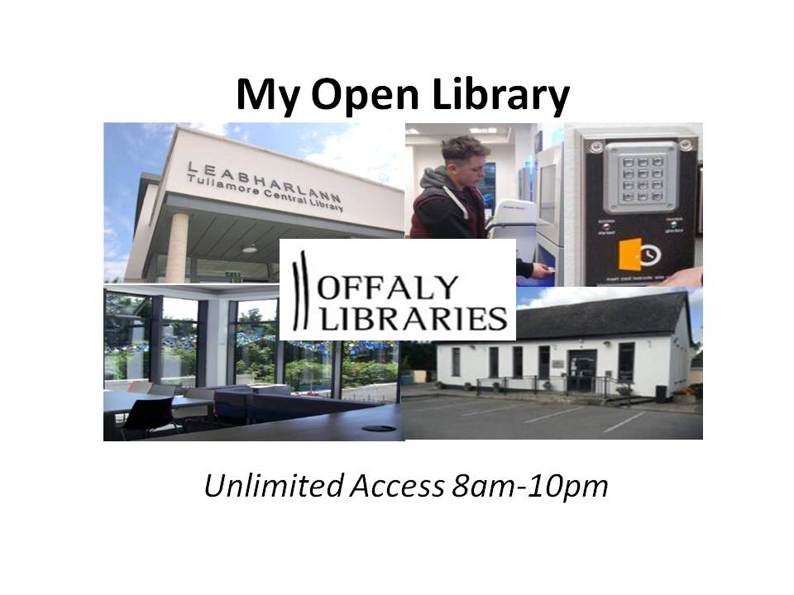
To access the library you need your full sized library card and PIN.
- Insert your card into the card reader at the door with the barcode facing up and the numbers facing in. When you hear a beep, enter your PIN. You should see a green light on the card reader and the door will open automatically. Please do not use the door handle.
- For Health and Safety Reasons, each Open Library member should follow these steps, even if they are visiting with another Open Library Member.
- To exit, just push the handle on the front door. The other exits are alarmed and should only be opened in the event of an emergency.

At closing time (10pm)
Tullamore Library User Information Pack
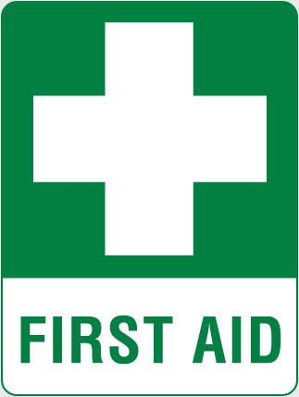 A first aid box is available in the library beside the staff desk
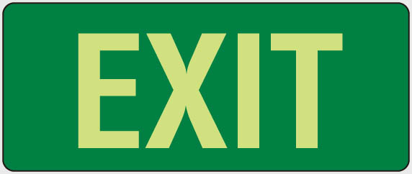 In the event of a fire alarm activation or a power cut, you should exit the library through the nearest emergency exit. A fire alarm will trigger red lights in the building, an audio recording instructing you to evacuate and a siren. There are 2 emergency exits, one at the front and one at the back of the building. The assembly point is in the square in front of the doctors surgery. A picture is displayed below of all exits.
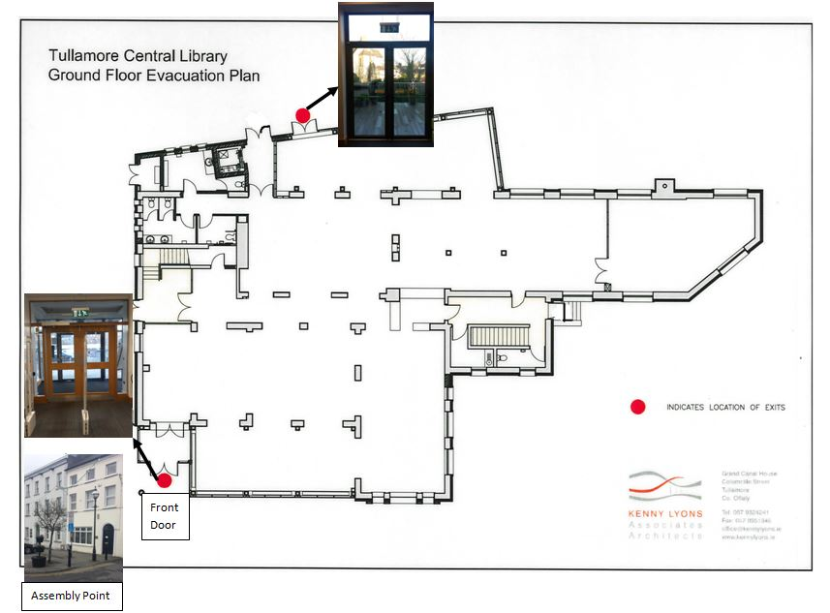
The Library is monitored by CCTV at all times.
If you feel unsafe in the library, or someone follows you in without validating their card, you can text or phone our security company on
086 2214301
How To Use a Computer
This is a free service. To Log in to a computer, select the coloured text and enter your library card number and PIN when prompted. The terms and conditions of use will appear on screen. Click “Accept” and the computer will unlock. Please don’t save your work to the computer as it will not remain there once your session has finished. If you need to save something, we recommend using a USB key.
How to Print
There are now 3 different Print options
- Surfbox – Print Copy and Go,
- Library Credit
- Princh
Surfbox
The default printer is Printstation, A4 & A3 printing– B&W and Colour, Cash only
Please remember to write down your 6 digit release code when using Surfbox
Library Credit
Change print option to A4 B&W or A4 Colour or A3 B&W or A3 Colour or A4 Duplex or A3 Duplex
Princh
Change print option to Tullamore Library,
Option to print A4 and A3, Colour and B&W
Pay using debit card

To print from our library computers send your document to print and the price and page amount should appear. Click ‘OK’ and when you are ready to collect them you must go to the screen on the wall beside the printer to then release and pay for your printing and it will be released.
Tullamore Library also has mobile wireless printing. This allows you to send jobs to the library printer while connected to the library Wifi on your phone/laptop/tablet and also to send a print job to the library printer from home before coming to the library to collect it.
To find out more about this please check our website: http://www.offaly.ie/eng/Services/Libraries/Documents/Wireless-Printing-in-Tullamore-Library.html
Tullamore Library uses a top up system to pay for all printing and Internet. Wireless print jobs and pay for printing.
How to Use the Wifi

Tullamore Library has free Wifi. Search for wireless connections on your Wifi enabled device and connect to one of the three options. Once it says connected - open your browser, refresh a webpage and continue/proceed anyway on the security alert page and then you will be redirected to a page to enter using your library card number and PIN to gain access to the Wifi.
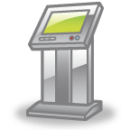Using the Library Self Service Machine

There are three machines in the library that can be used to borrow and return items, to renew items, pay fines and to see your account information. Follow the instructions on screen. When you are returning items, place items in the holds box (the box between the machines). Some items may remain on your account until the librarian is present due to a request placed by someone else. The machine will not allow items in the holds box to be borrowed until the librarian has approved them on the library system.

Closing Time
At 10pm, please follow the audio instructions and leave the library on time. The alarm will set automatically at closing time. Anyone remaining in the library will activate the alarm and a security company will attend.

