TRAINING WEEK

North sydney


Tuesday July 3, 2018
9:00AM – 9:30AM  9:30AM – 12:00PM | Welcome!  Employment Readiness Skills – Chris Angione Safety Check
12:00PM – 1:00PM | LUNCH
1:00PM – 3:00PM | Employment Readiness Skills – Chris Angione Safety Check

Wednesday July 4, 2018
9:00AM – 12:00PM | 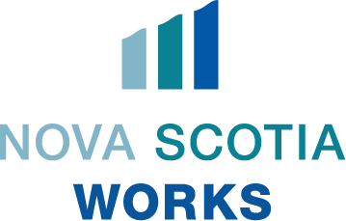  Personality Dimensions – Tracey MacMullin NEDAC
12:00PM – 1:00PM | LUNCH
1:00PM – 3:00PM | Financial Literacy – Credit Union

Thursday July 5, 2018
8:00AM – 12:00PM | First Aid – St John’s Ambulance
12:00PM – 12:30PM |   LUNCH
12:30PM – 3:30PM | First Aid – St John’s Ambulance

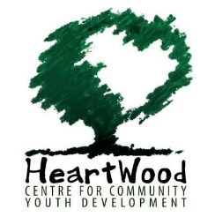
Friday July 6, 2018
9:00AM – 12:30PM | HeartWood Centre for Community Youth Development
12:30PM – 1:30PM | LUNCH
1:30PM – 3:00PM | Huddle
LOCATION:
Emera Centre Northside 175 King St, North Sydney, NS
Upstairs in the Credit Union Community Room

We provide lunch! Please arrive on time daily
NOTE: START AND END TIME ON JULY 5

Program Coordinator: Nicole MacIntyre (902) 579 – 8038
Week 2 (July 9 – 13) The group will meet at 9:00AM @ Emera Centre and return at 3:00PM

