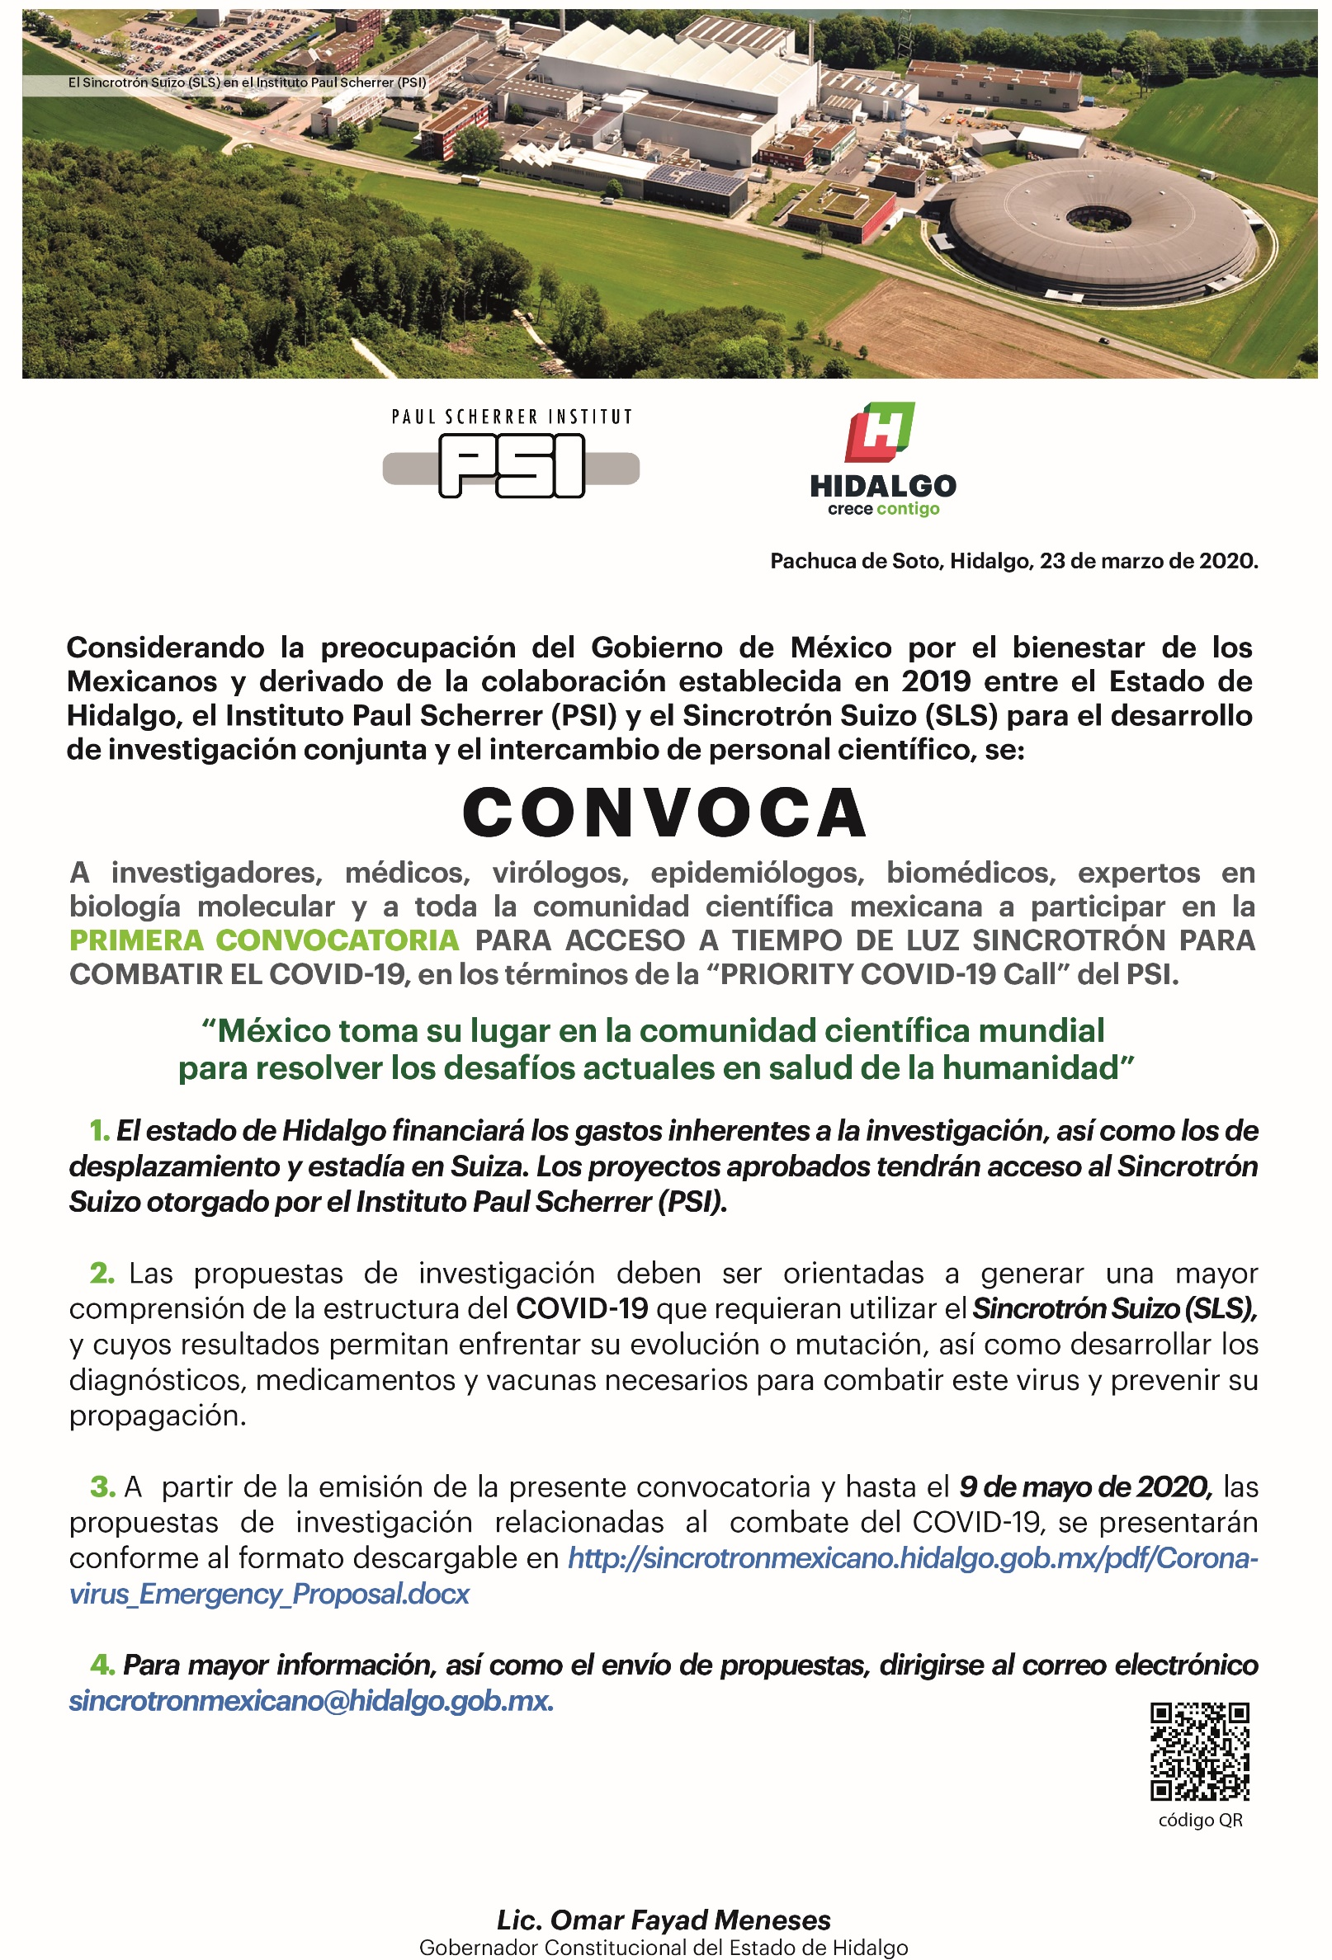
Title of the proposed experiment:
…text…

Abstract:
….4 lines of text ….

Please justify the requirement of rapid access:
….2 lines of text ….

Main proposer:
Name:
Affiliation:

Facility: ☐ SLS ☐ SwissFEL

Preferred beamline / experimental station:
…text…

Requested number of shifts (1 shift = 8 h):
…number…

Safety aspects:

After the experiment the sample will be
☐ removed by user ☐ stored at PSI ☐ disposed by PSI

Does the sample contain genetically modified, alien, pathogenic organisms, viruses or human tissue?
☐ no ☐ yes

Biosafety level:
☐ N/A ☐ 1 ☐ 2 ☐ 3 ☐ 4

Does the proposed experiment on this sample involve the use of human histological sample, human tissues or embryos/stem cells?
☐ no ☐ yes

Are animals involved?
☐ no ☐ yes
Scientific case:
- The recommended length of the scientific description is 2 page A4. Longer descriptions are not accepted.
- Please choose a font size not smaller than 12pt, recommended fonts are Arial/Helvetica/Symbol.
- Figures/Images must be included into the scientific description.
- Please adhere to the structure below:

A) Goal of the experiment
... text ...

B) Background
... text ...

C) Experimental method; specific requirements
... text ...

D) Results expected
... text ...

E) Estimate and justification of the beamtime
... text ...

F) References relevant to the experiment description
... text ...

