THE EVOLUTION OF E-ME DIGITAL EDUCATIONAL PLATFORM AND EXPERIENCES FROM ITS NATION-WIDE USE IN SCHOOLS DURING COVID-19 PANDEMIC
E. Megalou, Y. Tsilivigos, C. Kaklamanis, A. Politi
CTI "DIOPHANTUS" (GREECE)

Abstract
e-me is a social, collaborative, and extendable cloud-based digital educational platform for students and teachers, designed to support formal, non-formal, or informal learning experiences. e-me provides each member with a safe personal digital workspace to connect, communicate, collaborate, set up public or private collaborative learn-spaces, store and exchange files, along with a suite of tools (apps) to create and share learning resources, develop and monitor assignments, create e-portfolios, etc. We introduced e-me in 2015, as a Personal Learning Environment (PLE) we designed and developed for the Greek Ministry of Education (MoE) to operate as an educational platform for all students and teachers in Greece. Since then, e-me has greatly evolved and expanded with new functionalities, being today a mature and innovative educational platform supporting modern pedagogy, with three installations, and more than 650,000 registered users. In 2020, e-me was offered by the Greek MoE to all students and teachers to support emergency remote teaching in primary and secondary education in response to the Covid-19 pandemic-crisis. The paper presents the extended and updated e-me of today (v3.0), as well as our experiences from its nationwide official use in pandemic times.
Keywords: Digital Educational Platform, Personal Learning Environment, PLE, collaboration platform, Covid-19 pandemic, distance learning, e-learning

INTRODUCTION
The recent impact of the Covid-19 epidemic on school systems around the globe along with upcoming challenges related to the 4th Industrial Revolution (e.g. augmented reality, artificial and virtual intelligence, ubiquitous technologies, big data management, learning analytics) make evident that education faces a 21st-century pedagogical shift.
Over the past decades, Learning Management Systems (LMSs) have been used for distance learning, management of the learning process and content, and evaluation of student performance [1]. LMSs (e.g. Moodle, Blackboard, Schoology) have ever since evolved by supporting remote collaborative activities via communication channels (e.g., forums, chats), but such tools are rather supplementary add-ons instead of core design functionalities based on student participation [2]. Further concern regarding LMSs is their emphasis on a top-down hierarchical process, course-bound and teacher-centered, where peer-to-peer and instructor-trainee interaction and participation are confined to a rather closed learning group adjusting to preset course objectives, consuming predefined learning content created by either experts or the instructor, the sole owners of this content.
A response to this was the development of social platforms (e.g. Edmodo) whose design focused on students' need for autonomy, interaction, and socio-experiential learning opportunities [3] via social networking tools [4] that provide opportunities for active participation, collaboration, and critical thinking. Many of these social media elements include creating public or private profiles, creating and sharing 'wall' comments and have also become an integral part of Next Generation Learning Management Systems (Next-Generation LMSs) the design of which, according to [1], ‘needs to be open, social, flexible, support learning analytics, and properly support the move to mobile computing’. Next generation learning environments lay emphasis on ‘learner autonomy’, ‘ownership’, and ‘empowerment’; these principles are well reflected on the design elements of openness, personalization, adaptability, flexibility, social networking, and user-generated content that characterize Personal Learning Environments (PLEs). Buchem in [5] defines PLEs as ‘integrated, individual environments for learning, which include specific technologies, methods, tools, contents, communities, and services, constituting complex learning infrastructures enhancing new educational practices and at the same time emerging from these new practices’. PLEs are considered a new Technology-Enhanced Learning (TEL) approach, an emerging learning practice of the 21st century [6] [7] being the result of a socio-pedagogical way of using technology for learning [8][7] that: (a) faces the limitations educators and students used to experience with typical LMSs due to their 'one size fits all approach' failing to meet the differentiated needs of learners [8] [10] [11]; and (b) raises the value of ongoing learning under various contexts and conditions and the need for lifelong competence development, which calls the learner to organize his individual learning environment based on their preferences and needs [8] [11] [12] [13].
A PLE is not a monolithic learning technology, standardized and applied in a controlled environment [14][15], but perceives learning as a continuous, dynamic process that evolves in space and time, crossing institutional barriers. PLEs, thus, function as a set of tools, materials, and human resources that one knows and uses for life [8], causing a transition from the traditional model of knowledge transfer toward a new model of socially-mediated, knowledge construction. PLEs provide access to a variety of learning and human resources while the user interacts with other people [12] using tools tailored to their needs and preferences in a single learning environment. As opposed to LMSs, users in PLEs engage in lifelong learning practices acquiring knowledge that transcends from formal to non-formal and informal learning environments [3][16], benefitting from Web 2.0 technologies and social software tools (such as wikis, blogs, instant messaging, social networks and services). This allows the learner to take control of their learning path, manage their learning pace, make decisions regarding their learning goals, manage the content of learning, and communicate with others [17]. PLEs can be seen, thus, as an opportunity for constructive learning as long as they are used in a way that highlights the characteristics of meaningful learning, i.e., active, social, collaborative, and authentic learning [18].
Despite the aforementioned pedagogical benefits outlined by scholars, massive use of educational platforms for school education would never have occurred should it not have been for the world outbreak of the COVID-19 pandemic. As of mid-April 2020, ‘network platforms assumed a central role in the educational process’ [19] to confront emergent quarantine measures that forced long-term school closures in about 188 countries. This necessarily urged authorities in about 83 % of the countries globally to rely on online platforms, besides other Internet-based (social media, websites) and audio-visual learning solutions (radio, TV), which overall affected 94 % of learners worldwide (i.e., 1.58 billion children and youth from pre-primary to higher education) [20]. Switch to digital solutions caused an unprecedented digitalization of education; traditional face-to-face learning was replaced by e-learning solutions, and emergency remote teaching practices [21] were adopted to facilitate student learning during the closure of educational institutions [22] and formal education continuity. Various nationwide and international reports [23] provide a detailed analysis on the way educational systems urged teachers to use digital tools; web conferencing tools (e.g. Zoom, Google Meet, WebEx, MS Teams, Skype) for live lecturing and real-time (synchronous) learning, and learning management platforms (e.g. Moodle) for asynchronous learning. In Greece, the Ministry of Education (MoE) offered teachers and students the Cisco WebEx for synchronous learning and two asynchronous learning solutions, namely either to choose the e-class LMS (eclass.sch.gr) or the e-me PLE (e-me.edu.gr).

What the paper is all about (contribution)
Digital Educational Platform e-me is a social, collaborative, and extendable cloud-based platform for students and teachers, which grounds its pedagogical innovation on the Personal Learning Environment (PLE) model and on student-centered design principles, encouraging equal participation, socially mediated construction of knowledge, and co-creation of educational content easily redistributed among peers.
We introduced e-me in 2015 [24] as a next-generation educational platform, a PLE we designed and developed for the Greek Ministry of Education to operate as an official educational platform for all students and teachers in Greece. Since then, e-me has evolved greatly and expanded with new functionality, being today a mature and innovative educational platform supporting modern pedagogy, with three editions/installations, and more than 650,000 registered users (140,000 teachers and 530,000 students). To the best of our knowledge, e-me is one of the first, if not the first, open-source implementation of a PLE for school education, designed for nationwide use by all students and teachers. This paper presents the current expanded and updated e-me of today (v3.0).
In 2020, e-me was one of the two official platforms made available by the Greek MoE to all students and teachers to support emergency remote teaching in primary and secondary education, in response to the Covid 19 pandemic crisis and the subsequent global shutdown. This paper also provides a brief overview of e-me’s official nationwide use in times of pandemic. Reflecting on teachers’ practices using e-me for formal learning, outlining the challenges faced, and overall pinpointing pedagogical gain, we aim to explore how this experience positively influenced the evolution and growth of e-me, adding value to the existing literature on large-scale implementation of PLEs.

e-me design

e-me origins and background
e-me was designed and developed by CTI ‘Diophantus’ in the framework of the ‘Digital School’ large-scale initiative of the Greek MoE (2010-2021) [25]. Its design was initiated in 2014, in response to an invitation by the MoE for the development and operation of a digital educational platform to address the entire Greek K-12 community of 1,500,000 students and 120,000 teachers, and to support learning in primary and secondary education.
e-me implemented a key component of the national plan for the digital transformation of education in Greece, being the third pillar of the digital infrastructure developed to support learning. Until then, this infrastructure included (a) an online digital library offering all textbooks in open digital format, enriched with interactive resources (e-books.edu.gr), and (b) a large digital ecosystem for hosting, organizing and sharing learning resources, with a strong focus on open access, consisting of an ecosystem of OER repositories with several thousand interactive learning objects, and a national aggregator of educational content, harvesting OERs from different sources (photodentro.edu.gr) [26]. What was missing and e-me was called to fulfil was a safe digital workspace for all students and teachers that supports their collaboration and communication, as well as the creation, sharing, and pedagogical use of learning resources, together with tools to facilitate daily learning activities. The first version of e-me was launched in 2015; the fully functional version 2.0 was released in late 2019, just before the Covid 19 pandemic; the current version 3.0 was released in 2022 and is a stable, mature, and upgraded version that incorporates all the experience gained from its nationwide use and from 650,000 users.

e-me design principles and approach
Designing for a large, national scale is an interesting, yet challenging task. Our goal was to develop a pedagogically modern, easy-to-use and technologically advanced platform, with state-of-the art architecture while providing a sustainable solution for the future. The design of e-me took into consideration the needs and expectations of school community members as expressed via an open call and was based on a fruitful exchange of views with pedagogical and technical experts as well as on extensive market research on educational and social platforms, focusing on their popular features.
The main design principles of e-me are:
User-centered platform: Our key approach was to design an educational platform that focuses on people i.e. students and teachers, rather than on classroom and classroom-related activities. Learning occurs anytime and everywhere within formal, non-formal, or informal settings. Hence, the platform should provide a personal workspace for students and teachers to support all their daily activities (e.g. communication and collaboration with peers for extracurricular activities, daily life self-organization, or activities for teachers’ personal or professional development). This promotes development of 21st century skills and leads to self-regulated, individual knowledge management and socially-constructed learning, which are principles of PLEs that e-me was designed to follow.
Students first / equal participation of students and teachers: e-me is primarily aimed at students. Offering a modern and intuitive user interface and providing a familiar user experience was thus important to attract students, leading e-me to adopt the look and feel of smart devices. In addition, e-me is a democratic platform, encouraging students to actively participate and have a responsible role in all activities and opportunities offered by the platform, on an equal footing with teachers.
Smooth transition to the ‘digital world’: A design goal of e-me was to first support and facilitate what is already happening in schools, using real-world metaphors simulating the real world in the digital world. Abstractly speaking, in their daily life students and teachers (a) communicate; (b) collaborate, i.e. create teams, work in groups; (c) collect, exchange/share, and use educational materials; (d) assign and implement tasks and exercises; and (d) display / present their work to the outside world.
Open container for apps, a sustainable model for growth and expansion: rather than developing a closed integrated platform, e-me was designed as an open framework that enables third-party integration of tools and applications, and encourages the educational community as well as the software market to contribute with apps that extend its functionality.
A social platform, empowering the development of soft skills: the social dimension was a key axis of the e-me design, through which the development of 21st century skills (e.g. cooperation, communication, leadership, critical thinking, flexibility, adaptability, and negotiation skills) is promoted.

e-me FUNCTIONALITY & FEATUreS
Based on the above fundamental principles, e-me was developed and functions as follows.

What is e-me? (e-me in a nutshell)
e-me is a social, collaborative, and extendable cloud-based digital educational platform for students and teachers designed to support formal, non-formal, or informal learning experiences. e-me provides each member with a safe personal digital workspace to communicate, cooperate and collaborate, socially connect with other members of the school community, set up public or private regulated collaborative learn-spaces, organize, store and exchange files, along with a suite of digital tools (apps) to create and share learning resources, develop and monitor assignments, create personal e-portfolios, present/display their work and results to the outside world, and facilitate everyday activities.
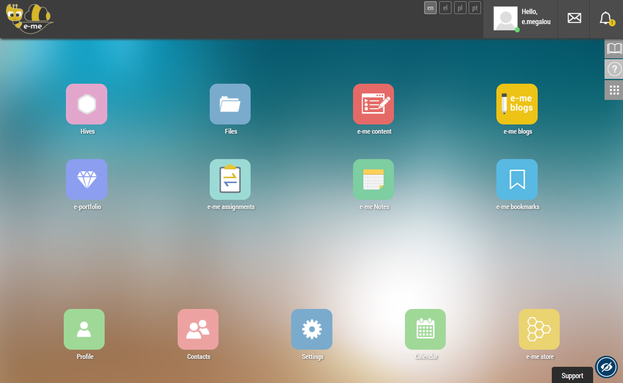
Figure 1: e-me Home

e-me editions
e-me is available in three installations (editions): (a) the Greek official edition of e-me (e-me.edu.gr), offered by the MoE to all students and teachers in primary and secondary education, providing a secure environment where access is only allowed through national Greek School Network accounts via a Single Sign-On mechanism; (b) the open to everyone ‘e-me for all’ Greek edition (4all.e-me.edu.gr), aimed at all educators, learners, researchers, academics, and any other interested party through free registration; and (c) the multilingual European edition (e-me4all.eu), launched recently to support collaboration among schools, Universities, institutions, etc. at the European level.

e-me Home
Following the PLE approach [8][5], e-me Home represents the main digital personal workspace of each member where all the selected tools and applications are collected and which can be customized and personalized according to their needs (Figure 1). It provides an intuitive user interface similar to mobile devices and allows access to member’s profile, settings, contacts and all apps, either pre-installed or individually installed through the ‘e-me Store’, the application repository of e-me.

e-me social: members, user profile, contacts, and communication
e-me is a social educational platform that emphasizes learning through social interaction [10] and leverages social networking to foster collaboration, communication, experience sharing, and soft skills development. The main concepts of the e-me social dimension are:
e-me user profile: each e-me member has a personal profile that represents their digital identity in the e-me community (Fig. 1a). e-me user profile contains some public information (i.e., their name and role in the K12 community, a description and their motto, an avatar selected from a non-discriminatory character palette), while they are free to decide which additional elements are displayed publicly or not (e.g., selected achievements from their e-portfolio or the groups and collaborative spaces they participate in). By managing their digital identity, e-me members can learn how to manage their ‘digital self’ and develop skills for managing personal data in social networks.
e-me contacts: e-me members can find peers who are already in e-me, either through direct search or through their participation in common activities. e-me members can connect and become 'contacts' by sending connection invitations (that require acceptance for the connection to occur). In this way, students and teachers can build their own social network of friends and contacts in e-me (Fig. 1b), while developing social skills and behaviors in the digital world through this process.
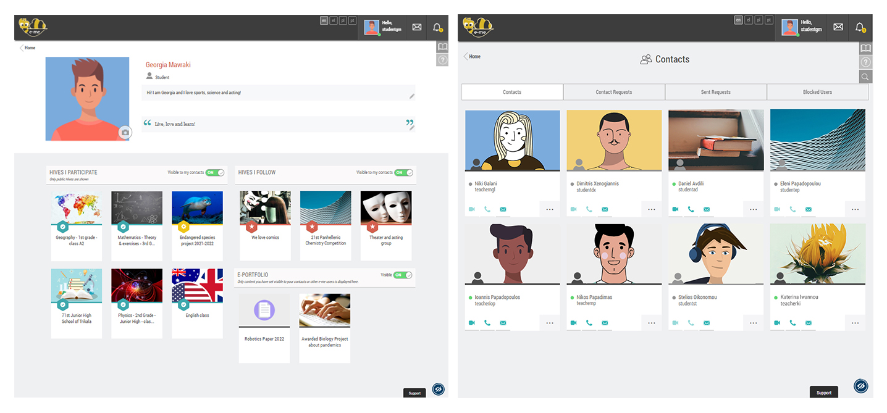
Fig. 1: e-me member’s profile page (left) and personal contacts (right)
e-me communication: Upon becoming contacts, e-me members can communicate with each other both synchronously and asynchronously via instant messages (chat), and/or audio and video calls, participate in private or group discussions, share files and folders, etc.

e-me hives: the key structural concept of e-me
Hives are a key structural concept in e-me; they are smaller, self-contained social learn-spaces and serve as main work and collaboration environments for students and teachers. A hive represents a group of people and provides a space for their communication, collaboration, file sharing, tasks assignment, etc.
As a structural element, a hive consists of four components: (a) members who are either invited by the leader of the hive or ask to participate. Following the social network paradigm, membership in hives requires consent from both parties; (b) a workspace that is configured by the hive's creator and includes the hive's desktop environment and a shared storage space on the cloud; (c) communication channels, with the hive’s Wall being the most important for the internal communication of members, and the collaborative blog for their external communication with the outside world; and (d) a set of collaboration or other tools (apps) that the leader can install from the ‘e-me hive store’, according to their relevance to the hive’s objectives.
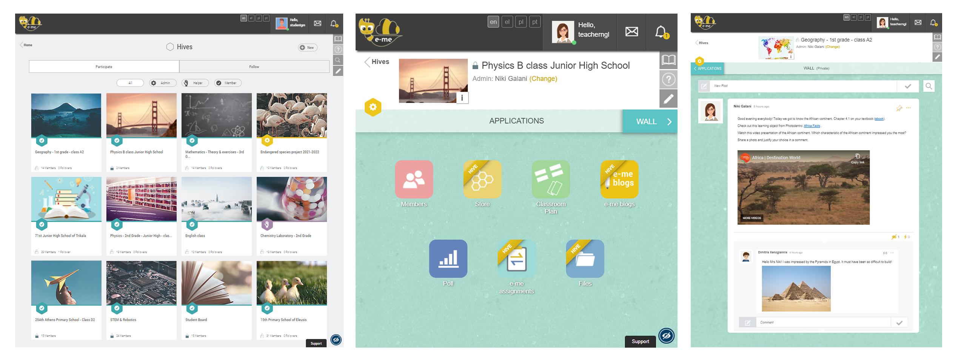
Fig. 2: e-me hives (left), hive workspace (middle), and hive Wall (right)
Hives can be created by both teachers and students; this implements a fundamental design principle of e-me that calls for their equal participation in e-me activities. Each hive has a leader who is the creator of the hive and can invite members, manage all options, and moderate content; this is an important role that can be taken on by either the teacher or the student. There is also a role for an assistant who has advanced moderation and content management rights.
A hive usually represents a classroom, providing a private space regulated by the teacher. However, a hive can also represent a group of students working together for a school project or an extra-curricular activity, e.g. a theatre performance, and needing a private space to do so; or a group of teachers participating in a professional development programme; or a whole school community needing to exchange ideas on school-related issues; or students and teachers from different schools in different places or countries working on a national or European project, etc. In these participatory digital communities, members exchange views, ideas, and build individual and collaborative learning experiences; share files, learning resources and user-generated content; and learn to explore, analyze and construct socially-mediated knowledge based on shared activities.
Hives can be either private or public. In the design of e-me, a private hive implements the concept of a closed working group (like a classroom with a closed door), providing a collaborative space for its members only. A public hive, on the other hand, provides a public space for discussion and sharing that members can join, encouraging communication and collaboration among people sharing common interests, thus, implementing the concept of an Open Educational Community.
The hive’s Wall is the main communication channel of hive’s members, favoring a dynamic dialectical relationship among members and promoting interaction in a meaningful context. It is open to all hive members to add new posts or comment on existing ones, share their ideas and thoughts, post announcements or assignments, or upload interactive learning material, hyperlinks, images, videos, or files in various formats, using the multiple features of its word processor. The e-me hives' Wall is widely used and has proven to be a powerful educational tool for communicating ideas and thoughts, engaging in social dialogue, collaborating on assignments and projects, guiding peers in regulating their studies, asking and clarifying questions, outlining the flow of course activities, providing feedback and verbal rewards for assigned tasks, and informing about the progress of individual or team work.
Hives also offer collaboration tools (apps) that encourage creation and co-creation, including: (a) hive files app, which provides shared cloud storage for all members and enables the creation of collaborative files, and (b) hive collaborative blog where all hive members can post articles. Other apps that interact with hive members include: (c) Polls app, which allows members to conduct live polls among hive members and (d) Class Plan app, which visualizes classroom layout arrangement of desks and students.

e-me apps: extending the functionality of e-me
Similar to smart devices, e-me supports the integration of apps that extend its functionality. The e-me apps are HTML5 applications that e-me members can select from the ‘e-me Store’ and use directly in the platform. The main e-me apps available in its v3.0 are the following:
e-me content (Content Creation): Implementing the e-me design approach where the platform is expanded by integrating third-party apps, the open source tool H5P (h5p.org) was localized into Greek, adapted and fully integrated into e-me. The resulting 'e-me content' app provides a powerful and user-friendly tool for the development of interactive learning resources, supporting forty-five types of resources, such as interactive videos, course presentations, quizzes, memory games and multiple-choice questions. e-me content artefacts (.h5p files) can be used within hive’s collaborative environment, assigned to hive members, or shared via the hive’s Wall. e-me content supports and encourages the role of teachers and students as content creators and as active participants in the content production process.
e-me assignments (Assigning and monitoring tasks): the 'e-me assignments' app allows teachers to create, manage, and assign assignments to students, monitor their progress and provide assessments and feedback on students’ submissions. Assignments can include multimedia resources, attachments, interactive objects, etc. and can be organized in teacher’s e-me assignments library. The app was also designed to support the Flipped Classroom model, while during e-me wide use, it emerged its value as a tool for supporting a differentiated approach to teaching by allowing the assignment of different tasks to individuals or groups based on students' interests, preferences and strengths.
e-me Blogs (publishing, creation and co-creation): 'e-me Blogs' is the tool that e-me provides to its members to communicate to the outside world, either as an individual or as a team. Each member of e-me has a personal blog pre-installed, available in their workspace, where they can post articles. The blogs are public to everyone, and are used to showcase and highlight the work of students, teachers and schools. It is based on the WordPress blogging platform.
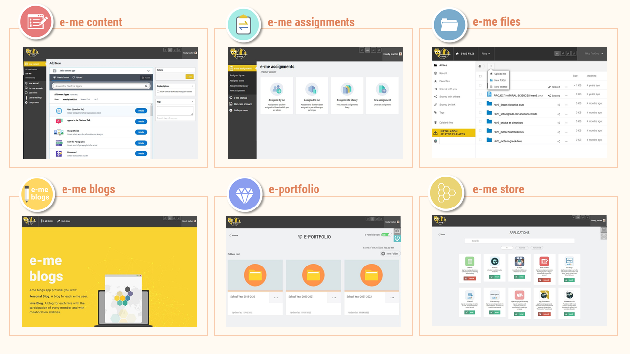
Figure 2: e-me main apps
e-me portfolio (reflection and maintenance): the ‘e-me portfolio’ allows e-me members to collect, select, document, and maintain year-by-year achievements or representative work that best support their self-presentation. The process of selecting representative achievements implies reflection on the teaching or learning process preceding each school year. It is a complex and multi-layered process involving all the achievements of the creator, the thoughts that developed into actions, the ideas that were implemented, the experiences that were made and the knowledge that was acquired. Thus, the e-me portfolio becomes a pedagogical tool for reflection and preservation. It is optionally visible in e-me user’s profile.
e-me files: e-me provides each member with a personal cloud-based storage (2GB) to upload, organize, and store personal files, or to share them with their contacts or hives. The 'e-me files' app is based on the open source software NextCloud (nextcloud.com). e-me members can also synchronize their e-me files with their personal computer or mobile device.

Other e-me apps
e-me v3.0 offers more apps to support collaboration and learning, among them: (a) MyPhotodentro, which connects e-me to the national Photodentro OER repositories [26] and allows e-me members to select, annotate, and comment on them, thus creating their own OER repository in e-me; (b) e-me Notes, which provides e-me members with a personal notebook to create, organize and share notes; (c) e-me Bookmarks, for collecting bookmarks from favorite websites and storing them in e-me. These apps can be used to support learning activities aimed at developing skills such as searching, organizing, or documenting resources.

e-me development technologies and infrastructure
Software development of e-me is based on modern Web 2.0 technologies and approaches, enabling mobile-friendly user experience. It makes extensive use of HTML5, Free and Open Source Software (FOSS), such as WordPress (wordpress.org) and the Nextcloud file sharing and collaboration platform (nextcloud.org), open protocols, and specifications. The system architecture of e-me follows the cloud computing paradigm. The core components have been built using the node.js framework (nodejs.org). Persistent data is managed by a distributed MongoDB NO-SQL database (mongodb.org), while volatile information is handled with a Redis data structure server (redis.io). As for its deployment, e-me is based on a cloud-based infrastructure of Debian GNU/Linux virtual machines provided by GRNET, the Greek National Infrastructures for Research and Technology (grnet.gr).

NATION-WIDE USE Of e-me in schools DURING COVID-19 PANDEMIC
Like everywhere else in the world, the Covid-19 pandemic crisis in Greece was an opportunity to push forward many reforms for the development of digital skills in the education community. The Greek Ministry of Education's plan to guarantee continuity in primary and secondary education had three axes: (1) Synchronous, real-time teaching, using Cisco's Webex teleconferencing platform to support live digital classes; (2) Asynchronous distance learning; and (3) Educational TV lessons. For the asynchronous axis, teachers were offered two options: (2a) the brand-new Personal Learning Environment e-me (e-me.edu.gr) and (2b) the e-class (e-class.sch.gr) traditional LMS, already in use for many years. Students and teachers access to both platforms was through their GSN (Greek School Network) accounts, a unique ID, which is used as authentication method for all services and platforms offered by the MoE. Other solutions such as MS Teams or Google Classroom were also explored, but not selected for K-12 education. In terms of numbers, Greece has 13,000 primary and secondary schools, 167,000 teachers and 1.5 million students.
Within two months, e-me reached 400,000 users, an increase of 4,000 %; over 120,000 hives were created, representing either formal school classes or informal collaboration spaces. Among them, 10,000 hives were initiated by students, covering their need for cooperation and communication with peers during quarantine time. 15,000 public hives were also set up to support open educational communities. The e-me hive’s Wall proved to be a very powerful communication and educational tool; teachers and students used it extensively to discuss, post comments, exchange opinions, share materials, assign tasks, give feedback, etc. They also used extensively the other communication tools of e-me, by exchanging thousands of messages, audio and video calls to effectively communicate and collaborate among each other. Figure 3 presents some statistics.
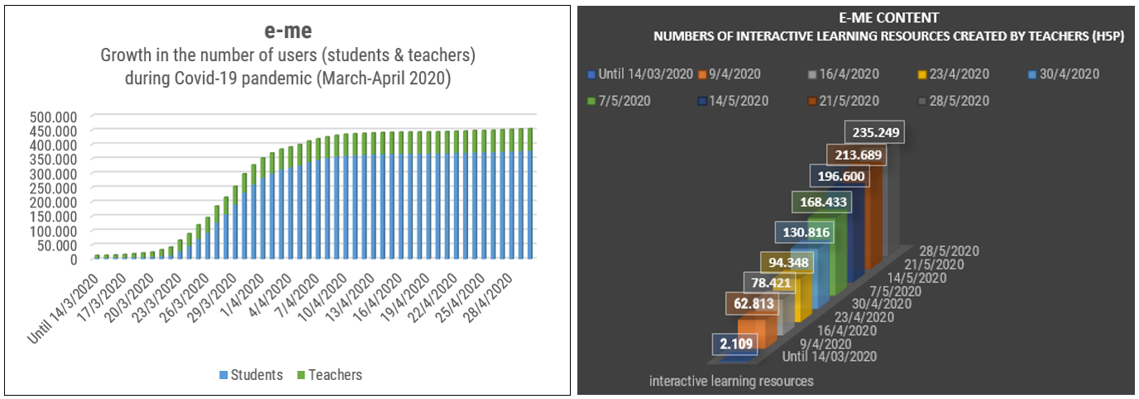
Figure 3: Growth in the number of e-me users and e-me content resources created (Mar-Apr 2020)
Regardless of their limited prior experience, teachers became content creators and developed over 230,000 interactive learning resources using the H5P-based ‘e-me content’ app. In order to share good practices, guide each other, and exchange learning resources, they also created several open educational communities of practice in e-me (e.g. primary school teachers’ public hive hosts 1630 participants). Along with teachers, students developed digital literacy and participatory learning skills by creating their own hives, becoming co-creators of content, managing, thus, not only to cope with new teaching practices but also to view digital tools as informal learning tools for peer-to-peer communication and collaboration [27], trying to deal with their emotional, psychological, and mental stress generated by lockdown and social isolation.
Considerable rise in e-me usage raised issues of scalability that had to be quickly resolved. Users requested for higher performance and upgraded file storage capacity that urged e-me to triple its initial infrastructure, both in VMs (increased from 20 to 66) and in other computational resources (i.e. CPUs, RAM, disk space), as well as to improve and enhance e-me app features to meet additional user needs. Along with upgrading the system, e-me team provided systematic guidance to teachers and learners by creating teacher and student support material (guides, video tutorials etc.) and by activating helpdesk email, social media and phone services. We also experienced community-based training: teachers created numerous video tutorials for e-me to support each other. Understanding their need and acknowledging their effort, we quickly responded and launched the ‘e-me FROM all’ site (dschool.edu.gr/emefromall/), gathering and sharing all training materials created by teachers and learners for teachers.
Teachers discovered alternative ways of using e-me apps; they, for instance, used e-me assignments and e-me content for applying differentiated learning strategies by adjusting digital content and tasks to meet students’ differentiated learning needs, and even respond to learning disabilities. Members of the e-me community also contributed with remarks, suggestions that led to e-me upgrading its services, improving and extending its functionality to better fit users’ needs and requests. Indeed, e-me currently provides advanced notification options, upgraded features and further services for popular apps (e-me content, e-me assignments, hive wall such as hive member participation ready-to-use lists, new apps for team-work, new chat features, an updated infographic menu assembling all guidance material and further new, pedagogically-oriented guides, which have been embedded in e-me main workspace for users to easily navigate while actual use.

CONCLUSIONS / NEXT STEPS
The Covid-19 pandemic signified evolution of the e-me platform. Our experience of e-me large-scale use as a PLE sets an example on the benefits of these new generation learning environments in terms of their openness, personalization, customization, flexibility, social networking, which is a stimulator for innovative pedagogy. We look forward to documenting how e-me can foster future pedagogy innovation attained by empowering its members, both teachers and learners to contribute to a rather participatory culture of learning. With this premise, and based on e-me’s PLE framework, its fundamental design principles, and its constant evolution, e-me views innovation as the opportunity given to its members: (a) to take responsibility and self-regulate their own learning; (b) to adopt active participation roles within their own open educational digital communities; (c) to co-work and communicate in self-paced, social spaces to construct individual and socially-mediated learning; and (d) to become prosumers (a combination of being a consumer and producer) of ICT tools and technology-based methodologies, adjusted to their own educational needs so as to reach learning outcomes and multiple literacies.
All in all, despite overwhelming challenges and ‘vulnerabilities in education systems’ caused by the pandemic, new pedagogical practices, as also witnessed with e-me, have emerged concerning e-learning unfolding a broader need for flexible and resilient education systems.
ACKNOWLEDGEMENTS
The authors would like to acknowledge and thank the rest of the technical and pedagogical team who contributed to the e-me evolution: Chatzis, C., Galatoulas, M., Giakoumakis, D., Gialamas, A., Gouvalas, V., Kyrtsoni, A., Michailidis, H., Papadimitriou, I., and Schizas, T.
REFERENCES
- Stone, D. & Zheng, G., “Learning Management Systems in a Changing Environment”. In Handbook of Research on Education and Technology in a Changing Society, 2014.
- Basal, A., “Perceptions of ore-service English teachers towards the integration of an LMS into English language teacher education,” Journal of Technology and Teacher Education, vol. 23, no 4, pp. 485-507, 2015. Retrieved from https://www.learntechlib.org/primary/p/149917/
- McLoughlin, C. & Mark., L., “Personalised and self- regulated learning in the Web 2.0 era: International exemplars of innovative pedagogy using social software”. Australasian Journal of Educational Technology. 26. pp. 28-43, 2010. https://doi.org/10.14742/ajet.1100
- Mazman, G., & Usluel, Y., “The usage of social networks in educational context”. World Academy of Science, Engineering and Technology. 37, pp. 404-408, 2009.
- Buchem, I. Editorial for the special issue on personal learning environments. Journal of Literacy and Technology, 15(2), 2–13, 2014.
- Buchem, I., Tur, G., Hoelterhof, T., “Learner control in Personal Learning Environments: A Cross-Cultural Study”. Journal of Literacy and Technology, vol. 15, no 2, 2014.
- Castañeda, L., Tur, G., Torres- Kompen, R. and Attwell, G., “The influence of the personal learning environment concept in the educational research field: a 2010- 2020 systematized review,” Int. Journal of Virtual and Personal Learning Environments, vol. 12, no 1, 2022.
- Attwell, G., “Personal learning environments- the future of eLearning?,” ELearning Papers, vol. 2, no 1, pp. 1-8, 2007.
- Downes, S., “Learning networks in practice. Emerging technologies for learning, vol. 2, pp. 19- 27, 2007. Retrieved from https://www.academia.edu/2869500/Learning_networks_in_practice
- Chatti, M. A. “Toward a personal learning environment framework,” International Journal of Virtual and Personal Learning Environments, vol. 1, no 4, pp. 66–85, 2010.
- Martindale T., Dowdy, M., “Personal learning environments”. In Emerging technologies in distance education, Edmonton, Canada: UBC Press, pp. 177- 193, 2010.
- van Harmelen, M. Personal learning environments. In Proceedings of the 6th IEEE International Conference on Advanced Learning Technologies, pp. 815-816, 2006.
- Chatti, M., Jarke, M., Frosch-Wilke, D., “The future of e-learning: a shift to knowledge networking and social software,” International Journal of Knowledge and Learning (IJKL), vol. 3, pp. 404-420, 2007.
- Dabbagh, N., Kitsantas, A., Al-Freih, M., Fake, H., “Using social media to develop personal learning environments (PLEs) and self-regulated learning skills: A case study,” International Journal of Social Media and Interactive Learning Environments, vol. 3, no 3, pp.163-183, 2015.
- Fiedler, S., & Väljataga, T., “Personal learning environments: concept or technology?,” Intl. Journal of Virtual and Personal Learning Environments (IJVPLE), vol. 2, no 4, pp. 1-11, 2011.
- Yen, C.J., Tu, C.-H., Sujo- Montes, L. E., Harati, H., & Rodas, C. R. “Using personal learning environment (PLE) Management to Support Digital Lifelong Learning”, International Journal of Online Pedagogy and Course Design,9 (3), 13-31, 2019. doi: 10.4018/IJOPCD.2019070102
- Marín, V., Negre, F., Pérez, A. “Construction of the Foundations of the PLE and PLN for Collaborative Learning, Media Education Research Journal”, 42 (XXi), 25-43, 2014.
- Jonassen, D.H., Strobel, J., “Modeling for meaningful learning,” in Engaged Learning with Emerging Technologies. pp. 1-27, 2006. https://doi.org/10.1007/1-4020-3669-8_1
- Meier, E.B. “Designing and using digital platforms for 21st century learning”. Education Tech Research Dev 69, 217–220, 2021. https://doi.org/10.1007/s11423-020-09880-4
- United Nations. “Policy Brief: Education during COVID-19 and beyond”, 2020. Retrieved from www.un.org/sites/un2.un.org/files/sg_policy_brief_covid-19_and_education_august_2020.pdf.
- Hodges, C., Moore, S., Lockee, B., Trust, T., and Bond, A., “The difference between emergency remote teaching and online learning,” EDUCAUSE Review. 2020. Retrieved from https://er.educause.edu/
- Pokhrel, S., Chhetri, R., “A Literature Review on Impact of COVID-19 Pandemic on Teaching and Learning”. Higher Education for the Future 8 (i), 133- 141, 2021.
- Wang, X., Chen, W., Qiu, H., Eldurssi, A., Xie, F., & Shen, J. “A Survey on the E-learning platforms used during COVID-19”. In 11th IEEE Annual Information Technology, Electronics and Mobile Communication Conference (IEMCON), pp. 0808-0814, 2020.
- Megalou, Ε., Koutoumanos, Α., Tsilivigos, Y., Kaklamanis, C., “Introducing “e-me”, the Hellenic Digital Educational Platform for Pupils and Teachers”. In Proceedings of EDULEARN15, the 7th Intl. Conference on Education and New Learning Technologies. pp. 4858-4868, 2015.
- Megalou, E. & Kaklamanis, C., “Open Content, OER Repositories, Interactive Textbooks, and a Digital Social Platform: The Case of Greece”, in Proceedings of the END 2018 International Conference on Education and New Developments, pp. 2184-1489, 2018.
- Megalou, E. & Kaklamanis, C., “Photodentro LOR, the Greek National Learning Object Repository”, In Proc. of the 8th International Technology, Education and Development Conf. INTED2014, pp. 309-319, 2014. Retrieved from https://dschool.edu.gr/publications/
- Jones, I.D., Brady, G., “Informal education pedagogy transcendence from the ‘Academy’ to society in the current and post COVID environment,” Educational Sciences, vol 12, 37, 2022. https://doi.org/10.3390/educsci12010037

In Proceedings of EDULEARN22: 14th International Conference on Education and New Learning Technologies, Palma de Mallorca, Spain, 4-6 July, 2022. ISBN: 978-84-09-42484-9, doi: doi.org/10.21125/edulearn.2022

