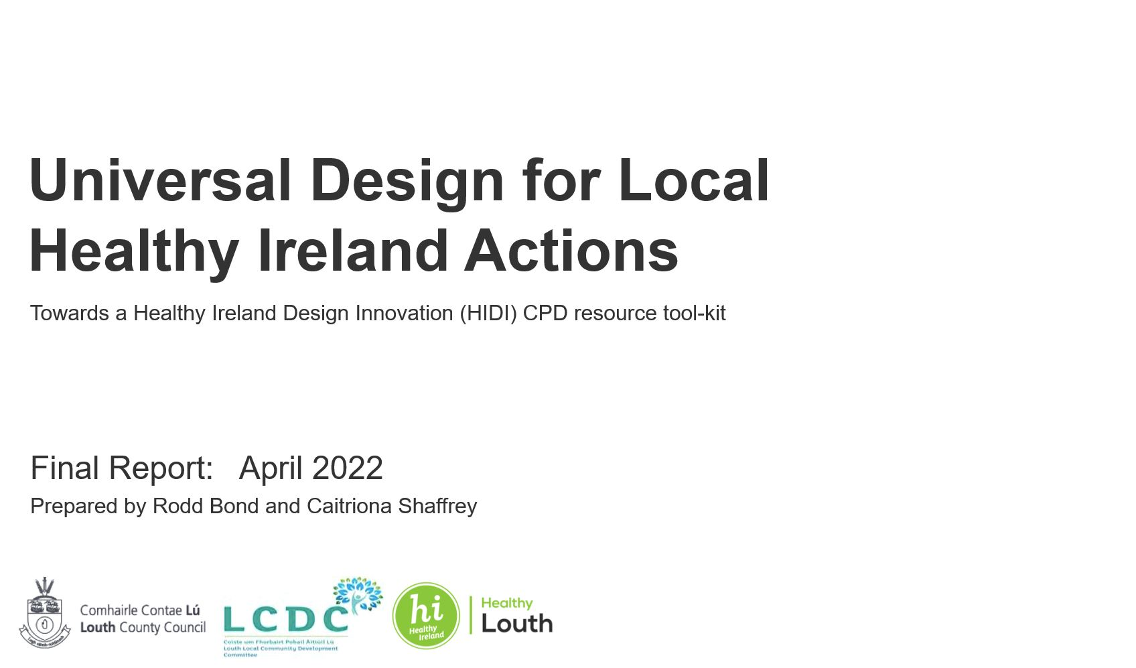

Contents
1 Executive Summary 4
2 Introduction 5
2.1 Context 5
2.2 Problem area 5
2.3 Project Elements 5
2.4 Programme Objective 6
2.5 Inclusivity, health and wellbeing in County Louth’s planning. 6
2.6 Local Economic and Community Planning 7
2.7 Working together 7
2.8 Universal Design – Principles and Goals 7
3 Preparing the HIDI Resource 10
3.1 Initial on-line survey/questionaire. 10
3.2 Focus Group 16
4 Designing the HIDI Resource 20
4.1 General Approach 20
4.2 Designing for Module 1: Principles 21
4.3 Designing for Module 2: Practices 22
4.4 Designing for Module 3: Processes 23
4.5 Designing for Module 4: Pathways 24
5 Trialling the HIDI Resource 25
5.1 The pilot implementation of the resource 25
5.2 The resources 25
5.3 Interaction at the beginning of the course delivery 26
5.4 Interaction at the end of the Module 1: Principles 27
5.5 Interaction at the end of the Module 2: Practices 28
5.6 Interaction at the end of the Module 3: Processes 29
5.7 Interaction at the end of the Module 4: Pathways 31
6 Evaluation and Future Steps 33
6.1 Feedback within session 33
6.2 Feedback from staff member after the course 35
6.3 Some reflections from the design and delivery team 35
6.4 Proposed improvements and next steps 36
7 Appendices 37
7.1 Survey Questions: 37
7.2 Digital Resource Locations. 41

Executive Summary

HEALTHY IRELAND DESIGN INNOVATION (H.I.D.I.)
A CPD programme to support universal design innovation for local Healthy Ireland strategies and action plans.
The overall learning objective of the HIDI training resource is to raise awareness, up-skill, and foster a deeper appreciation of Universal Design (UD) principles, design goals, and application guidelines across many areas of integrated local county and community development as they relate to promoting health and wellbeing for all. Recognising the important role of the social and physical environment towards positive health outcomes, the HIDI course should help support participants to understand, and undertake more inclusive local planning, design, alignment, implementation and delivery of the many actions within Local Economic and Community Plans (LECPs) that are oriented towards promoting, fostering and sustaining the health and wellbeing of all our citizens. The programme is aimed at, and co-designed with, a wide range of stakeholders across diverse disciplines. It is implemented as a series of 4 inter-related modules that are available on-line and can be completed over a half-day.
MODULE 1: PRINCIPLES. Module 1 provides an overview of the principles and goals of UD and how it fits within a range of local social and environmental policy and strategy development frameworks affecting health and wellbeing. It addresses; place and belonging, planning and design, health and well-being, universal design, drivers for change, addressing accessibility, legal and guidance frameworks and practicing UD.
MODULE 2: PRACTICES. Module 2 explores a wide range of application areas within domains addressed by LECP/HIDI objectives where UD practices can be applied. It addresses the questions of when and where can universal design be applied in the development and delivery of Local Economic and Community Plans, and healthy county plans.
MODULE 3: PROCESSES. Module 3 is to introduce the recently adopted standard IS EN 19161 2019 – and explore how it might be adopted within organisations involved in HI/LECPs so that their strategies and plan are Designed for All, and reach the widest range of people. This module is addressing the challenge of how Universal Design can inform all aspects of our planning, design, development and implementation processes.
MODULE 4: PATHWAYS/TOOLS. Module 4 provides an overview of the issues to consider, and some of the mechanisms available to teams and groups when bringing forward innovative solutions across the LECP/HI application spectrum. The module explores what tools and techniques are at our disposal to design inclusive environments and services that foster health and wellbeing and how do we channel conflicts as, and when they arise, into impulses for more inclusive innovation.
The draft on-line programme was piloted in early March 2022 within County Louth, and its resources are available to download. This report provides an introduction and rationale for the project and summarises the work involved in preparing, designing and trialling the resource. It evaluates the results gathered from the pilot trial and identifies a range of future adaptations and improvements that might be implemented to advance it’s wider delivery.

Introduction

Context
Much of the implementation of recent public policy strands in Ireland addressing inclusivity, sustainability, and health and wellbeing have been converging in objectives, action areas and tasks that comprise the Local Economic and Community Plans developed within the framework of Local Government planning and delivery. Universal Design is emerging as an inclusive approach to innovative environmental, product and service design that can guide practice, and that can underpin the development, delivery and evaluation of outputs that span the needs of all citizens in the many dimensions of their lives that fall within the influence of local government actions. Inclusive design is not just for children, families, older persons, or persons with physical and/or intellectual disabilities, it’s for everyone, being together, and sharing place.

Problem area
To-date, universal design guidelines sit alongside many other design resources, guidelines and toolkits from statutory agencies, advocacy groups and specific providers, carrying various levels of regulatory reinforcement, subject/domain authority, or under-pinning evidence bases. This diverse milieu of information provision (and the variability of application within UD guides) makes it difficult for service planners, designers, developers and assessors to approach universal design from a common perspective and to achieve a consistency of application approach across the various domains of action within convergent Healthy Ireland and LECP action areas. There is a growing need for a synthetic resource that can draw these approaches into a more unified framework that can make it easier for local authorities and their professional partners of work together in delivering a healthier and more inclusive environment.

Project Elements
To address this unmet need, HIDI (Healthy Ireland Design Innovation), was proposed as a continuous professional development (CPD) universal design resource and toolkit to support Healthy Ireland Actions in Local Economic and Community Planning. The key activities and organisational requirements for the project have included:
- Governance: to ensure that the voices, inputs and directions of the many relevant stakeholders are taken on board in shaping the development, content, design and delivery of the resource.
- Research: to ensure that the resource is based upon the most up-to-date information sources, including user needs, attitudes and practice surveys, current reference materials, and relevant evidence bases.
- Design Development and Pilot Testing: to ensure that the resource/tool-kit is appropriately designed and organised to be successfully delivered in the diverse operating contexts of relevant stakeholders.
As a result, the project developed through phases of preparation, designing, piloting and evaluating the draft programme. While originally conceived to being developed over the period of 2020/2021, the disruptions caused by the COVID-19 pandemic significantly affected the project’s delivery schedule. Over the period, face to face meetings were no-longer possible so the project activities, its resources, and its delivery, have been implemented through digital and on-line channels.

Programme Objective
The overall learning objective of the HIDI training resource is to raise awareness, up-skill, and foster a deeper application of Universal Design (UD) principles, design goals, and application guidelines across many areas of integrated local county and community development as they relate to promoting health and wellbeing for all.
Recognising the important role of the social and physical environment towards positive health outcomes, the HIDI course should help support participants to undertake more inclusive local planning, design, alignment, implementation and delivery of the many actions within Local Economic and Community Plans (LECPs) that are oriented towards promoting, fostering and sustaining the health and wellbeing of all our citizens.
The programme is aimed at, and co-designed with, a wide range of stakeholders across diverse disciplines. It is implemented as a series of 4 inter-related modules that are available on-line and can be completed over a half-day.

Inclusivity, health and wellbeing in County Louth’s planning.
The vision for Louth within The Louth County Development Plan 2015-2021 (LCDP) is to be a place -
“where people want to live, work, visit and invest now and in the future, - that is well planned, well managed, safe and inclusive - and that there exists equality and opportunity for all.”
This vision of a prosperous and thriving county where ‘no individual or social group is excluded from the benefits of development’ is being pursued through a planning process undertaken in close partnership with community stakeholders.
Amongst 11 strategic objectives set out in the plan, objective 7 sets out to:
“acknowledge the complimentary role of the Local Economic and Community Plan (LECP) … which will be an integrated strategy designed to promote social inclusion at all levels of society within the county. Encourage and support the development of inclusive communities that engage and include all members of society facilitating equal physical, social and cultural access and integration.’
The Council endeavours to ensure that all it’s policies and objectives are fully inclusive. These span the council’s buildings and services, facilitating and promoting rural transport, facilitating the provision of small scale enterprise start-ups, encouraging the provision of suitable and appropriate accommodation for all (in keeping with Louth’s age friendly ethos), ensuring that new initiatives do not decrease local community access to services through cost or location, seeking to target anti-racism and promote inter-cultural solidarity, and to support the implementation of the National Action Plan for Social Inclusion. The LCDP also recognises the built environment as a determinant of health and well-being in its support for physical activities and behaviours - particularly walking and cycling - promoting both tourism and the quality of life (QoL) for local communities.

Local Economic and Community Planning
The community section of Louth’s Local Economic and Community Plan (LECP) sets out 6 integrated priorities (and outcomes) addressing job creation (improved employment), access to education and skills development (greater participation), empowering inclusive communities (fewer people experiencing consistent poverty), health and wellbeing (confident, healthy & resilient communities), entrepreneurship, innovation and enterprise (thriving resourceful urban & rural economies), and a valued, sustainable and connected environment (connectivity and future sustainability).
Within the LECP, the community section establishes 8 goals, 29 objectives and 189 actions. Of these, over 50 actions, spanning all 8 goals, represent opportunities to apply universal design (UD) approaches to issues such as access to information, access to user friendly services, shared places and spaces, safety, equality, diversity, housing, quality standards, participation, empowerment and inter-generational solidarity. Quality of life (QoL) for all - physical, mental and emotional health and well-being across the life-course from cradle to grave, - is a common thread and ambition for all these activities, both individually and as an integrated action agenda.

Working together
The delivery of these actions call on more than 20 organisations (not including members of their extended networks – i.e. schools etc) to cooperate and work together in different combinations and leadership models, to make this diverse, though converging, change happen. Beyond these core stakeholder groups, other environmental professionals, consultants, citizen groups, regulators and evaluators play varying roles in informing, designing and implementing resultant projects. Across this resource base, the local authority, and its administrative and technical staff, play the central role to frame plans, coordinate actions, assure quality and monitor progress.

Universal Design – Principles and Goals
Originally set out in 2001 (Kose et al. 2001), universal design goes beyond the issue of physical accessibility and promotes a more integrated approach to design which is framed in the 7 internationally established Universal Design principles - equitable use; flexibility in use; simple and intuitive; perceptible information; tolerance of error; low physical effort; and size and space for approach and use.
To help facilitate the application of these principles into environmental design, Steinfield and Maisel (2012) have translated them into a framework of 8 goals. As noted by CEUD, these goals are more oriented towards health and wellness, human functioning, and social participation, and as such, align closely with the wider health and inclusivity objectives within the LECP. They address:
- Body fit – accommodating a wide range of body sizes and abilities
- Comfort – keeping demands within desirable limits of strength and stamina
- Awareness – insuring that critical information for use is easily perceived
- Understanding – making methods of operations and use intuitive, clear and unambiguous
- Wellness – contributing to health promotion, avoidance of disease and prevention of injury
- Social integration – treating all groups with dignity and respect
- Personalisation – incorporating opportunities for choice and the expression of individual preferences
- Cultural appropriateness – respecting and reinforcing positive cultural values and local context.
Beyond people interacting with the physical environment at micro, mezo and macro scales, universal design can also provide a wider framework to guide public service design, and underpin efforts towards addressing the three pillars of the UNECE Convention (The Aarhus Convention - 1998) on
- access to information,
- public participation in decision-making, and
- access to justice in environmental matters.
UD can also animate, and underpin, creativity in the development and delivery of social innovations within the community and social enterprise sector. As noted in the Invitation to Tender, ‘inclusive design is not just for children, families, older persons, or persons with physical and/or intellectual disabilities, it’s for everyone, being together, and sharing place’.

‘Within the County Louth LECP, the community section establishes 8 goals, 29 objectives and 189 actions. Of these, over 50 actions, spanning all 8 goals, represent opportunities to apply universal design (UD) approaches to issues such as access to information, access to user friendly services, shared places and spaces, safety, equality, diversity, housing, quality standards, participation, empowerment and inter-generational solidarity. Quality of life (QoL) for all - physical, mental and emotional health and well-being across the life-course from cradle to grave, - is a common thread and ambition for all these activities, both individually and as an integrated action agenda.’  The table shows a breakdown of the current LECP highlighting action areas where UD application and practice might be relevant. | 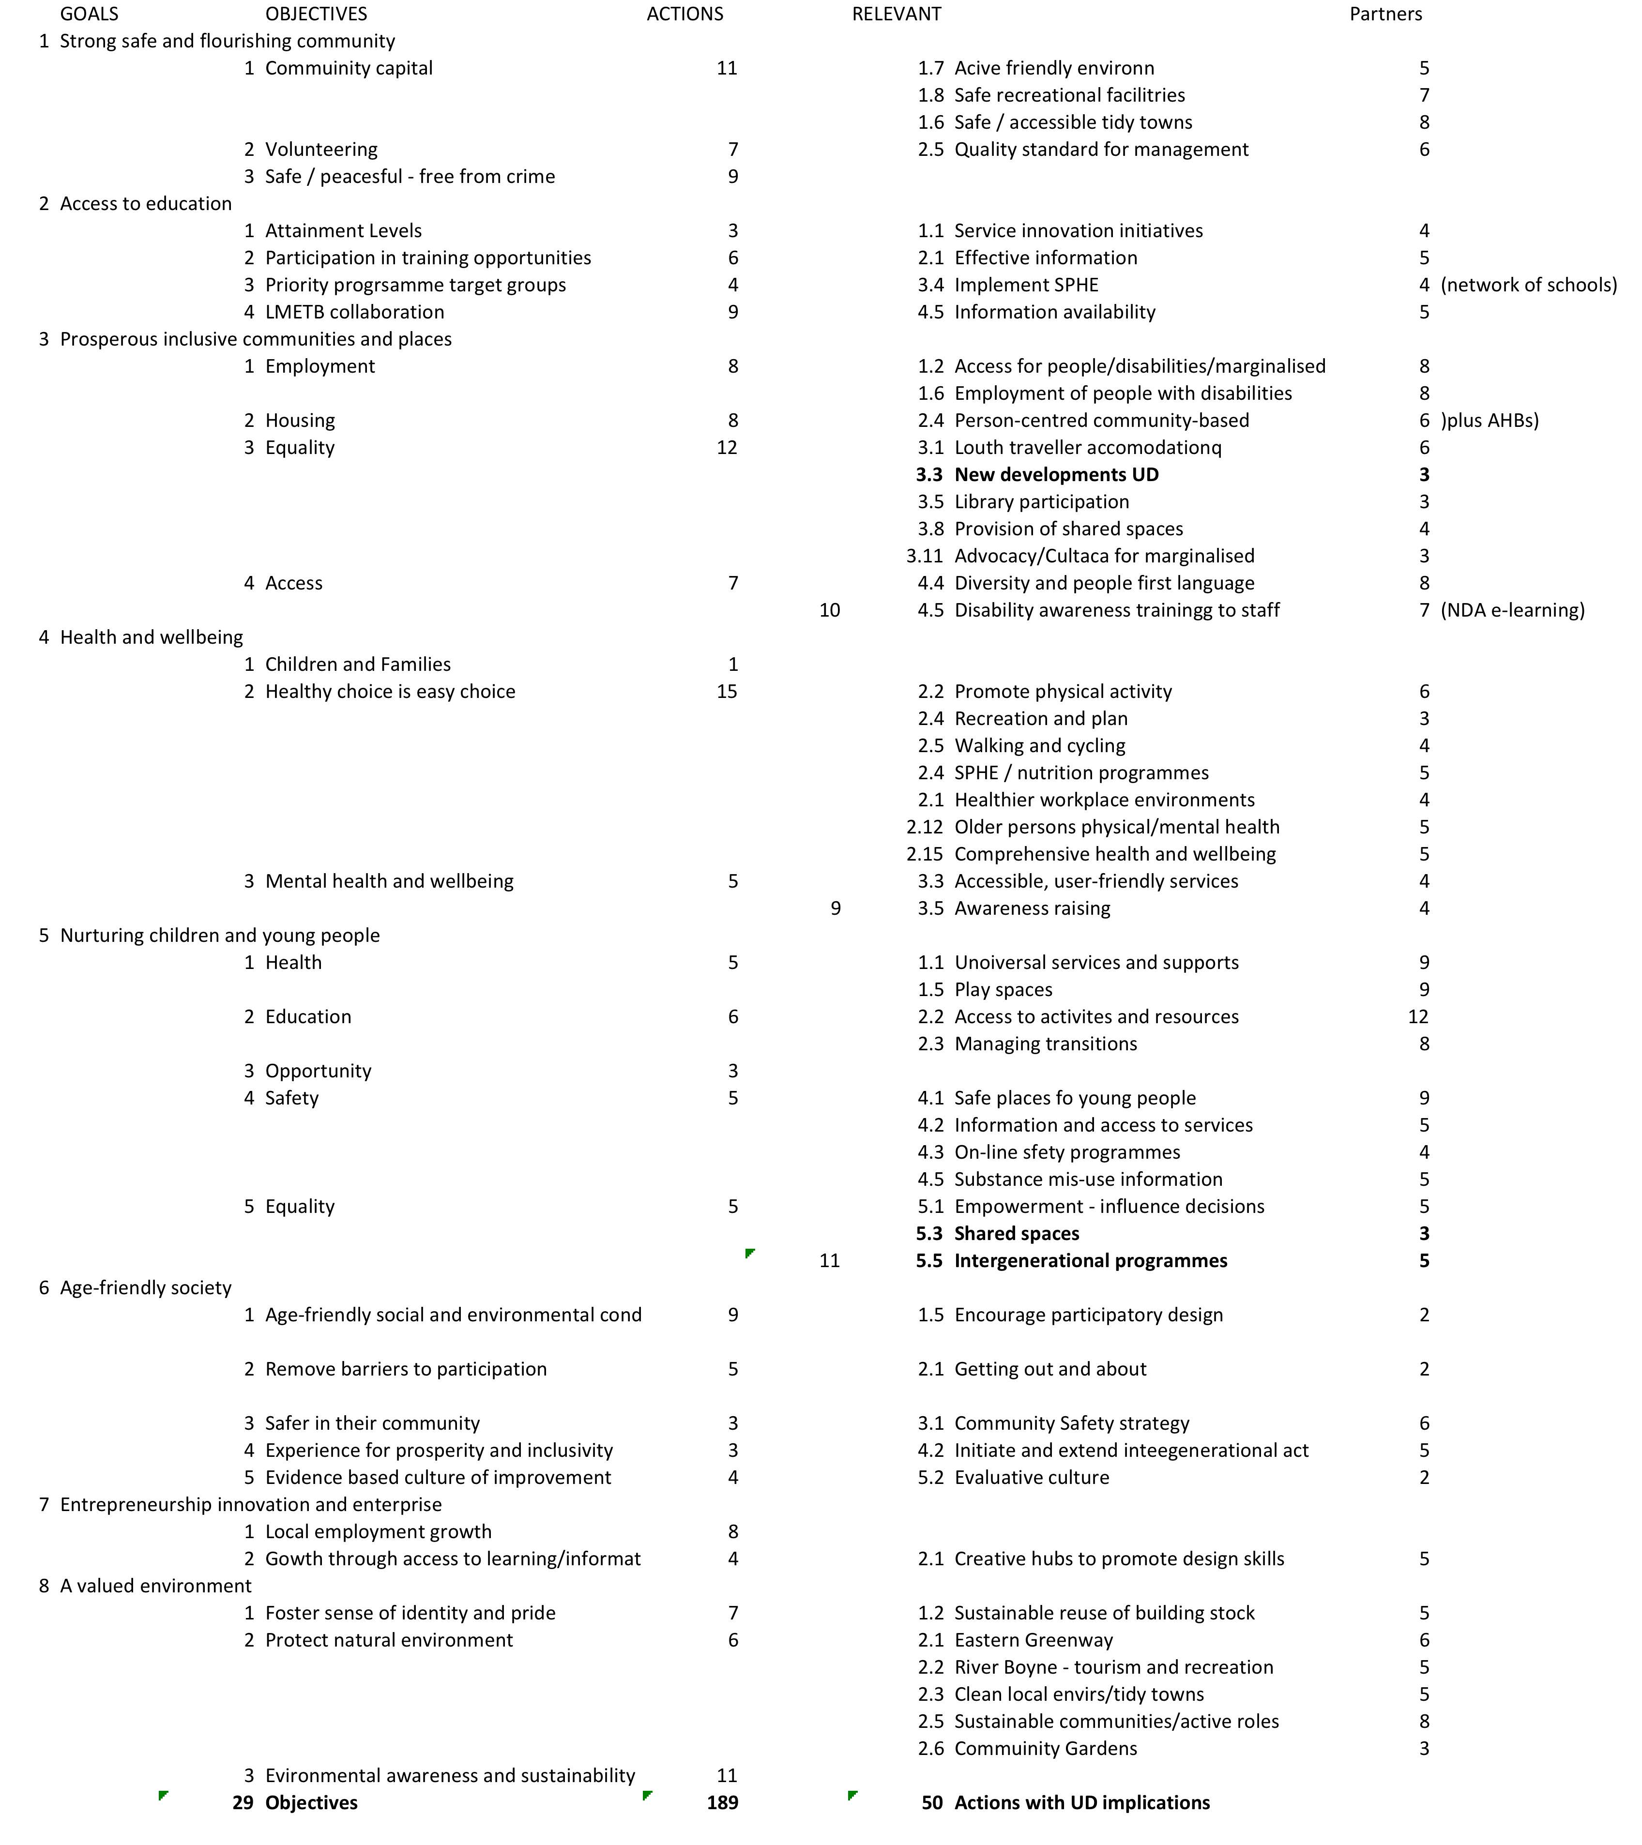

Preparing the HIDI Resource
Along with reviews of several core Universal Design reference and guidance documents, the two primary input sources into the design of the HIDI resource were an online survey with potential participants and a focus group with a selected group of stakeholders either directly or indirectly involved in Healthy Ireland actions in County Louth.

Initial on-line survey/questionaire.
A questionnaire was prepared to glean an initial understanding of the current levels of Universal Design (UD) awareness, and training needs for a range of targeted participants in the training programme. A copy of the survey questions are included in appendix 6.1. The results of the survey are contained in the project dropbox file.
The survey comprised 13 questions and was completed by 26 respondents – 22 from the Local Authority and 4 from local NGO/CSOs. Overall, about 25% of respondents had some earlier training or awareness of design for accessibility or UD.
Q2: What is your role(s) in the organisation ? | 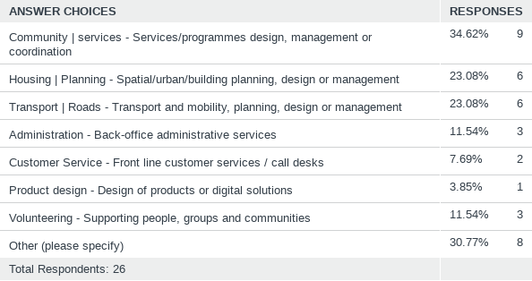  A broad mix of interests and activities – spanning social (community / administration / volunteer support) - and environmental (housing / planning / transport/roads)  ‘Other’ added context such as– arts, libraries, projects, regeneration, water services
Q3: To which local community goals and objectives are your work activities mostly directed towards ? | 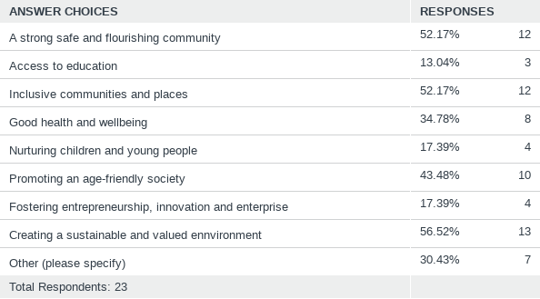  Many people involved in multiple goals simultaneously  Role of other stakeholders – education, children, enterprise under allocated  Others: Adding context or more environmental – housing / roads/pavements
Q4: What aspect of peoples' experiences in our community does your work relate towards ? | 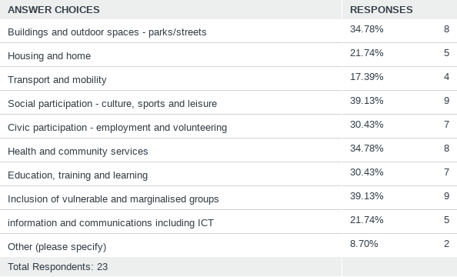  Generally, an even spread across 8 WHO Age-friendly community themes – (plus education / learning)  Other: Issues of bio-diversity, environmental quality for good air / good nutrition
Q6: Which, if any, of the key principles of UD are most relevant to your work ? | 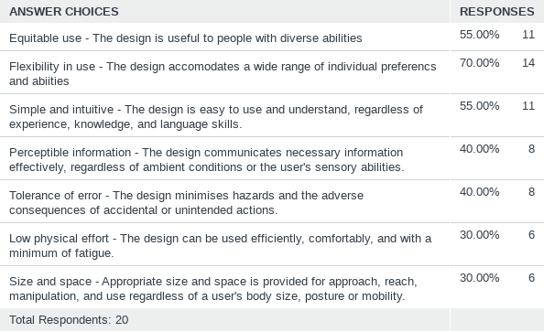  Not sure if low mark for ‘physical effort’ and ‘size and space’ is about ‘relevance’ or maybe lack of clarity about these principles ? Should address in resource.
Q7: Which, if any, of the following key goals of UD are most relevant to your work ? | 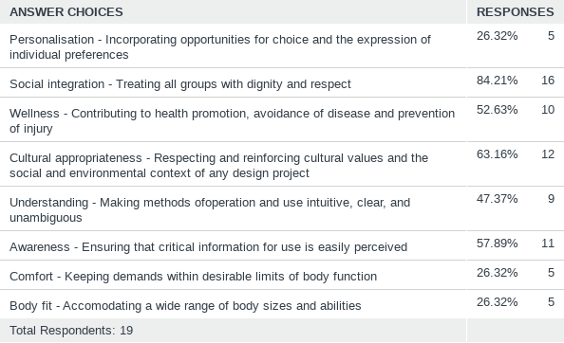  Interest in social groups against low response for personalisation (people v person ?)  Again, not sure if low mark for ‘comfort’ and ‘body fit’ is about ‘relevance’, or maybe lack of clarity about the intention and impacts of these goals ? Should address in resource.
Q8: Which, if any, of the following factors do you consider to be a barrier to the wider adoption and application of UD ? | 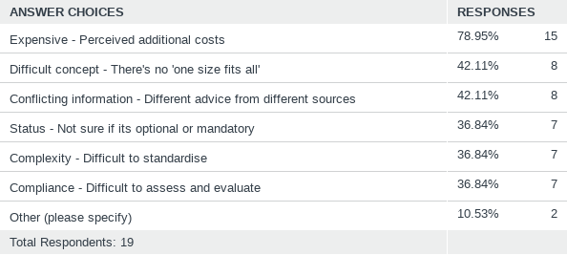  We will need to explore cost/benefit analysis and monitising social value over a life-cycle.  How is it financed - public provision / partnership / privately ?  Other – complexity of issues to be considered when designing ?
Q9: Which of the following UD application areas would be most relevant to you in your work ? (Please rank in order of importance). | 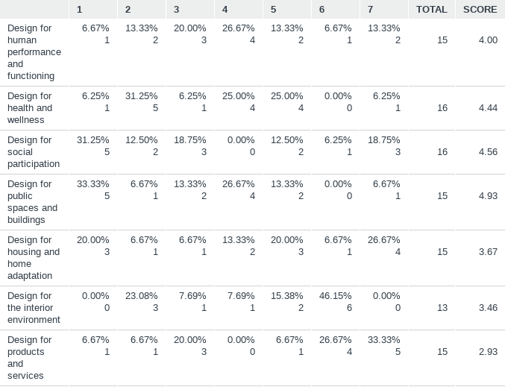  While balanced interest across areas, impact of built environment and public realm (shared spaces) still prevalent.
Q10: Which, if any, of the following ancillary topics would be helpful  in fostering the broader adoption of UD in your work ? | 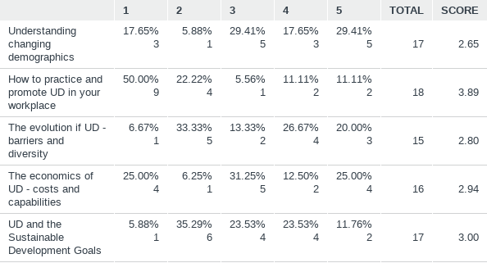  No very pre-dominant ancillary topic but strong interest in howe to practice and promote UD in the workplace. ( Relevant to the new Design for All standard).
Q11: In which of the following business/functional areas do you envisage applying your future knowledge of UD principles, goals and approaches ? | 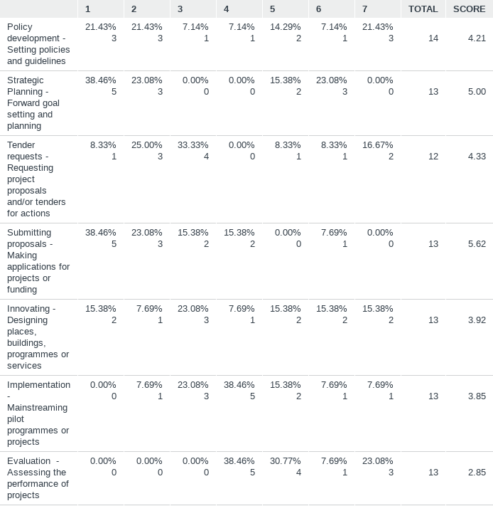  Anticipate learning will be used across many functional areas, particularly accessing finance for project proposals.
Q12: How much time would you be prepared to allocate to a UD training course ? | 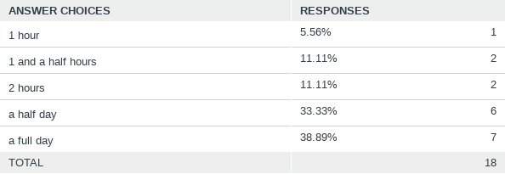  People seem committed to investing time in the programme. While there would certainly be content for a day – it may be more prudent to plan for a half-day (morning) programme.

Focus Group
The analysis of the on-line questionnaire helped shape a focus group of 9 stakeholders (7 from LCC and 2 from NGOs). Due to COVID restrictions the focus group was held on-line on ZOOM in September 2021. The discussion looked at 8 topics for consideration and the general approach to the discussion was to explore what was positive? what was problematic? And how can the area be improved ?. The discussion on each topic lasted between 10 and 20 minutes.
Understanding Universal Design ? | Universal Design | Accessible Design | Design for All | Barrier-free-design | Inclusive design | Trans-generational design.?  The group considered the positive aspects of a universal design approach ( - design for all, inclusivity, opportunity for people of different abilities to share, connect and be together).  The group thought that key problem areas associated with the concept and approach of universal design that impinge on its wider adoption were its additional cost, and the risk that it points to sense that ‘one size fits all’. While this is not the case, it’s a perception that needs to be constantly addressed.  The group thought that the HIDI resource might improve UD understanding and foster wider adoption if it could show how it’s being used in good practice it many areas of application – and if it could demonstrate good/better outcomes.
The new demographics ? | Societal ageing | Population mobility and migration | Population disability ?  The group discussed which of the emerging demographic trends in Co Louth – across different demographic groups we’re good at serving. (strong tradition in addressing disabilities / strong momentum for addressing ageing)  The group were keen to look beyond disability and ageing – and to explore if we are adequately inclusive of people permanently or temporarily vulnerable and at risk of weak social participation ? (Caregivers/dependents – psycho-social conditions - behavioural (alcohol/drugs), minorities/ethnic groups - dislocated/remote accessibility - abused/homeless)  It was thought that while CSO data is very good – that we don’t always have the right information at the right level to plan – and that we need better data and evidence. We need more awareness and skills to be able to balance a universal approach alongside specific approaches to groups that have distinct/specialist needs and relationships. (Also - a sense that we’re not encouraged or supported to take longer-term / lifecycle perspectives – and tend to be more siloed and short term focussed)
Universal design as innovation and creativity ? | Beyond rules, regulations, instructions and constraints. ?  In shifting thinking from compliance to innovation, the group reflected on some of the key enablers we have in County Louth that can help foster and promote inclusive innovation. (i.e. Champions / resources / investments / persuaders etc ) Although there is room for improvement, it was thought we are well positioned here in County Louth to progress.  The group considered some of the barriers towards take-up and adopt that were facing, and that are inhibiting success. There seems to be a lack of consistency and commitment across the different hierarchies of government from local to regional and national – and across different sectoral agencies.  In considering what types of resources do we need to accelerate and sustain diffusion – greater participation and co-design and collaborative working were highlighted.
The people and persons were thinking about ? | Similarity and diversity - Designing ‘with’ people rather than ‘for’ them. ?  In relation to aspects of human performance and functioning (Body size/shape/ability – effort expended to do things – perception – cognition etc ?) - the group considered that physical accessibility is well understood (even if addressing it is ad hoc) but that we have a blind spot for issues around perception and supporting people with cognitive issues might be weak. (situations where the a person’s challenges or capability deficits are less visible).  Beyond addressing physical/sensory disability and ageing – there maybe areas of concern that we might be loosing sight of(Mental well-being - ID / Autism / Brain injuries – and their varied lived experiences between home, community and work)  Can we avoid layers of specific standards/guidelines – or does UD provide an envelope for being integrated and wholistic ? (How can HIDI address these challenges effectively ?).  The focus of HIDI should be to put a framework around these layers of standards and guidelines – rather than to simplify or synthesise them. CEUD is doing a piece of work on this (comparisons between different guidelines and standards) and can be added to the resource when available.
Designing for health and wellness ? | From protection and prevention to promotion and empowerment?  The group felt that the dimensions of the Healthy Ireland agenda we are addressing well in County Louth today included physical activity, recreation, promoting more walking and cycling.  Healthy Ireland actions that could benefit from a greater awareness and application of Universal Design thinking might include support for better diet and nutrition, and healthier workplaces and workspaces.  When considering gaps that exist that we should prioritise, and how might we improve the application of UD when designing and delivering HI actions, it was thought that the end-to-end chains between service providers and partners could be better identified, understood and managed.
Designing for social participation ? | Social inclusion | rights | social justice | exclusions  The primary social inclusion framework/programme for inclusivity and participation is SICAPS where the programme has two goals that focus on supporting communities and individuals:  - to support communities and target groups to engage with relevant stakeholders in identifying and addressing social exclusion and equality issues, developing the capacity of local community groups and creating more sustainable communities  - to support disadvantaged individuals to improve the quality of their lives through the provision of lifelong learning and labour market supports  There are opportunities to raise UD awareness to stakeholders involved in this programme to remove barriers to social participation and to foster more positive inter-personal interaction, and people fulfilling their potential. (Knowledge & awareness - social attitudes - technical guidelines - social distance)  HIDI could promote some strategies that focus on enhancing social inclusion through greater participatory mechanisms. (Issues for consideration include: Interpersonal distances - access to resources – de-segregation and clustering - de-institutionalisation - participatory design ? )
Housing and homes | Promoting UD for new homes and home modifications ?  With GNH, awareness seminars, and subsequent projects, County Louth has promoted positive initiatives and actions that are fostering the growth of UD in new home building in County Louth. Apart from funding, the main barriers that are holding back the wider adoption and provision of UD homes in County Louth are strengthening the buy-in of private sector developers.  In relation to home adaptation, a primary channel (both motivational and financial) is in the area of thermal comfort and better energy usage as part of climate action – and it was thought that where appropriate, there could be some opportunities to promote UD adaptations as part of modification works associated with energy upgrades.
The Public Realm | Accommodating the public in shared spaces ?  County Louth is doing OK in relation to developing the inclusivity of our shared / public spaces, and buildings used by the public (Sense of place – parks/landscaping – streets – plazas/squares – transport/mobility/parking – seating – lighting – wayfinding – safety ?)  Some of the difficulties in achieving public realm improvement that are positive for all are dealing with conflicting and lack of consistency between standards (Ie. Conflicts between needs across diverse capabilities – integrated design etc ? ). The AFI training on Public Realm is a valuable resource and HIDI should be able to compliment it.  We need to be able to make public realm improvements easier to design, deliver and sustain. This might involve some or all of the following: Ie. Partnership with private sector - DMURS-UD alignment – stronger sustainable neighbourhoods with integrated climate actions/bio-diversity ?

Designing the HIDI Resource

General Approach

The general approach to designing the resource was to organise it into 4 inter-related modules that could be delivered in a ½ day programme. The modules would each be about 45mins, allowing time for interactive work, and would address:

- Principles
- Practices
- Processes
- Pathways.

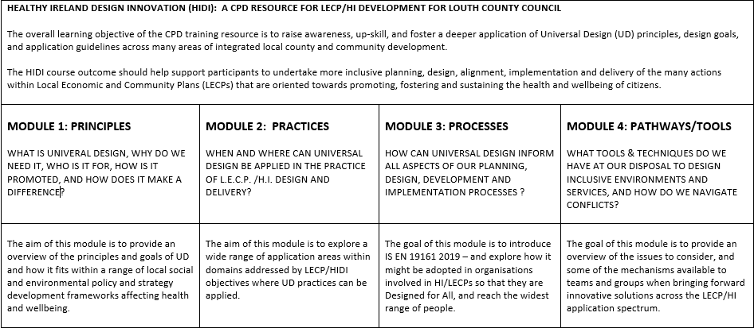

Designing for Module 1: Principles

Module 1 would address the ‘what | why | who | how | where | and when’ of UD. The index to the module content is as follows:
Local Planning:  - UD in the current LECP/HIDI plan actions  - UD awareness amongst stakeholders  Place:  - Barriers and functioning  - Evolution, adaptation / ‘fit’  Health and Wellbeing:  - Intrinsic abilities  - Environment  - Interaction  - Capabilities and choice  Design:  - The physical environment  - The social environment  - Design quality - Strength / utility / beauty (function / form)  - Function, form, economy, time,  - Social relationships (concepts)  Defining Universal Design:  - Universal design principles  - Universal design goals  - Accessibility - The 5 A’s | Understanding human functioning (WHO Model):  - Functioning (mobility / sensory / cognitive)  - Activity and participation  - Environment  Good fit: ISO: Guide 71  - Understanding needs/requirements  - Understanding features/characteristics  - Getting a good match – for now and into the future  - Managing diversity – (for as many as possible)  Innovation and SDGs (no one left behind)  - Urbanisation  - Globalisation  - Climate  - Demographics – ageing (globally /locally)  Legal and guidance frameworks:  - UN declarations  - European/directives legislation  - National regulations and sectoral frameworks  Practicing UD  - UD as innovation  - UD as customer service  - UD in procurement  - Increasing adoption/communication | 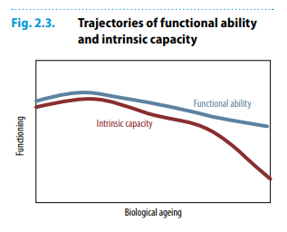

Designing for Module 2: Practices

Module 2 would address the primary universal design application areas for inclusion and equality. The index to the module content is as follows:
Design for inclusive human performance  - Body fit – anthropometry  - Comfort – bio-mechanics  - Awareness – perception  - Understanding – cognition  Design for Inclusive Health and wellness  - Dimensions of health and wellness  - Injury protection and prevention  - Disease prevention  - (Low resource/remote settings)  - Mental health  - Design for H&W guidelines  Design for Social Participation  - Social construction theory  - Interpersonal interaction  - Interpersonal distances  - Access to resources  - Segregation and clustering  - De-institutionalisation  Design participation UD and the Interior Environment  - Wayfinding & signage  - Acoustics  - Lighting  - Colour  - Furnishings  - Floor finishes and coverings | Accommodating the public  - Access routes and rights of way  - Intersections  - Site circulation  - Site topography  - Parking  - Parks/playgrounds  - Seating and street furniture  - Shared Surfaces  - Building entry  - Space planning/movement  - Ramps and stairs and lifts  - Toilets and restrooms  - Business practices /customer services  - Compliance/certification  Product design  - Furniture  - Appliances  - Devices  - Assistive technology  Web Accessibility  - Perceivable  - Operable  - Understandable  - Robust | 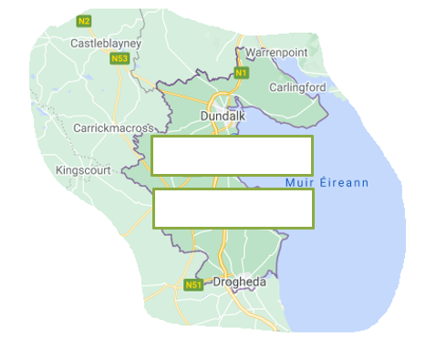

Designing for Module 3: Processes

Module 3 would look at processes and making an organisation ready for – Design for All. The index to the module content is as follows:
Design for All - scope / outcomes:  - Products,  - Goods ,  - Services,  - Extending the range of users  Overall management of approach:  - Design for All Framework  - Components  - Improvement: PDSA/PDCA  Key Terms/definitions  Context of the Organisation  - The Organisation and Context  - The needs and expectations of interested parties  - Determining the scope of DfA/UD  - Integration with established process systems  Leadership  - Leadership and commitment  - Policy  - Organisational roles, responsibilities and authorities | Planning  - Actions to address risks and opportunities  - Objectives and planning  - Planning for changes  Support  - Resources  - Competence  - Awareness  - Communication  - Documented information  Operation  - Planning and control  - Design and development  - User involvement  - End-to-end chains  - External suppliers  Performance evaluation  - Monitoring and measurement  - Internal audit  - Management  Improvement | 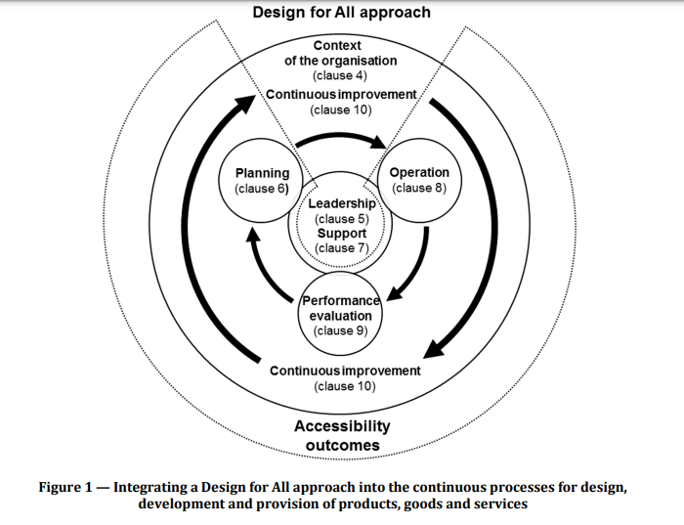

Designing for Module 4: Pathways

Module 4 is targeted at tools and techniques to implement Universal Design. The index to the module content is as follows:
Sensory/cognitive building blocks:  Sight/visual:  - Light / dark – brightness  - Colour – range / palette /  - Foreground/background contrast  - Shine / reflection  - Linear, area and volumetric shapes / spaces  - Size and dimension  - Reading – fonts  - Icons / images / pictures  Hearing:  - Sound / tone, volume, pitch  - Speech / music  - Noise / echo / white noise  - Sounds from nature – water/wind/birdsong  - Rhythm / tempo  Touch/Feeling:  - Temperature – warmth / cold  - Ventilation – humidity / freshness  - Texture – rough / smooth  - Even – uneven  - Gradients / levels / smoothness / roughness  - Scent / aroma / odour  - Nature / landscape | Comprehension:  - Clarity / ambiguity  - Simplicity / complexity  - Coherence / understanding  Mobility and strength: (CFD)  - Upper body lifting / reaching / turning  - Squeezing, holding, pouring  - Lower body – transferring from chair/bed  - Walking, balancing  Working with Guides  - Roadmap - HA Designing Housing to Meet the needs of all.  - DMURS and accessibility  Innovation v Regulation  - Conflicts  - Users and co-design  - Evidence and experiments  - Life-cycles – costs/benefits  Whole System thinking  - Social, Environmental  - Experiences – person-centred  - Physical, mental health  - Place – meaning/purpose | 

Trialling the HIDI Resource

The pilot implementation of the resource

With a dependency on delivering the programme on-line due to COVID-19, the delivery design was centred on using the ZOOM video-conferencing platform. To enhance the interactive experience, the real-time mentimeter interactive presentation tool was integrated into the zoom sessions to support a mixed media experience. For this to work well, participants were advised in advance to use both a laptop/tablet for the zoom presentation, and their mobile phone for interaction with the menti-app. Generally this worked well. There was an internal technical hiccup (ICT availability) on the originally planned morning for the pilot training and the programme delivery was rescheduled to a fortnight later.
The session was planned to run for 3.5 hours from 9.30 to 13.00. The agenda timing was as follows:
- Start / introduction: 9.30 – 9.35
- Module 1: Principles: 9.35 – 10.20
- Module 2: Practices: 10.20 – 11.05
- Break: 11.05 – 11.20
- Module 3: Processes 11.20 – 12.05
- Module 4: Pathways: 12.05 – 12.50
- Final questions/finish 12.50 – 13.00
The 45min allocation for each module included a 10 minute period for interactive mentimeter questions. The attendance on the programme was 28 people for most of the period. The programme ran out to 1.15pm, and 8 or the participants had to finish and log-out at 13.00 promptly. At the start of the session, particpants were asked for, and they granted, permission to record the programme delivery

The resources
The following digital artifacts represent the resources developed for the programme: (access to these resources are currently shared between LCC and the authors). Appendix 2 provides the current URL locations of the resources.
- The module sides: 4 powerpoint files - one for each module located on the project’s shared Dropbox folder
- The menti surveys: The HIDI menti presentation is stored on the Mentimeter cloud server on the account of the author (PDF results on file)
- The recorded sessions: Recordings of the 4 module presentations – slides and narrative, stored on a local authority ‘We Transfer’ file location.

Interaction at the beginning of the course delivery

At the start of the session, before module 1, the following ice-breaker questions were asked on mentimeter. Rather than informing before and after attitudes and awareness, these were primarily included to give the participants a sense of the diversity of understandings and interests within the group.
What three things come to mind when you think about universal design ?  A broad range of ideas where suggested with a leaning tending towards:  - Access / accessibility  - Inclusion / Inclusive | 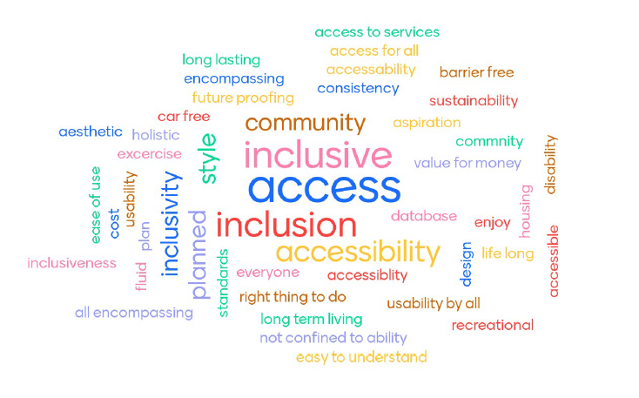
What three things come to mind when you think about people’s health and well-being ?  Again, a broad range of concepts were suggested with the following highlighted:  - Exercise (physical health)  - Work life balance  Awareness, quality of life and access to services were also mentioned. | 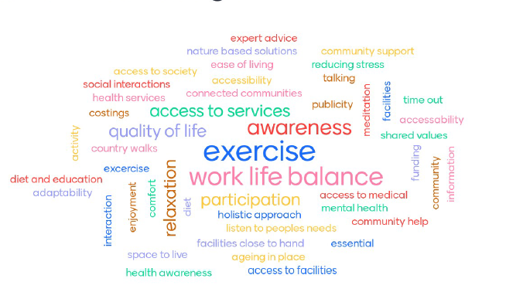
When thinking about Universal Design, to what extent do you consider it is targeted to benefit ?  While ‘universal’, participants considered it UD is targeted towards disabilities and then older persons, with considering it is for ‘everyone’. | 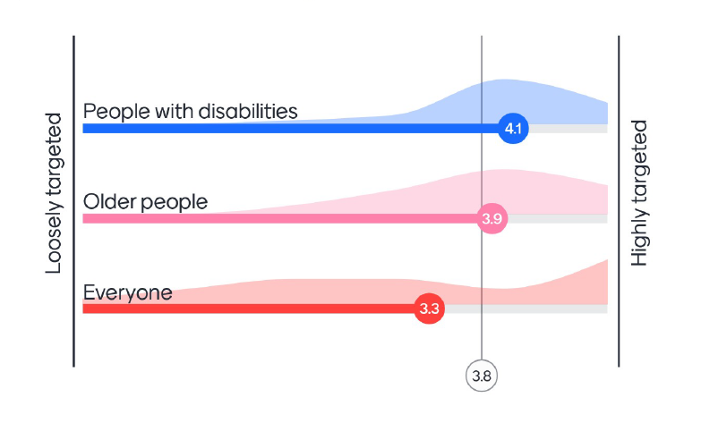

Interaction at the end of the Module 1: Principles

The following questions at the end of module 1 were not related to retention of content (the slides were available con-line) but were to encourage participants to reflect on the diversity and prevalence of disabilities across Irish society.
How would you rank the prevalence of different disabilities in Ireland ?  The results of a Disability Federation of Ireland (DFI) study found the following ranking. The participants ranked the highest prevalence third.  - 296,783 – Difficulties with pain, breathing or other chronic illness/condition  - 262,818 – Difficulties with basic physical activities  - 156,968 – Learning difficulty  - 123,515 – Mental health  - 103,676 – Deafness or serious hearing impairment  - 66,611 – Intellectual disability  - 54,810 – Blindness or a serious vision impairment | 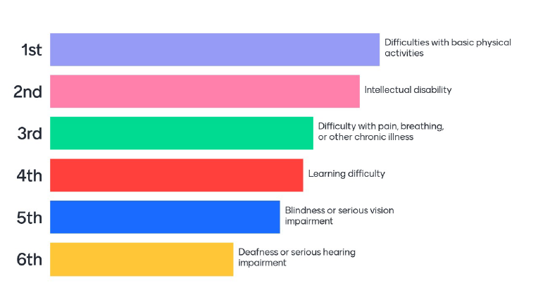
How would you rank the size of the distribution of disabilities across different age groups in Ireland ?  - 224,388 - 65+  - 182,554 – 45 – 64  - 123,638 – 25 – 44  - 59,086 – 0 – 14  - 53,465 – 15 – 24  The participants views aligned very well with the DFI study report. | 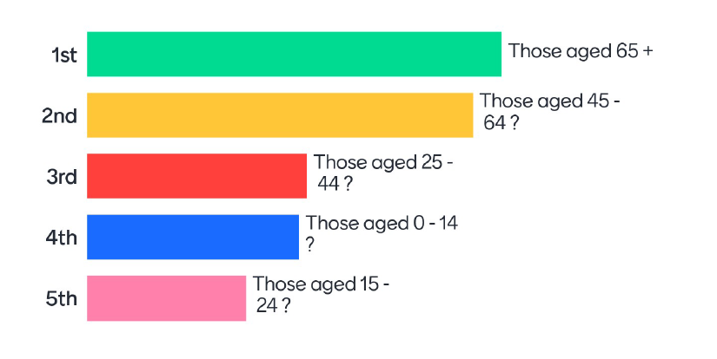
If Universal Design can establish a strong case for ‘value for money’, what other barriers do you think may limit its wider adoption ?  A wider range of barriers to adoption were suggested, but issues highlighted included:  - Lack of awareness  - Public perception  - Design  - Policy and  - Funding | 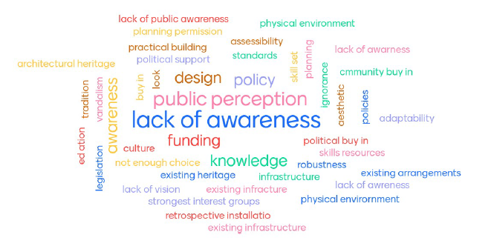

Interaction at the end of the Module 2: Practices

Following exposure to wide range of UD applications and practices, the interactive questions at the end of module 2 were oriented towards where the group might see their own practice, and that within the council, being directed.
On a scale of 1-5, which of these 3 statements would you consider to be most relevant to LECP/HI planning in County Louth ?  The tendency amongst participants was slightly more towards community oriented health and wellbeing and social participation, although individual human performance is also highly recognised. | 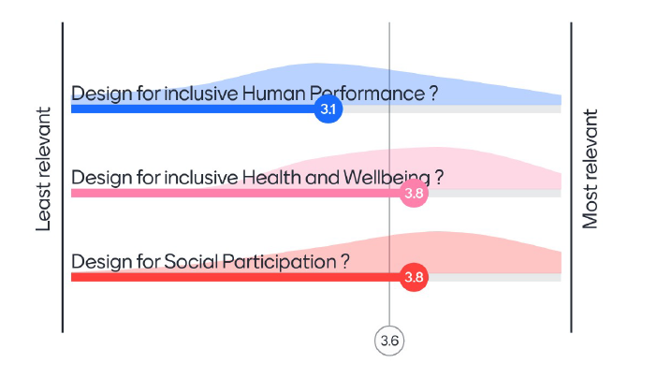
How would you rank these three headings in relation to having the most immediate benefit to the general community in Louth ?  Currently, the group did not prioritise digital services, and look more towards public space accessibility and greater participation in design activities. | 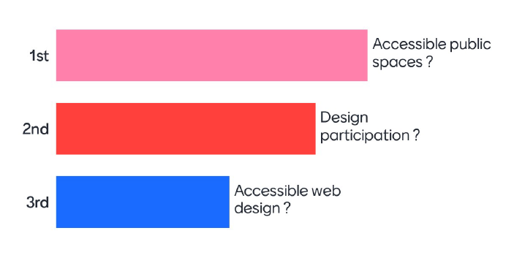
What accessibility feature do you find least successful (for you or someone you know) and how might you improve it ?  The participants highlighted a wide range of features that are currently causing difficulties. While many of the issues identified were in the domain of the public realm, participants did identify areas such as  - difficult to use computer applications  - sensory experiences in busy areas  - the contrast and scale of signage  - traffic build up around schools at busy times
  Level access / Changes in levels / at junctions / dished ramp access
  Cars parked on footpath - zero tolerance
  Computer applications which don’t work on screen readers
  Car parking spaces / lack of parking / Car parking spaces too small.
  Seating, not having arm rests to aid getting up and down / Benches need backs
  Sensory challenges in shopping centres
  Obstructions on paths
  Footpath accessibility - variance in towns - width.
  Access to services
  Colour change in surfaces and better promotion to improve
  Road crossings at traffic lights. Street furniture. Dog dirt.
  Poor design of crossing points for example the square Dundalk
  The red emergency cord in toilets, mistake it for the flush as it is similar to that in older continental toilets
  Small scale signage at bus stops
  Stair lifts in homes
  Too many cars around schools at busy times. Cheap bus fares and cycling facilities
  Lack of loop systems
  Councils laying new paving that is very slippery. Dots for visually impaired at crossings are very hard for people who are not good on their feet
  Poles, rails and lighting columns

Interaction at the end of the Module 3: Processes

With module 3 oriented towards the implementation of the Design for All standard (EN 19161:2019), the questions at the end of module 3 were related to the readiness, and barriers to readiness, to adopting and embedding a Design for All approach.
How would you rank the importance of the following organisational elements in achieving a Design for All approach throughout your organisation ?  Module 3 looked at the implementation of the new Design for All standard – EN 19161:2019. Participants considered that leadership and planning competencies where the most important organisational elements to develop when aiming to achieve a design for all approach. | 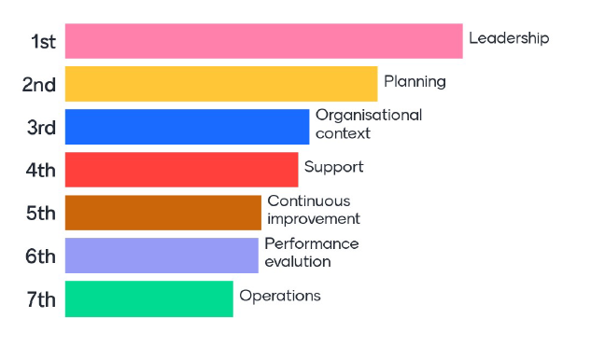
If applying a Universal Design approach to the improvement of a service you’re involved in, what might you like to achieve ?  When participants considered applying UD in their own service areas, a wide range of goals and objectives were identified.  Of particular interest was a goal of normalising the approach – so that its seen as normal and mainstream and almost unnoticed.
  I would like to achieve a sense of inclusiveness for all
  Improved accessibility for all / Accessibility for all / ease of access
  Ease of use
  Quality of Life
  Becomes normal and unnoticed / Making it become normalised
  Faster turn-around times for customers
  Awareness of the different needs of users
  User involvement
  Need to discuss with the public who require the service
  Get it right at the start
  Welcoming / Pleasing
  Clear concise framework
  Standardisation
  Positive feedback
  Buy in
  Satisfaction for end user
  Ring-fenced funding
  More services for certain users
When involving users and partners in service planning and design, which of the following statements best characterises your approach ?  There was a diverse range of responses of equal intensity in relation to differing levels of co-design and partnership deployed when designing services. However, it is clear that there is scope for advancing skills and practice is co-design and participatory service design methods. | 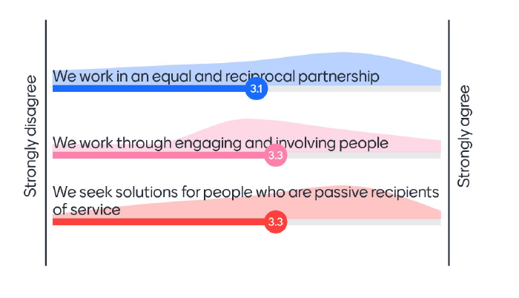
What three words come to mind when thinking about working with partners to develop action plans that involve a design for all approach ?  Amongst the many ideas presented, participants highlighted the importance of good communications when trying to work collaboratively and the importance of providing enough time to allow collaborative work to proceed effectively. | 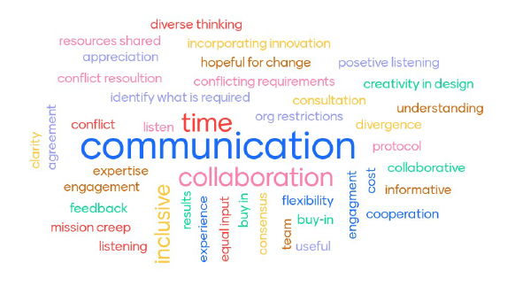

Interaction at the end of the Module 4: Pathways

After module 4, participants looked at the following questions to highlight the tools they use, and impacts and outcomes they may seek to achieve, in shaping their approach to applying UD.
How would you rank the following to provide the most beneficial mid-term results for a local community ?  The participants continued to prioritise the importance of public realm accessibility. | 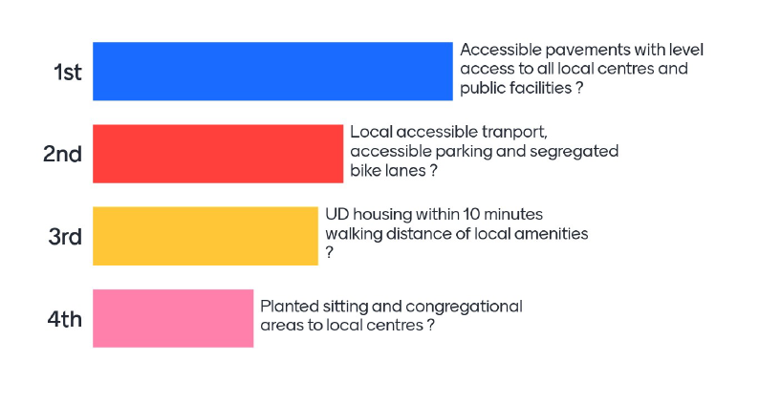
If doing any spatial, service or on-line service design work or action planning, what three resources would you reference most by your desk ?  With a mix of technical and administrative participants, a wide range of reference documents were identified as desk-side and/or on-line resources. It was interesting that no specific UD or Design for All documents were highlighted. | 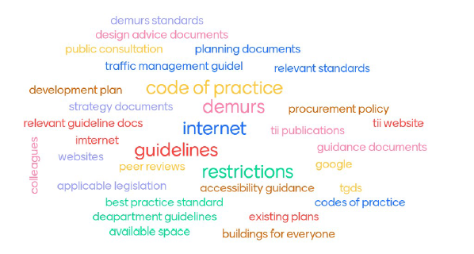
If universal design may add some additional costs to environmental and service design, what values and benefits might you expect in return ?  The participants indicated a wide range of beneficial outcomes that related to three primary pillars and the links between then:  - Impacts on individuals and their quality of life (functioning, health and wellbeing and participation)  - Impacts on the quality of neighbourhoods and communities (quality and sense of place)  - Impacts on the quality and effectiveness of our systems and services.
  Greater usage / increased use
  Better outcomes
  Inclusive
  Less changes to made in the future / Do it once and do it right
  More participation
  Quality of life
  Accessibility for all
  Reduced care home costs
  Less injury claims
  Satisfaction of end user / customer/user satisfaction
  Low future maintenance costs / - less maintenance going forward
  Less cost in hospitals:/ nursing homes
  Vibrant communities
  Less complaints.
  Healthier, more engaged community, future proofing
  Protection against liability. Increased good reputational value.
  Living in your home as you age / Stay in home longer
  Spaces look nicer / simple clear design
  Promotion of the benefits
  Community benefit making it better place to live

Evaluation and Future Steps

Evaluation of the programme is informed by the following data sources:

- Feedback from participants at the end of the session
- Staff reflection after the delivery of the course
- Some reflections by the design and delivery team

These are discussed in the next sections before discussing proposed improvements and future steps.

Feedback within session

The session closed with a set of questions to gather how participants experienced the programme and what areas might be considered for improvement.
On a scale of 1 to 5, how useful did you find the information presented in each of the four modules ?  Reflections by the participants at the end of the session suggest that all the modules were useful, but there was a slight leaning towards the value of the practices module. | 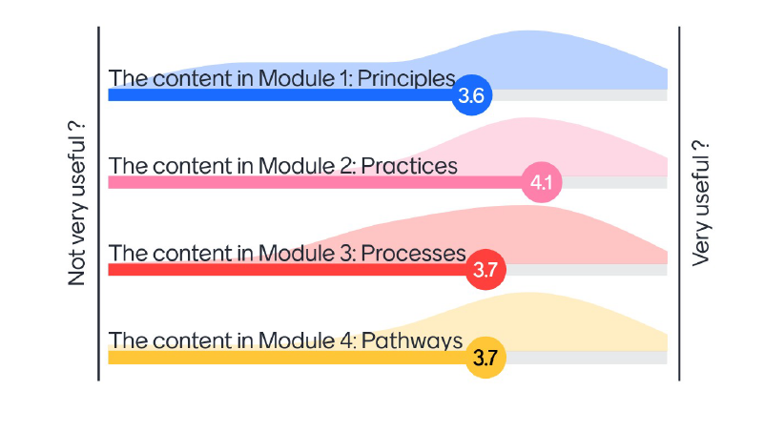
We covered a lot of ground in a morning. How would you rank the time allotment for the programme ?  For a programme of this type – overall it seems that a half day time allocation may be about right. | 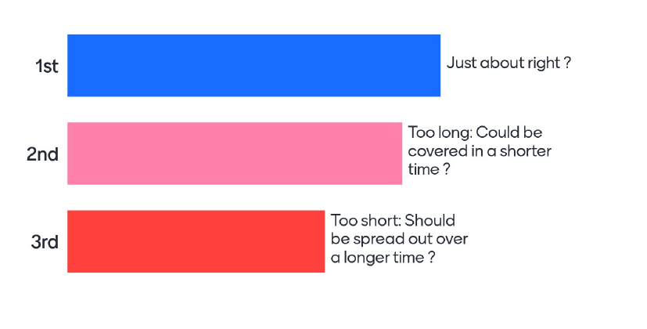
Can you mention areas where the programme worked well, and suggest areas where it could be improved ?  Overall, feedback was very positive. Due to the range of participants and their varying administrative and technical roles, feedback was quite variable and in some cases a bit contradictory. Important issues raised include:  - Getting the right content/format balance between visuals and text, and considering the use of video or animated simulations could be used to enhance examples.  - While the course did not require previous experience with the topic, at times it did get a bit technical, and this was challenging for some with little or low levels of previous experience  - The interactive work with mentimeter worked well and some felt that even more interactive work could be supported  - Generally the quality of graphics and photos were acceptable but some could be improved (scale / focus etc)  - For a few, the process and organisational development module was very relevant, but could have benefited from some concrete examples.  - Greater consistency across the 4 modules in transitioning between the topic areas could be achieved, – and this may have helped in providing a clearer structure between the examples in modules 2 and 4.  - A more comprehensive Index/overview of relevant documents could be provided within the resource.
  Less text on slides
  The first module was quite intense especially is it was your first introduction to UD
  Polling and interaction really useful
  Video
  Course participants should be made aware of need to have alternative internet access
  The Practical modules worked well
  more focus on examples of good UD
  3D graphics
  Nice visuals
  Menti worked well - more particpation from viewers could be included
  Modules 2 and 4 seemed a little scattered and could benefit for clear delineation when changing topic.
  Less text and more pictures.
  Assumes that all have heard of Universal Design prior to this. The 4 modules in one sitting is a bit too much
  Interaction was very useful
  simulation of barriers to UD
  Planners in LA awareness to include in Development plans if not already in
  More graphics than text will work well too
  Public servants generally operate around a 1 pm finish. Numbers have dropped off after 1 so watch for that going forward
  Good overview and context. Some practical examples and insight. However. was quite technical in places for those who are being introduced to this for the first time. Photos/graphics could have been better -some were difficult to see/read
  Areas where the programme worked well = Refresher course re UD
  Suggest areas where it could be improved = Highlight relevant docs
  Good presentations thank you. A lot to take in at once for concentration levels. Good to have the slides to refer back to. Different knowledge levels and skill sets in room make it difficult to apply all learnings.
  Module 3 was really interesting from an organisational point of view but maybe could benefit from from real examples of how this works
  Module 4 could be more structured better. The contexts of the examples could be emphasised better

Feedback from staff member after the course

A staff member provided the following feedback which highlighted some of the short-comings of the programme:

‘…. I found that it spoke a lot about inclusion and accessibility but only gave examples of people with physical disabilities or elderly people. It didn’t really touch on children and adults with invisible disabilities such as Autism and sensory processing issues. As a parent to a child with additional needs I feel that everyone needs to be educated in this area and if you are rolling this course out to all employees it might be an idea to mention these type of disabilities.’

‘…. Also I wasn’t sure whether this initiative was going to be across the different organisations i.e. Local Authorities, HSE, Education maybe you could clarify what the final objective is with this initiative. And if it’s just the local authorities what changes can be made from our point of view to make life a little easier for our citizens with an invisible disability’

These two remarks are important pointers to the future design of the programme.

Some reflections from the design and delivery team

The team recognise the impact of a few early decisions to the direction and design of the current version of the pilot programme.

- It was decided that initially, it should be oriented, focussed and delivered to a range of technical and administrative local authority staff, and in the first instance, to not include staff from related organisations (ie HSE, Garda, Enterprise, NGO/CSOs etc) who would be stakeholders and delivery partners in many LECP/HI actions. As a result, it tended to focus on areas where the local authority had the largest direct influence, and paid less attention to areas outside the local authority’s direct competency.
- Many of the benefits of UD are soft, social and qualitative gains where it is difficult to enumerate, quantify or ‘monetise’ the social value gained. Financing the incremental costs of UD improvement remains a challenge and a future iteration of the programme could provide further guidance on how to make the case for greater UD investment, particularly as it relates to submissions for grants or access to relevant funding streams
- Digital exclusion is a vital challenge facing communities as they strive for greater inclusivity. While the programme looked at web-accessibility – further content could be included to show examples of digital services and innovations where the risks of exclusion are very prevalent.
- The programme was oriented towards awareness raising - rather than a hands-on desk-side tool to support inclusive service design decision-making. Following the course, it seems that there may be a real need for an on-line, desk-side resource for service design innovators. This is beyond the scope of this initial work, but might be considered in collaboration with related partners.
- We recognise that there is an opportunity to improve the balance of between examples of good practice and the bad practice.
- While the programme highlighted the need for a shift towards organisations undertaking more participatory, co-design work, perhaps it might be possible to provide some in-course tangible practice to help participants get the feel for ‘releasing control’ for more collaborative working.

Proposed improvements and next steps

The pilot of the prototype HIDI resource has demonstrated the value of a training and support resource to help develop more integrated and coherent LECP and Healthy Ireland plans that are both inclusive and sustainable. While the pilot programme is now available to be replicated, re-presented on-line or published - over the next period, the programme designers suggest the following proposed improvements and next steps should be considered, by those with an interest in it’s further development.

- Consider its orientation and delivery in an integrated fashion beyond the boundary of a local authority to a wider range of collaborative stakeholders working together (LA, HSE, Garda, PPN members etc)
- Further advance on-going discussions with the Institute for Public Administration (IPA) in relation to its accreditation within local athorities and across the public sector
- Consider how it might be re-packaged/modularised to address the varying needs of different users with different experience levels and purposes for engagement.
- Liaise with related bodies, to ensure and highlight it’s complimentary nature and value, so that it can align as a supporting resource and framework for organisations directly or indirectly impacted by Universal Design and Design for All.
- With a very high dependency upon new participatory and co-design development principles and techniques, examine how this dimension can be strengthened within the resource/programme.
- Update its content to reflect the very recent launch and publication of the new standard EN 17210:2021 – Accessibility and usability of the built environment – Functional Requirements.
- Generally update the quality and consistency of the content format of the pilot resource. (including the balance of images and text)
- In collaboration with relevant partners, consider it’s repurposing ( or a follow on format) where it might form part of a desk-top guide.

Across this range of improvement opportunities, items 1 and 5 represent the areas that are likely to have the greatest influence on shaping its further development pathway. Over the coming weeks, the designers will liaise with the client to explore how these avenues of development may be explored.

Appendices

Survey Questions:
The following are the set of questions that were asked of potential users of the proposed HIDI CPD resource. The survey was implemented on-line using Survey Monkey web-based survey/questionaire portal. Before presenting the questions, the following introductory statements with be made: (Statements are yet to be defined I detail)
- Who is undertaking the survey:
- What is the Healthy Ireland Design Innovation (HIDI) project and resource tool-kit and why is it needed:
- Why you have been invited to participate in the survey:
- The purpose of the survey - to inform the design of the tool-kit:
- How long the survey should take:
- GDPR Data protection and you option not to participate:
- Oportunity at the end of the survey to add comments or further information to inform the design of the resource:
SECTION | QUESTION | OPTIONS
Your Organisation and Role: | What type of organisation do you work in ? | Choose which option applies:  - Local Authority  - Health Service  - Garda Siochana  - NGO/C&V Sector / Service provider  - Private Sector / Service provider  - Other
 | What is your role in the organisation ? | Choose which option applies:  - Service/programme management and design  - Urban / building planning and design  - Back-office services – internal focus  - Front-line services – customer/client facing  - Product design  - Other ?
 | What is the nature of your engagement with your organisation ? | Choose which option applies:  - Employee  - Consultant/mentor  - Volunteer
You’re area of interest | What local community goals and objectives are your work activities mostly directed towards ? | Select any that are relevant:  - A strong safe and flourishing community  - Access to education  - Inclusive communities and places  - Health and wellbeing  - Children and young people  - Age-friendly society  - Entrepreneurship, innovation and enterprise  - A sustainable and valued environment
 | What aspects of peoples’ experiences in our community does your work relate to ? | Select any that are relevant:  - Buildings and outdoor spaces – streets / parks etc  - Housing  - Transport, mobility  - Information provision and ICT / digital services  - Education, training and learning  - Civic participation – employment and volunteering  - Social participation – Sports, leisure, culture  - Health and community services  - Inclusion of vulnerable and marginalised groups
Current level of Universal Design awareness | Have you had any previous training in Universal Design or a related approach (ie design for all, inclusive design, web accessibility, design guidelines for specific groups ) ? | Please rate your level of previous training from 1 to 5  None – a little – moderate – quite a bit – extensive  1 2 3 4 5
 | Which, if any, of the key principles of Universal Design are most relevant to your work ? | Select any that are relevant to your work in order of priority: (will include sentence explaining concept)  - Equitable use  - Flexibility in use  - Simple and intuitive use  - Perceptible information  - Tolerance of error  - Low physical effort  - Size and space
 | Which, if any, of the following key goals of Universal Design are most relevant to your work ; | Select any that are relevant to your work in order of priority: (will include sentence explaining concept):  - Personalisation  - Social integration  - Cultural Appropriateness  - Health & Wellness  - Understanding  - Awareness  - Comfort  - Body fit
 | Which, if any of the following factors do you consider to be a barrier to the wider adoption and application of Universal Design ? | Select any that are relevant:  - Expensive - perceived additional costs  - Difficult concept – there’s no one size fits all  - Unnecessary concept – it’s just good design  - Not sure if its optional or manadory  - Difficult to standardise  - Difficult to evaluate compliance  - Other
Prioritising training areas | Which of the following Universal Design application areas would be most relevant to you in your ? | Select any in order of priority: (1 being the highest priority)  - Design for human performance and functioning  - Design for health and wellness  - Design for social particcipation  - Design for public spaces and buildings  - Design for Housing and home adpatation  - Design for the interior environment  - Design for products and services
 | Which, if any of the following ancilliary topics would be helpful in fostering the broader adoption of Universal Design in your organisation ? | Select any in order of priority: (1 being the highest priority)  - Understanding the new demographics  - How to practice and promote Universal Design  - The evolution of UD – barriers and diversity  - The economics of UD – a capabilities approach  - Universal design and Sustainable Development
Key application areas for applying Universal Design knowledge | In which of the following business/functional areas do you envisage applying your future knowledge of Universal Design principles, goals and approaches ? | Select any that are relevant:  - Setting policies and guidelines  - Requests for proposals / tenders  - Making funding applications  - Procurement – evaluating proposals  - Innovating – designing places, services, programmes  - Mainstreaming pilot programmes  - Replicating / scaling / transferring services  - Evaluating the performance/compliance of actions/interventions  - Other
Resource design | How important is it for you that the HIDI training programme/resource kit is accredited | Please rate the level of importance from 1 to 5  not – a little – medium – quite a bit – very  1 2 3 4 5
 | How much time would you be prepared to allocate to a HIDI Universal Design training programme | Please indicate the time effort you could invest:  - 1 hour  - 2 hours  - ( a morning / afternoon)  - 1 day
Additional Information | If you would like to provide any additional ideas, suggestions, comments or information to the team to help with the resource/tool-kit design and development, please add here:

Digital Resource Locations.

This is to be completed by the Local Authority and may be kept separately from the report.

File location for powerpoint presentations of modules:
File location for presentation recordings:
File location for supporting documents:

Kose, S., Preiser, W. & Ostroff, E (2001) Universal Design Handbook
Steinfeild, E. & Maisel, J. (2012) Universal Design: Creating inclusive environments.
Grey, T., Xidous, D., Kennelly, S.,Mahon, S., Mannion, V., de Freine, P., de Siún, A., Murphy, N., Craddock, G. & O’Neill, Desmond (2018) Dementia Friendly Hospitals from a Universal Design Approach.

