Holomedicine association

https://holomedicine-association.org/founding-members
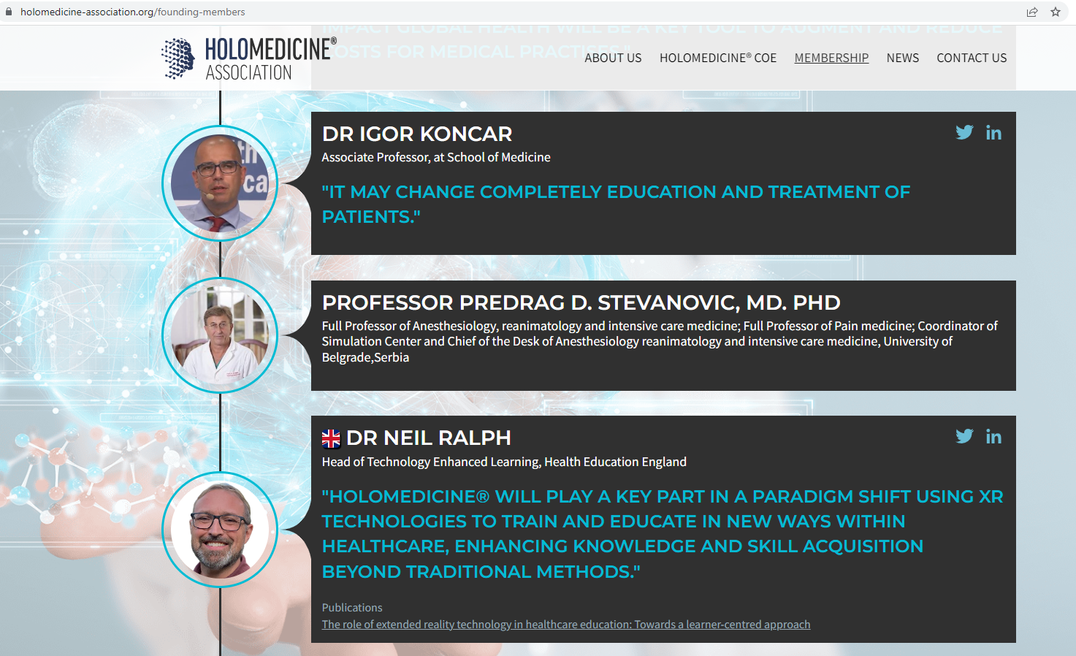

https://www.apoqlar.com/clinical-care
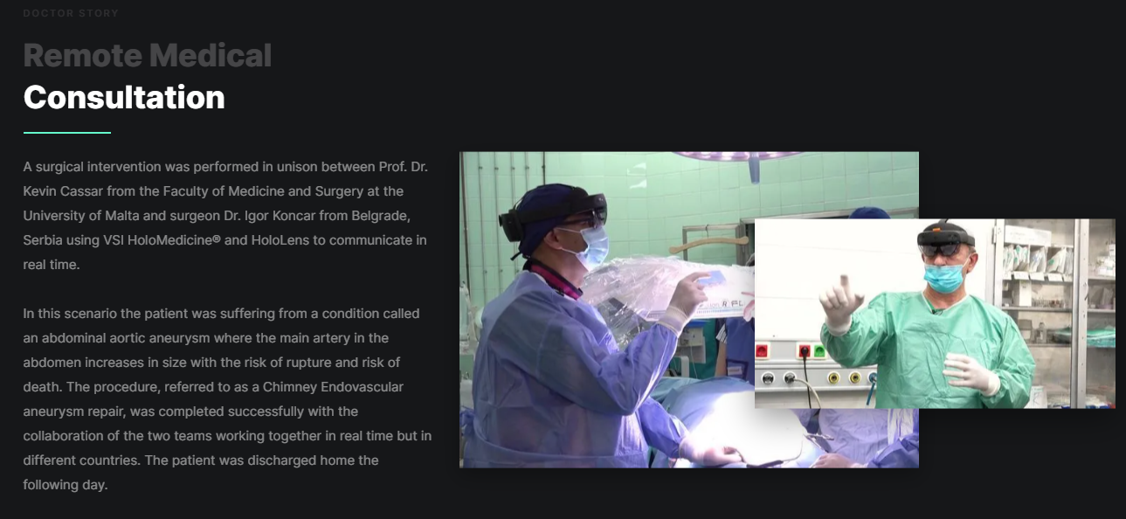

https://www.igi-global.com/chapter/introducing-mixed-reality-for-clinical-uses/311769
