FLAG: DEPARTMENT OF CULTURAL AFFAIRS AND SPORT
[headline] Our Libraries Embracing Design Thinking
[teaser]The Department of Cultural Affairs and Sport highlights why public libraries play a vital role in communities, as innovation hubs for knowledge, education, and social interaction
[copy]
In today's changing world, libraries face the challenge of meeting the evolving needs of their diverse patrons. One approach that has gained popularity in recent years is Design Thinking. In this article, we explore how a partnership through the Department of the Premier’s Innovation for Impact initiative is supporting the use of Design Thinking in public libraries, making them more adaptable, user-centric, and future-fit.
To this end, the University of Cape Town’s Hasso Plattner School of Design Thinking Africa and the Western Cape Library Service (WCLS) agreed to collaborate on this innovative problem-solving approach through the Foundation Phase Design Thinking challenge.
With the Wellington Library in the Drakenstein Municipality as a pilot site, this user-centered methodology was applied to encourage experimentation, build creative confidence, and embrace an innovative future. Through design thinking, WCLS and Innovation for Impact aim to revitalise libraries’ creative capacity, generate fresh ideas, and improve responsiveness to the needs of the communities we serve.

Libraries Embracing Design Thinking: A Global Trend
Libraries around the world are embracing design thinking as a powerful approach to redefining their purpose and offerings. By adopting this approach, libraries can transform themselves into dynamic hubs of citizen services, co-working spaces, and platforms for experimentation.

So, what exactly is Design Thinking?
Design thinking is a problem-solving methodology that prioritises users’ needs and experiences. This user-centricity allows problem solvers to arrive at innovative and practical solutions.
The process involves five stages: empathise, define, ideate, prototype, and test.
[insert picture of stages – see Powerpoint in folder]

The Challenge Statement: Redesigning the Multi-Use Experience for Young Adults in Libraries
A pressing challenge for libraries is to redesign the multi-use experience for young adults (aged 18-35) in under-resourced communities. In many cases, libraries are viewed as facilities exclusively for school-going youth, leaving young adults excluded from the resources, support, and engagement libraries can offer.
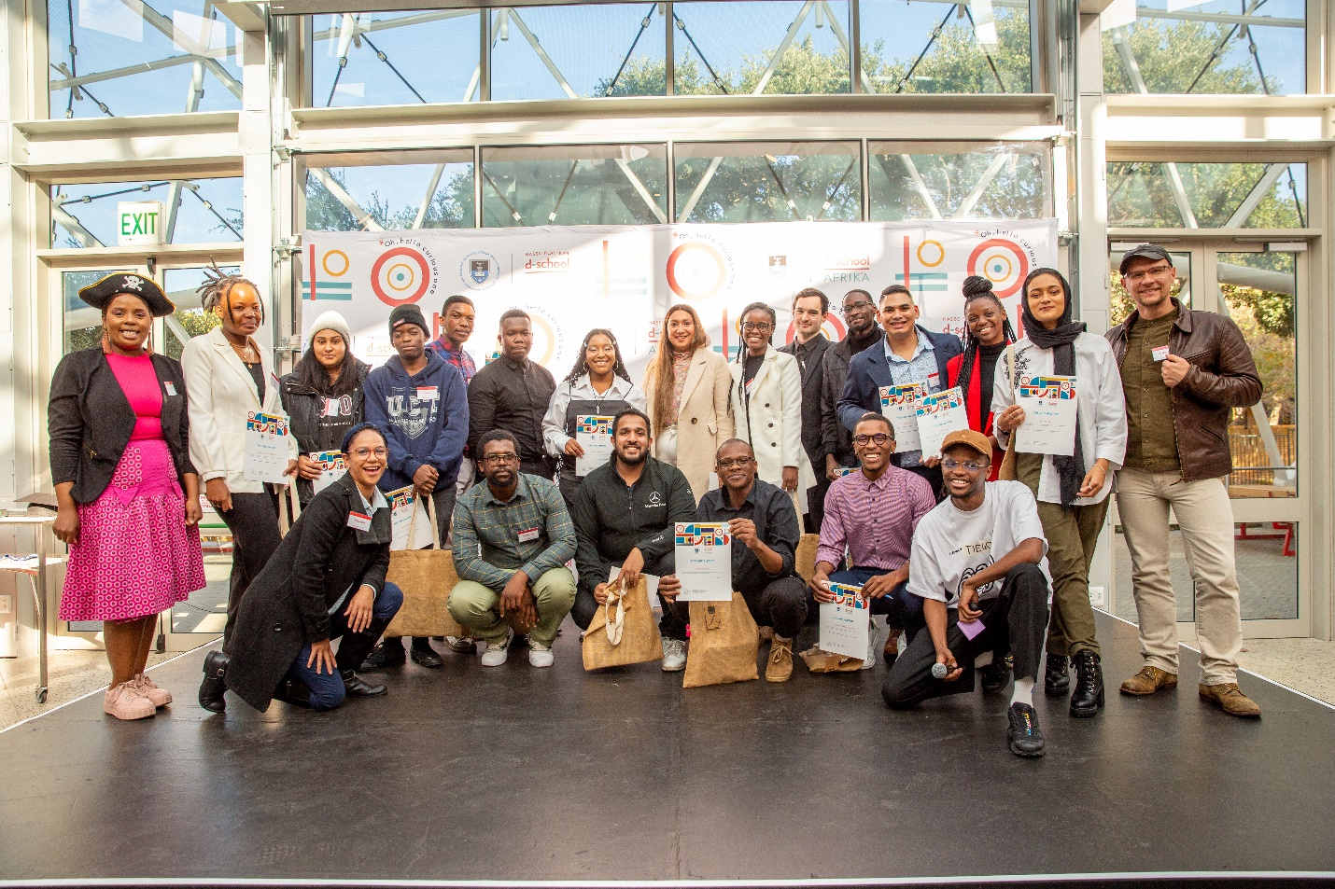
[CAPTION: The UCT Design School group of young design thinkers on this partnership.]

Innovation 1: Event-planning cell phone application
One solution, "To D-Day" (TD-D), is an event-planning online application designed to semi-automate the process for library staff to organize social gatherings with communities. Through guided event planning, TD-D simplifies the process, making it efficient and accessible on various digital devices. The platform features calendar invitations, GPS-based location suggestions, checklists, and invitation posters to enhance event organisation.
The team conducted in-depth interviews and observations of users, including library volunteers, university students, and elderly community members, to gather insights for refining their solution. This allowed the team to gain an understanding of the user’s experiences with the library and their opinions.

Innovation 2: Career, employment and personal development services
The Youth Development Initiative is a program aimed at fostering engagement among young adults within the Wellington community. The focus is to provide early career, employment, and personal development services to address youth unemployment challenge.
The program consists of a mobile (moving station) system that offers guidance in CV writing, cover letters, and interview skills. The initiative aims to break barriers between employment opportunities in underserved areas, and provide an offering that improves the quality of job applications.
To implement, the library needs to acquire desktop computers and laptops, or can utilise existing library computers, and invest in portable furniture or stations for flexible use. Allocating a designated person to manage the service, and training library staff or volunteers further strengthens the program. Youth interviewed about the viability of this idea were very excited to see it implemented.

Innovation 3: Registering Volunteers with specific skills
User interviews with key stakeholders shed light on the challenges faced by the librarians due to the constraints on human resources.
To address these challenges, the solution enables the librarian to access and source local volunteers to assist with activities and programs. It creates a process of pairing volunteers with users to work together on small tasks and the possibility of collaborating with local NGOs to leverage their volunteer base for more complex needs.
Existing programs like outreach sessions, literacy programs and other activities can be organized through trained volunteers who can provide the support need so librarians can focus on delivering quality services.

Congratulations to the teams involved in this project! With ideas like this, WCLS is poised to be an innovation frontrunner for the Western Cape Government.

---------------------------------------------------------------------------------------------------------------------------
The Western Cape Library Service (Department of Cultural Affairs and Sport) and the Innovation for Impact (Department of the Premier) team wish to extend our condolences to the staff of Wellington Library for the loss of Adeelah Whatney, the Library Manager at the Wellington Library and a key contributor to the success of this project. This work would not have been possible without her. May she rest in peace.

